#### **Project Report**

##### ON

**RENTER’S.COM**

PROJECT DONE BY

**Niraj Kumar Verma**

**Abstract:**

This project is done as the major project of the 6th semester of 3rd year of NTTF at RD Tata Technical Education Centre, Golmuri, Jamshedpur.

The project is undertaken to plan, design and develop a Website named as “Renter’s.com”.

The website is being designed with the aim of providing a portal for renters and lenders. It will give a platform on the internet where a variety of renting services are being rendered are:

* House
* Hall
* Room
* Ground

**Project Members:**

|  |  |  |
| --- | --- | --- |
| **Serial No.** | **Name** | **Token No.** |
| 1 | Niraj Kumar Verma | RNTC 08 16 036 |
| 2 | Parmeet Singh | RNTC 08 16 038 |
| 3 | Kirandeep Kaur | RNTC 08 16 023 |
| 4 | Neha Priya | RNTC 08 16 032 |





**INDEX**



|  |  |  |
| --- | --- | --- |
| **Serial No.** | **Content** | **Page No.** |
| **1** | Acknowledgement |  |
| **2** | Introduction |  |
| **3** | Problem Domain |  |
| **4** | Description of the software used |  |
| **5** | Block Diagrams   |  |  | | --- | --- | | **i** | Flow of process | | **ii** | Data-Flow-Diagram (DFD) | | **iii** | Entity-Relationship (E.R.Diagram) | |  |
| **6** | Database Design |  |
| **7** | User Interface Design and Code Snippets |  |
| **8** | Testing & Validation Checks |  |
| **9** | Future Scope |  |
| **10** | Conclusion |  |
| **11** | Bibliography |  |



**Acknowledgment**

We the members of “Dollar$“ Project Number: PRJ0816007 here by, feel privilege to release our gratitude to people who helped us directly or indirectly for the completion of the major project.

We express our hearty indebtedness and owe a deep sense of gratefulness to our major project incharge Mr. Mrinmoy Kumar Mahato for her constant and sincere supervision and guidance in successful conduction of the project.

For providing the opportunity to do such a project we would like to thank our PRINCIPAL – Mr. Satish Joshi and HOD –Mr. Ayan Bhattacharjee and their support and encouragement throughout the project.

This major project has indeed helped us explore more knowledgeable avenues related to information management and has expanded our knowledge.

Niraj Kumar Verma (RNTC0816036)

Parmeet Singh (RNTC0816038)

Kirandeep Kaur (RNTC0816023)

Neha Priya (RNTC0816032)

**INTRODUCTION**

The website Renter’s.com is a search website on the internet catering to the millennial population of a state. The website is created to provide a common place for property (house, hall, room, ground) renting facilities. It aims to provide a suitable and cost-effective resource where people looking for rental places and can find their ideal place.

The website gives the opportunity to find places for rents such as house, party hall, grounds etc. It also eases the communication between lenders and renters. The user can search without creating an account with renter’s.com by using the guest system.

**Problem Domain:**

The need for the system has risen due to the following reason are:

* + The manual work is tedious.
  + It is time consuming and waste of resources.
  + Lack of user-friendly environment in manual work.
  + Retrieval of the property (house, hall, room, ground) is not easy from the record of such a huge world.
  + Less prone to error.
  + To save money and time.
  + To maintain the data.



**SOFTWARE DESCRPTION**

**VISUAL STUDIO 2010**

Visual Studio 2010 replaces Visual Studio 2008 Team Suite. It includes new modelling tools, such as the Architecture Explorer, which graphically displays projects and classes and the relationships between them. It supports UML activity diagram, component diagram, (logical) class diagram, sequence diagram, and use case diagram.[Visual Studio 2010 also includes Test Impact Analysis which provides hints on which test cases are impacted by modifications to the source code, without actually running the test cases.[This speeds up testing by avoiding running unnecessary test cases.

Visual Studio 2010 also includes a historical debugger for managed code called IntelliTrace. Unlike a traditional debugger that records only the currently active stack, IntelliTrace records all events, such as prior function calls, method parameters, events and exceptions. This allows the code execution to be rewound in case a breakpoint was not set where the error occurred. Debugging with IntelliTrace causes the application to run more slowly than debugging without it, and uses more memory as additional data needs to be recorded. Microsoft allows configuration of how much data should be recorded, in effect, allowing developers to balance the speed of execution and resource usage.



**MICROSOFT SERVER SQL 2005**

SQL Server Management Studio (SSMS) is a software application first launched with Microsoft SQL Server 2005 that is used for configuring, managing, and administering all components within Microsoft SQL Server. The tool includes both script editors and graphical tools which work with objects and features of the server.

A central feature of SSMS is the Object Explorer, which allows the user to browse, select, and act upon any of the objects within the server. It also shipped a separate Express edition that could be freely downloaded. However recent versions of SSMS are fully capable of connecting to and manage any SQL Server Express instance. Microsoft also incorporated backwards compatibility for older versions of SQL Server thus allowing a newer version of SSMS to connect to older versions of SQL Server instances.

Starting from version 11, the application was based on the Visual Studio 2010 shell, using WPF for the user interface.

In June 2015, Microsoft announced their intention to release future versions of SSMS independently of SQL Server database engine releases. 

**FLOW OF PROCESS:**



Upload Property

Book and Pay for Property

**Data Flow Diagram:**

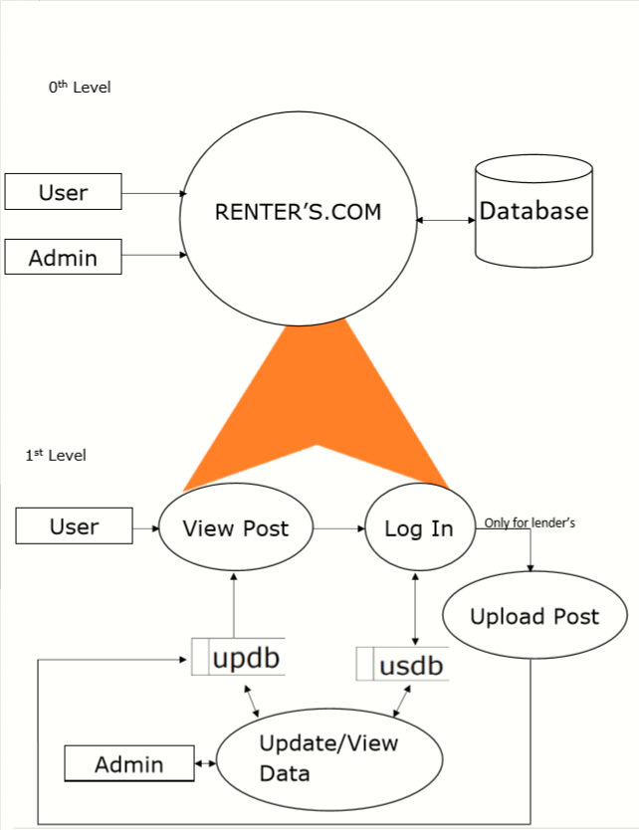

**ER Diagram:**

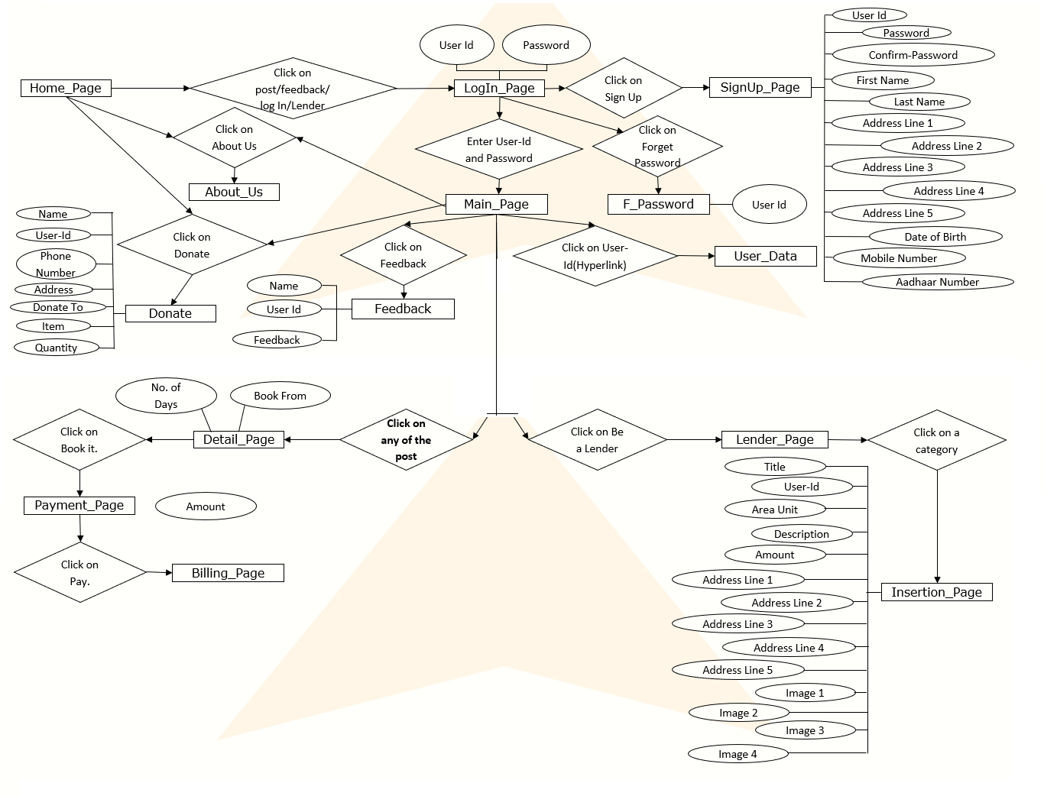

**Database Design:**

* **To store all the User Credentials**

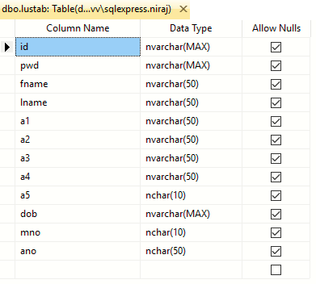

* **To store the Feedback of User**

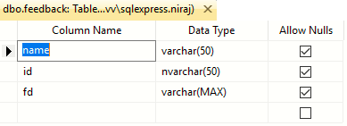

* **To store the data related house to be rent**

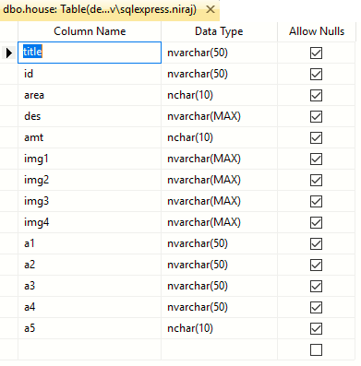

* **To store the data related room to be rent**

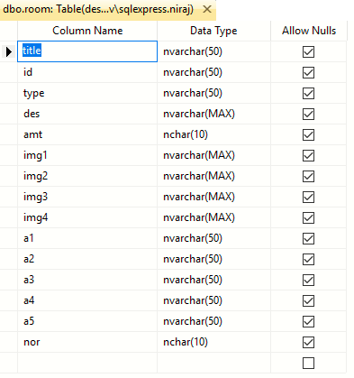

* **To store the data related hall to be rent**

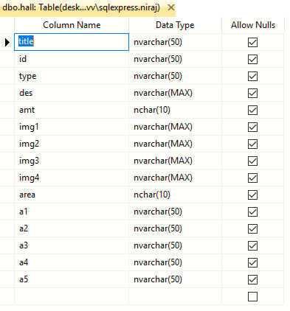

* **To store the data related ground to be rent**

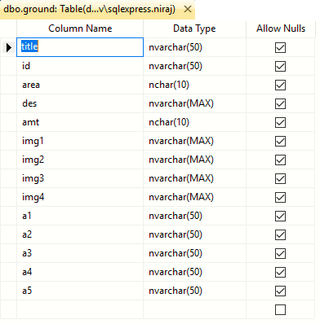

* **To store the data of donation made by users.**

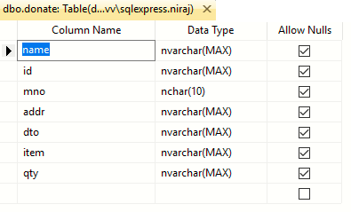

* **To store the which have all the information related to booking.**

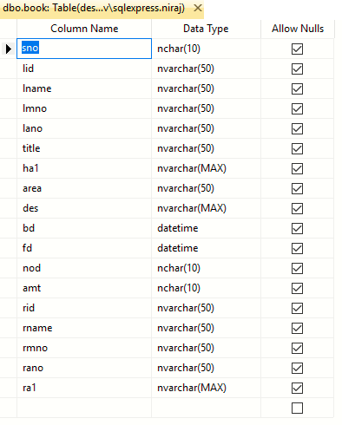

**User Interface Design:**

**Home_Page:**

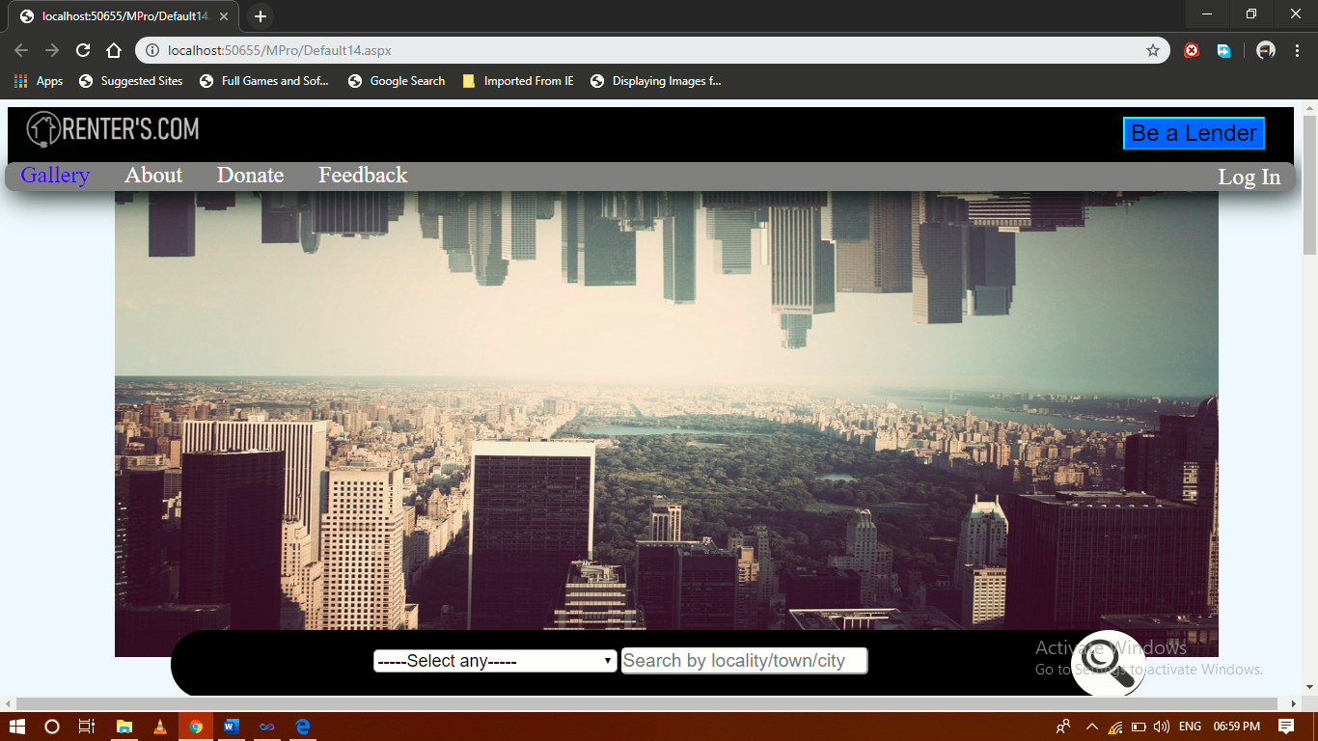

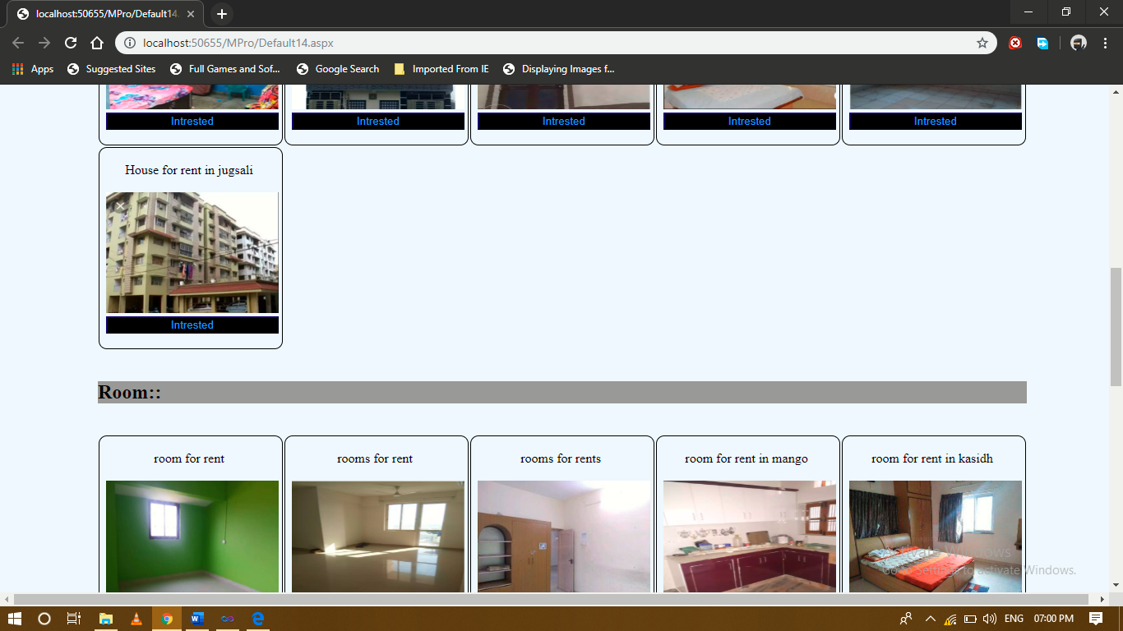

Design-

<%@ Page Language="C#" AutoEventWireup="true" CodeFile="Default14.aspx.cs" Inherits="Default14" %>

<!DOCTYPE html PUBLIC "-//W3C//DTD XHTML 1.0 Transitional//EN" "http://www.w3.org/TR/xhtml1/DTD/xhtml1-transitional.dtd">

<html xmlns="http://www.w3.org/1999/xhtml">

<head id="Head1" runat="server">

<title></title>

<style type="text/css">

a

{

color:White;

padding:14px 16px;

text-align:center;

font-size:x-large;

text-decoration:none;

}

a:hover.s

{

color:Gray;

background-color:White;

}

a.active

{

color:Blue;

}

a.t

{

float:right;

color:White;

padding:2px 16px;

text-align:center;

font-size:x-larger;

text-decoration:none;

}

a:hover.t

{

padding:14px 16px;

color:Grey;

background-color:White;

}

</style>

</head>

<body bgcolor="#F0F8FF" >

<form id="form1" runat="server">

<div style="background-color: Black; height: 78px; z-index: -2;">

<asp:Image ID="Image1" runat="server" ImageUrl="~/l.png" Height="50px" Width="250px" />

<div style="padding:10px 30px; float: right;"><asp:Button ID="Button1" runat="server"

Text="Be a Lender" BackColor="#0066FF"

style=" text-decoration:none; float:right; text-align:center; font-size:x-large; z-index: 2;"

BorderColor="Aqua" BorderStyle="Outset" onclick="Button1_Click"/>

</div></div>

<div style="background-color: #808080; height: 30px;-webkit-box-shadow:5px 5px 28px rgba(0,09,0,01); -webkit-border-radius:10px; z-index: 1; left: 05px; top: 65px; position: absolute; width:99.2%;">

<a class="active" href="">Gallery</a>

<a class="s" href="Default11.aspx">About</a>

<a class="s" href="Default17.aspx">Donate</a>

<a class="s" href="login.aspx">Feedback</a>

<a class="t" href="login.aspx">Log In</a>

</div><br />

<center>

<div style="top:78px; height:500px; width:1144px; z-index: -1; left: 119px; position: absolute;"

align="center">

<asp:Image class="mySlides" ID="Image2" runat="server" ImageUrl="~/about-img.jpg" style="width:100%;height:100%;"/>

<asp:Image class="mySlides" ID="Image3" runat="server" ImageUrl="~/close-up-door-focus-101808.jpg" style="width:100%;height:100%"/>

<asp:Image class="mySlides" ID="Image4" runat="server" ImageUrl="~/Decor-cup1.jpg" style="width:100%;height:100%"/>

<asp:Image class="mySlides" ID="Image5" runat="server" ImageUrl="~/event-venue-opt.jpg" style="width:100%;height:100%"/>

<asp:Image class="mySlides" ID="Image6" runat="server" ImageUrl="~/header-bg.jpg" style="width:100%;height:100%"/>

<asp:Image class="mySlides" ID="Image7" runat="server" ImageUrl="~/house_sky_changeling_59132_1280x720.jpg" style="width:100%;height:100%"/>

<asp:Image class="mySlides" ID="Image8" runat="server" ImageUrl="~/luxury-room-sofitel-the-palm-dubai-1200x675.jpg" style="width:100%;height:100%"/>

<asp:Image class="mySlides" ID="Image9" runat="server" ImageUrl="~/Melling_Int_9use.jpg" style="width:100%;height:100%"/>

<asp:Image class="mySlides" ID="Image10" runat="server" ImageUrl="~/nirvaan-ground-mira-road-thane-film-shooting-location-5iwbu.jpg" style="width:100%;height:100%"/>

<asp:Image class="mySlides" ID="Image11" runat="server" ImageUrl="~/park_autumn_trees_walking_paths_90924_1280x720.jpg" style="width:100%;height:100%"/>

<asp:Image class="mySlides" ID="Image12" runat="server" ImageUrl="~/service-bg.jpg" style="width:100%;height:100%"/>

<asp:Image class="mySlides" ID="Image13" runat="server" ImageUrl="~/tokyo-prince-hotel-rooms-ClubDeluxeTwinRoom-noon-01-800x520.jpg" style="width:100%;height:100%"/>

<script type="text/javascript">

var myIndex = 0;

carousel();

function carousel() {

var i;

var x = document.getElementsByClassName("mySlides");

for (i = 0; i < x.length; i++) {

x[i].style.display = "none";

}

myIndex++;

if (myIndex > x.length) { myIndex = 1 }

x[myIndex - 1].style.display = "block";

setTimeout(carousel, 5000);

}

</script>

</div></center>

<div style="-webkit-border-radius:190px; top: 550px; position: absolute; width: 100%;" >

<center>

<asp:Panel ID="Panel1" runat="server" Height="71px" Width="75%" BackColor="Black"

style="align-items:middle;-webkit-border-radius:190px;"

BorderColor="White">

<asp:ImageButton ID="ImageButton1" runat="server"

ImageUrl="~/Magnifying_Glass-512.png" Height="71px" ImageAlign="Bottom" style="float:right; border-radius:50%;"

Width="78px" BackColor="White" onclick="ImageButton1_Click" /><br />

<center>

<asp:DropDownList ID="DropDownList1" runat="server" Width="25%"

style="-webkit-border-radius:5px;" Font-Size="Large"

onselectedindexchanged="DropDownList1_SelectedIndexChanged" AutoPostBack="True">

<asp:ListItem>-----Select any-----</asp:ListItem>

<asp:ListItem>All</asp:ListItem>

<asp:ListItem>HOUSE</asp:ListItem>

<asp:ListItem>ROOM</asp:ListItem>

<asp:ListItem>HAll</asp:ListItem>

<asp:ListItem>GROUND</asp:ListItem>

</asp:DropDownList>

<asp:TextBox ID="TextBox2" runat="server" Width="25%"

style="-webkit-border-radius:5px;" Font-Size="Larger"

BorderStyle="Outset" placeholder="Search by locality/town/city"></asp:TextBox>

</center>

</asp:Panel></center></div><br /><br />

<div style="top:628px; position: absolute; left:119px;" >

<asp:Panel ID="Panel2" runat="server">

<div style="background-color: #999999"><h2><b>House::</b></h2></div><br />

<asp:DataList ID="DataList1" runat="server"

RepeatDirection="Horizontal" onitemcommand="DataList1_ItemCommand"

RepeatColumns="5" >

<ItemTemplate>

<asp:Panel ID="Panel1" runat="server" BorderColor="Black" style="-webkit-border-radius:10px;" BorderStyle="Inset" BorderWidth="1px">

<center><br />

<asp:Label ID="Label1" runat="server" Text='<%# Eval("title") %>'></asp:Label>

<br /></center><br />&nbsp;

<asp:ImageButton ID="ImageButton1" runat="server" Height="147px"

ImageUrl='<%# Eval("img1") %>' Width="210px" CommandName="Title" CommandArgument='<%# Eval("title") %>'/>

<br />&nbsp;

<asp:Button ID="Button2" runat="server" BackColor="Black" ForeColor="#3399FF"

style="margin-left: 0px" Text="Intrested" Width="210px" BorderStyle="Outset" CommandName="Title"

BorderColor="#000066" CommandArgument='<%# Eval("title") %>'/>

<br />

<br /> </asp:Panel>

</ItemTemplate>

</asp:DataList></asp:Panel>

<asp:Panel ID="Panel3" runat="server">

<br />

<div style="background-color: #999999"><h2><b>Room::</b></h2></div><br />

<asp:DataList ID="DataList2" runat="server"

RepeatDirection="Horizontal" onitemcommand="DataList2_ItemCommand"

RepeatColumns="5">

<ItemTemplate>

<asp:Panel ID="Panel1" runat="server" BorderColor="Black" style="-webkit-border-radius:10px;" BorderStyle="Inset" BorderWidth="1px">

<center><br />

<asp:Label ID="Label1" runat="server" Text='<%# Eval("title") %>'></asp:Label>

<br /></center><br />&nbsp;

<asp:ImageButton ID="ImageButton1" runat="server" Height="147px"

ImageUrl='<%# Eval("img1") %>' Width="210px" CommandName="Title"/>

<br />&nbsp;

<asp:Button ID="Button2" runat="server" BackColor="Black" ForeColor="#3399FF" CommandName="Title"

style="margin-left: 0px" Text="Intrested" Width="210px" BorderStyle="Outset" BorderColor="#000066" />

<br />

<br /> </asp:Panel>

</ItemTemplate>

</asp:DataList></asp:Panel>

<asp:Panel ID="Panel4" runat="server">

<br /><div style="background-color: #999999"><h2><b>Hall::</b></h2></div><br />

<asp:DataList ID="DataList3" runat="server"

RepeatDirection="Horizontal" onitemcommand="DataList3_ItemCommand"

RepeatColumns="5">

<ItemTemplate>

<asp:Panel ID="Panel1" runat="server" BorderColor="Black" style="-webkit-border-radius:10px;" BorderStyle="Inset" BorderWidth="1px">

<center><br />

<asp:Label ID="Label1" runat="server" Text='<%# Eval("title") %>' CommandName="Title"></asp:Label>

<br /></center><br />&nbsp;

<asp:ImageButton ID="ImageButton1" runat="server" Height="147px" CommandName="Title"

ImageUrl='<%# Eval("img1") %>' Width="210px" />

<br />&nbsp;

<asp:Button ID="Button2" runat="server" BackColor="Black" ForeColor="#3399FF" CommandName="Title"

style="margin-left: 0px" Text="Intrested" Width="210px" BorderStyle="Outset" BorderColor="#000066" />

<br />

<br /> </asp:Panel>

</ItemTemplate>

</asp:DataList></asp:Panel>

<asp:Panel ID="Panel5" runat="server">

<br /><div style="background-color: #999999"><h2><b>Ground::</b></h2></div><br />

<asp:DataList ID="DataList4" runat="server"

RepeatDirection="Horizontal" onitemcommand="DataList4_ItemCommand"

RepeatColumns="5">

<ItemTemplate>

<asp:Panel ID="Panel1" runat="server" BorderColor="Black" style="-webkit-border-radius:10px;" BorderStyle="Inset" BorderWidth="1px">

<center><br />

<asp:Label CommandName="Title" ID="Label1" runat="server" Text='<%# Eval("title") %>'></asp:Label>

<br /></center><br />&nbsp;

<asp:ImageButton ID="ImageButton1" runat="server" Height="147px" CommandName="Title"

ImageUrl='<%# Eval("img1") %>' Width="210px" />

<br />&nbsp;

<asp:Button ID="Button2" runat="server" BackColor="Black" ForeColor="#3399FF" CommandName="Title"

style="margin-left: 0px" Text="Intrested" Width="210px" BorderStyle="Outset" BorderColor="#000066" />

<br />

<br /> </asp:Panel>

</ItemTemplate>

</asp:DataList></asp:Panel>

</div>

</form>

</body>

</html>

Code Snippets-

using System;

using System.Collections.Generic;

using System.Linq;

using System.Web;

using System.Web.UI;

using System.Web.UI.WebControls;

using System.Data;

using System.Data.SqlClient;

public partial class Default14 : System.Web.UI.Page

{

SqlConnection cn = new SqlConnection("Data Source=DESKTOP-MP67RVV\\SQLEXPRESS;Initial Catalog=niraj;Integrated Security=True;Pooling=False");

SqlCommand cmd;

SqlDataReader dr;

SqlDataAdapter da;

DataSet ds;

protected void Page_Load(object sender, EventArgs e)

{

cn.Open();

cmd = new SqlCommand("Select * from house", cn);

dr = cmd.ExecuteReader();

DataList1.DataSource = dr;

DataList1.DataBind();

cn.Close();

cn.Open();

cmd = new SqlCommand("Select * from room", cn);

dr = cmd.ExecuteReader();

DataList2.DataSource = dr;

DataList2.DataBind();

cn.Close();

cn.Open();

cmd = new SqlCommand("Select * from hall", cn);

dr = cmd.ExecuteReader();

DataList3.DataSource = dr;

DataList3.DataBind();

cn.Close();

cn.Open();

cmd = new SqlCommand("Select * from ground", cn);

dr = cmd.ExecuteReader();

DataList4.DataSource = dr;

DataList4.DataBind();

cn.Close();

}

protected void Button1_Click(object sender, EventArgs e)

{

Response.Redirect("login.aspx");

}

protected void DataList1_ItemCommand(object source, DataListCommandEventArgs e)

{

if (e.CommandName == "Title")

Response.Redirect("login.aspx?t2="+e.CommandArgument.ToString());

}

protected void DataList2_ItemCommand(object source, DataListCommandEventArgs e)

{

if (e.CommandName == "Title")

{ Response.Redirect("login.aspx"); }

}

protected void DataList3_ItemCommand(object source, DataListCommandEventArgs e)

{

if (e.CommandName == "Title")

{ Response.Redirect("login.aspx"); }

}

protected void DataList4_ItemCommand(object source, DataListCommandEventArgs e)

{

if (e.CommandName == "Title")

{ Response.Redirect("login.aspx"); }

}

protected void DropDownList1_SelectedIndexChanged(object sender, EventArgs e)

{

if (DropDownList1.Text == "All")

{

Panel2.Visible = true;

Panel3.Visible = true;

Panel4.Visible = true;

Panel5.Visible = true;

cn.Open();

cmd = new SqlCommand("Select * from house", cn);

dr = cmd.ExecuteReader();

DataList1.DataSource = dr;

DataList1.DataBind();

cn.Close();

cn.Open();

cmd = new SqlCommand("Select * from room", cn);

dr = cmd.ExecuteReader();

DataList2.DataSource = dr;

DataList2.DataBind();

cn.Close();

cn.Open();

cmd = new SqlCommand("Select * from hall", cn);

dr = cmd.ExecuteReader();

DataList3.DataSource = dr;

DataList3.DataBind();

cn.Close();

cn.Open();

cmd = new SqlCommand("Select * from ground", cn);

dr = cmd.ExecuteReader();

DataList4.DataSource = dr;

DataList4.DataBind();

cn.Close();

}

else {

if (DropDownList1.Text == "HOUSE")

{

Panel2.Visible = true;

Panel3.Visible = false;

Panel4.Visible = false;

Panel5.Visible = false;

cn.Open();

cmd = new SqlCommand("Select * from house", cn);

dr = cmd.ExecuteReader();

DataList1.DataSource = dr;

DataList1.DataBind();

cn.Close();

}

else if (DropDownList1.Text == "ROOM")

{

Panel2.Visible = false;

Panel3.Visible = true;

Panel4.Visible = false;

Panel5.Visible = false;

cn.Open();

cmd = new SqlCommand("Select * from room", cn);

dr = cmd.ExecuteReader();

DataList2.DataSource = dr;

DataList2.DataBind();

cn.Close();

}

else if (DropDownList1.Text == "HALL")

{

Panel2.Visible = false;

Panel3.Visible = false;

Panel4.Visible = true;

Panel5.Visible = false;

cn.Open();

cmd = new SqlCommand("Select * from hall", cn);

dr = cmd.ExecuteReader();

DataList3.DataSource = dr;

DataList3.DataBind();

cn.Close();

}

else if (DropDownList1.Text == "GROUND")

{

Panel2.Visible = false;

Panel3.Visible = false;

Panel4.Visible = false;

Panel5.Visible = true;

cn.Open();

cmd = new SqlCommand("Select * from ground", cn);

dr = cmd.ExecuteReader();

DataList4.DataSource = dr;

DataList4.DataBind();

cn.Close();

}

}

}

protected void ImageButton1_Click(object sender, ImageClickEventArgs e)

{

int xyz=0;

DataList2.DataSource = "";

DataList2.DataBind();

DataList3.DataSource = "";

DataList3.DataBind();

DataList4.DataSource = "";

DataList4.DataBind();

if (DropDownList1.Text == "All" && TextBox2.Text=="")

{

Panel2.Visible = true;

Panel3.Visible = true;

Panel4.Visible = true;

Panel5.Visible = true;

cn.Open();

cmd = new SqlCommand("Select * from house", cn);

dr = cmd.ExecuteReader();

DataList1.DataSource = dr;

DataList1.DataBind();

cn.Close();

cn.Open();

cmd = new SqlCommand("Select * from room", cn);

dr = cmd.ExecuteReader();

DataList2.DataSource = dr;

DataList2.DataBind();

cn.Close();

cn.Open();

cmd = new SqlCommand("Select * from hall", cn);

dr = cmd.ExecuteReader();

DataList3.DataSource = dr;

DataList3.DataBind();

cn.Close();

cn.Open();

cmd = new SqlCommand("Select * from ground", cn);

dr = cmd.ExecuteReader();

DataList4.DataSource = dr;

DataList4.DataBind();

cn.Close();

}

else {

if (DropDownList1.Text == "HOUSE" && TextBox2.Text == "")

{

Panel2.Visible = true;

Panel3.Visible = false;

Panel4.Visible = false;

Panel5.Visible = false;

DataTable dt = new DataTable();

cn.Open();

da = new SqlDataAdapter("Select * from house", cn);

ds = new DataSet();

da.Fill(ds);

int colCount = ds.Tables[0].Rows.Count;

DataTable ta = new DataTable();

String abc;

for (int i = 0; i < colCount; i++)

{

for (int j = 0; j < 5; j++)

{

String s = (ds.Tables[0].Rows[i][j + 9].ToString().ToUpper()).Trim();

String l = (TextBox2.Text.ToUpper()).Trim();

for (int k = 0, a = 0; k < s.Length; k++)

{

if (l[a] == s[k] && l.Length <= s.Substring(k).Length)

{

if (String.Compare(l, (s.Substring(k, l.Length))) == 0)

{

abc = "select * from house where " + ds.Tables[0].Columns[j + 9].ColumnName + " = '" + ds.Tables[0].Rows[i][j + 9].ToString() + "'";

xyz++;

cn.Close();

cn.Open();

cmd = new SqlCommand(abc, cn);

dr = cmd.ExecuteReader();

DataList4.DataSource = dr;

DataList4.DataBind();

cn.Close();

}

}

}

}

}

}

else if (DropDownList1.Text == "ROOM" && TextBox2.Text == "")

{

Panel2.Visible = false;

Panel3.Visible = true;

Panel4.Visible = false;

Panel5.Visible = false;

DataTable dt = new DataTable();

cn.Open();

da = new SqlDataAdapter("Select * from ground", cn);

ds = new DataSet();

da.Fill(ds);

int colCount = ds.Tables[0].Rows.Count;

DataTable ta = new DataTable();

String abc;

for (int i = 0; i < colCount; i++)

{

for (int j = 0; j < 5; j++)

{

String s = (ds.Tables[0].Rows[i][j + 9].ToString().ToUpper()).Trim();

String l = (TextBox2.Text.ToUpper()).Trim();

for (int k = 0, a = 0; k < s.Length; k++)

{

if (l[a] == s[k] && l.Length <= s.Substring(k).Length)

{

if (String.Compare(l, (s.Substring(k, l.Length))) == 0)

{

abc = "select * from room where " + ds.Tables[0].Columns[j + 9].ColumnName + " = '" + ds.Tables[0].Rows[i][j + 9].ToString() + "'";

cn.Close();

cn.Open();

cmd = new SqlCommand(abc, cn);

dr = cmd.ExecuteReader();

DataList4.DataSource = dr;

DataList4.DataBind();

cn.Close();

}

}

}

}

}

}

else if (DropDownList1.Text == "HALL" && TextBox2.Text == "")

{

Panel2.Visible = false;

Panel3.Visible = false;

Panel4.Visible = true;

Panel5.Visible = false;

DataTable dt = new DataTable();

cn.Open();

da = new SqlDataAdapter("Select * from ground", cn);

ds = new DataSet();

da.Fill(ds);

int colCount = ds.Tables[0].Rows.Count;

DataTable ta = new DataTable();

String abc;

for (int i = 0; i < colCount; i++)

{

for (int j = 0; j < 5; j++)

{

String s = (ds.Tables[0].Rows[i][j + 9].ToString().ToUpper()).Trim();

String l = (TextBox2.Text.ToUpper()).Trim();

for (int k = 0, a = 0; k < s.Length; k++)

{

if (l[a] == s[k] && l.Length <= s.Substring(k).Length)

{

if (String.Compare(l, (s.Substring(k, l.Length))) == 0)

{

abc = "select * from hall where " + ds.Tables[0].Columns[j + 9].ColumnName + " = '" + ds.Tables[0].Rows[i][j + 9].ToString() + "'";

cn.Close();

cn.Open();

cmd = new SqlCommand(abc, cn);

dr = cmd.ExecuteReader();

DataList4.DataSource = dr;

DataList4.DataBind();

cn.Close();

}

}

}

}

}

}

else if (DropDownList1.Text == "GROUND" && TextBox2.Text == "")

{

Panel2.Visible = false;

Panel3.Visible = false;

Panel4.Visible = false;

Panel5.Visible = true;

DataTable dt = new DataTable();

cn.Open();

da = new SqlDataAdapter("Select * from ground", cn);

ds = new DataSet();

da.Fill(ds);

int colCount = ds.Tables[0].Rows.Count;

DataTable ta = new DataTable();

String abc;

for (int i = 0; i < colCount; i++)

{

for (int j = 0; j < 5; j++)

{

String s = (ds.Tables[0].Rows[i][j + 9].ToString().ToUpper()).Trim();

String l = (TextBox2.Text.ToUpper()).Trim();

for (int k = 0, a = 0; k < s.Length; k++)

{

if (l[a] == s[k] && l.Length <= s.Substring(k).Length)

{

if (String.Compare(l, (s.Substring(k, l.Length))) == 0)

{

abc = "select * from ground where " + ds.Tables[0].Columns[j + 9].ColumnName + " = '" + ds.Tables[0].Rows[i][j + 9].ToString() + "'";

cn.Close();

cn.Open();

cmd = new SqlCommand(abc, cn);

dr = cmd.ExecuteReader();

DataList4.DataSource = dr;

DataList4.DataBind();

cn.Close();

}

}

}

}

}

}

}

}

}

**Login_Page:**

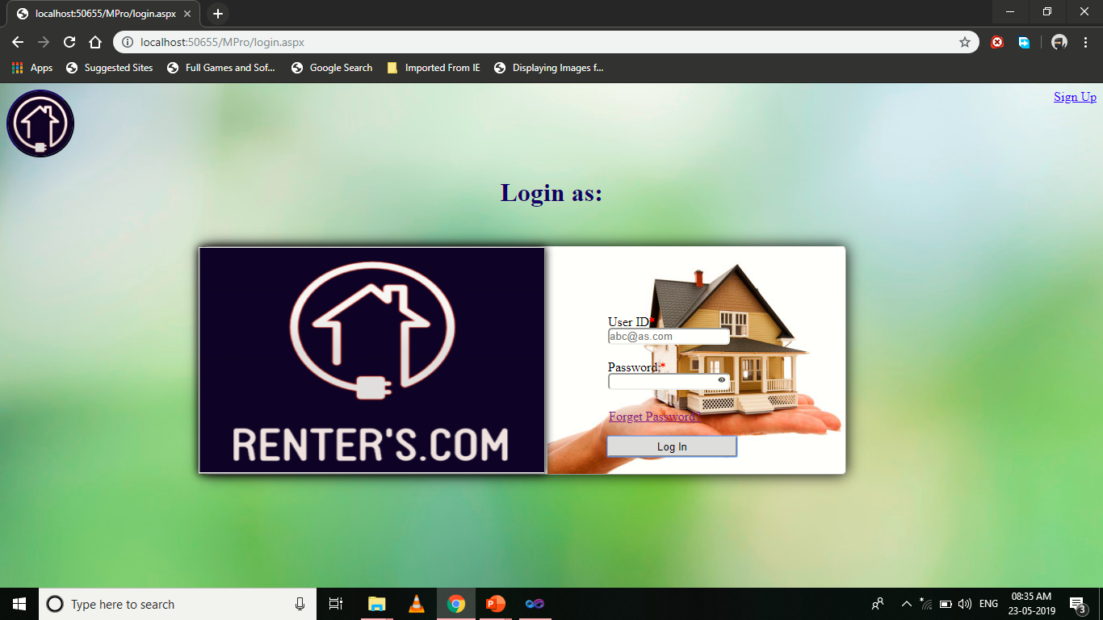

Design-

<%@ Page Language="C#" AutoEventWireup="true" CodeFile="login.aspx.cs" Inherits="Default2" %>

<!DOCTYPE html PUBLIC "-//W3C//DTD XHTML 1.0 Transitional//EN" "http://www.w3.org/TR/xhtml1/DTD/xhtml1-transitional.dtd">

<html xmlns="http://www.w3.org/1999/xhtml">

<head runat="server">

<title></title>

<style type="text/css">

.style2

{

color: #CC0000;

}

</style>

</head>

<body background="close-up-door-focus-101808.jpg">

<form id="form1" runat="server" defaultbutton="Button1">

<asp:ImageButton ID="ImageButton1" runat="server" ImageUrl="~/logo.jpg"

ToolTip="Gallery" style="border-radius:50%; height:80px; width:80px;"

BorderColor="#000066" BorderStyle="Outset" BorderWidth="2px"

AlternateText="Gallery" onclick="ImageButton1_Click" />

<a href="signup.aspx" style="float:right; color:Blue; text-decoration:underline">Sign Up</a>

<br />

<h1 align="center" style="color: #000066" >Login as:</h1>

<div style="-webkit-box-shadow:0px 0px 18px rgba(0,0,0,1); -webkit-border-radius:5px; border-style: outset; border-width: thin; background-image: url('Difference-Between-Joint-Tenants-Tenancy-In-Common.jpg'); height: 281px; width: 794px; top: 202px; left: 252px; position: absolute;"

align="center">

<asp:Label ID="Label1" runat="server" Text="User ID:" style="top: 84px; left: 500px; text-align: left; position: absolute;"

></asp:Label>

<span style="top: 84px; left: 550px; color:Red; position:absolute;">*</span><br/>

<asp:TextBox ID="TextBox1" runat="server" placeholder="abc@as.com"

style="top: 100px; left: 500px; width: 147px; position: absolute; -webkit-border-radius:5px;" ></asp:TextBox><br/>

<br/>

<asp:Label ID="Label2" runat="server" Text="Password:"

style="top: 140px; left: 500px; position: absolute;" ></asp:Label>

<span style="top: 140px; left: 564px; color:Red; position:absolute;">*</span><br />

<asp:TextBox ID="TextBox2" runat="server"

style=" -webkit-border-radius:5px; width: 147px; top: 156px; left: 500px; position: absolute;"

TextMode="Password"></asp:TextBox>

<asp:ImageButton ID="ImageButton2" runat="server" ImageUrl="~/m.png"

ToolTip="Show password"

style="-webkit-border-radius:5px; position:absolute; top: 158px; left: 633px; height: 15px; width: 16px;"

BorderColor="White" onclick="ImageButton2_Click"></asp:ImageButton><br/>

<asp:Label ID="Label3" runat="server"

style="top: 186px; left: 500px; height: 15px; text-align: left; position: absolute; font-size: small; color: #FF0000; width: 175px;"

></asp:Label><br/>

<asp:Button ID="Button1" runat="server" Text="Log In"

style="top: 234px; left: 499px; position: absolute; bottom: 21px; -webkit-border-radius:3px; width: 161px;"

onclick="Button1_Click" />

<h3 align="center" style="height: 26px; width: 794px; ">&nbsp;&nbsp;&nbsp;&nbsp;&nbsp;&nbsp;&nbsp;&nbsp;&nbsp;&nbsp;&nbsp;&nbsp;&nbsp;&nbsp;&nbsp;&nbsp;&nbsp;&nbsp;&nbsp;&nbsp;&nbsp;&nbsp;&nbsp;&nbsp;&nbsp;&nbsp;&nbsp;&nbsp;&nbsp;&nbsp;&nbsp;&nbsp;&nbsp;&nbsp;&nbsp;&nbsp;&nbsp;&nbsp;&nbsp;&nbsp;&nbsp;&nbsp;&nbsp;&nbsp;&nbsp;&nbsp;&nbsp;&nbsp;&nbsp;&nbsp;&nbsp;&nbsp;&nbsp;&nbsp;&nbsp;&nbsp;&nbsp;&nbsp;&nbsp;&nbsp;&nbsp;&nbsp;&nbsp;&nbsp;&nbsp;&nbsp;&nbsp;&nbsp;&nbsp;&nbsp;&nbsp;&nbsp;&nbsp;&nbsp;&nbsp;&nbsp;&nbsp;&nbsp; &nbsp;&nbsp; </h3>

<asp:Image ID="Image1" runat="server" style="-webkit-box-shadow: 0px 0px 10px rgba(0, 0, 0, 1); height: 279px; width: 427px; top: 0px; left: -7px; position: absolute; border-style: outset; border-width: thin; margin-left: 0px; background-image: url('Difference-Between-Joint-Tenants-Tenancy-In-Common.jpg')"

ImageUrl="~/logo (2).png" />

<asp:HyperLink ID="HyperLink1" runat="server"

style="top: 201px; left: 501px; position: absolute;"

NavigateUrl="~/fp.aspx" >Forget Password?</asp:HyperLink>

</div>

</form>

</body>

</html>

Code Snippets-

using System;

using System.Collections.Generic;

using System.Linq;

using System.Web;

using System.Web.UI;

using System.Web.UI.WebControls;

using System.Data.SqlClient;

using System.Configuration;

using System.Net;

using System.Net.Mail;

using System.Data;

using System.Data.SqlClient;

public partial class Default2 : System.Web.UI.Page

{

protected void Page_Load(object sender, EventArgs e)

{

if (this.IsPostBack)

{

TextBox2.Attributes["value"] = TextBox2.Text;

}

}

public void ImageButton1_Click(object sender, ImageClickEventArgs e)

{

Response.Redirect("Default14.aspx");

}

protected void ImageButton2_Click(object sender, ImageClickEventArgs e)

{

if (ImageButton2.ImageUrl == "~/unm.png")

{

ImageButton2.ImageUrl = "~/m.png";

TextBox2.TextMode = TextBoxMode.Password;

}

else if (ImageButton2.ImageUrl == "~/m.png")

{

ImageButton2.ImageUrl = "~/unm.png";

TextBox2.TextMode = TextBoxMode.SingleLine;

}

}

SqlConnection cn = new SqlConnection("Data Source=DESKTOP-MP67RVV\\SQLEXPRESS;Initial Catalog=niraj;Integrated Security=True;Pooling=False");

SqlCommand cmd;

SqlDataReader dr;

protected void Button1_Click(object sender, EventArgs e)

{

cn.Open();

cmd = new SqlCommand("select * from lustab where id='" + TextBox1.Text.Trim() + "' and pwd='" + TextBox2.Text.Trim() + "' ",cn);

dr = cmd.ExecuteReader();

if (TextBox1.Text=="admin" &&TextBox2.Text=="1234")

{

Response.Redirect("admin_side_page.aspx");

}

else if(dr.Read())

{

Session["s"] = TextBox1.Text;

String name = dr["fname"].ToString()+" "+dr["lname"].ToString();

String pass = dr["pwd"].ToString();

Response.Write("<Script>alert('Thank you for conecting with us')</Script>");

Response.Write("<Script>location.href = 'menubar.aspx';</Script>");

}

else

{

Label3.Text = "Enter correct user-ID/Password";

Label3.BackColor = System.Drawing.Color.Yellow;

}

cn.Close();

}

}

**Signup_Page:**

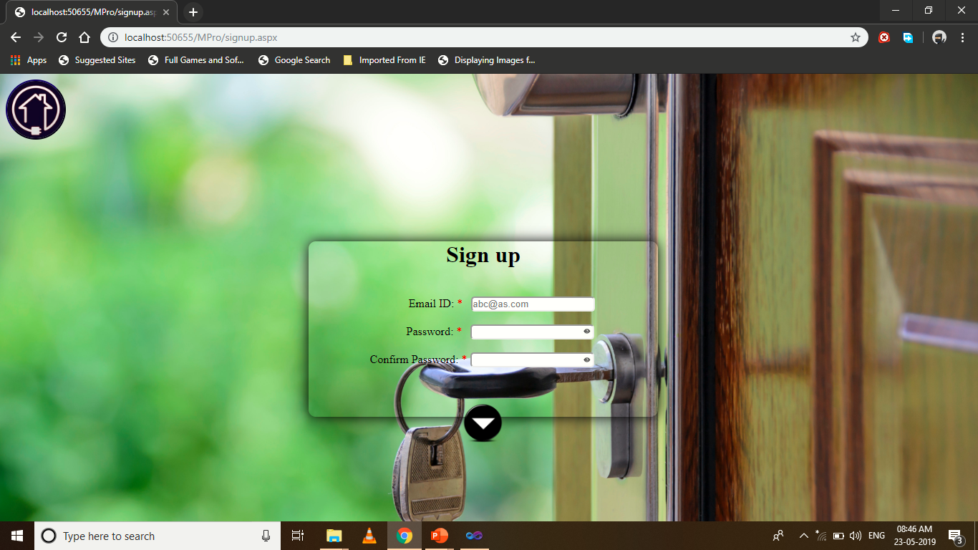

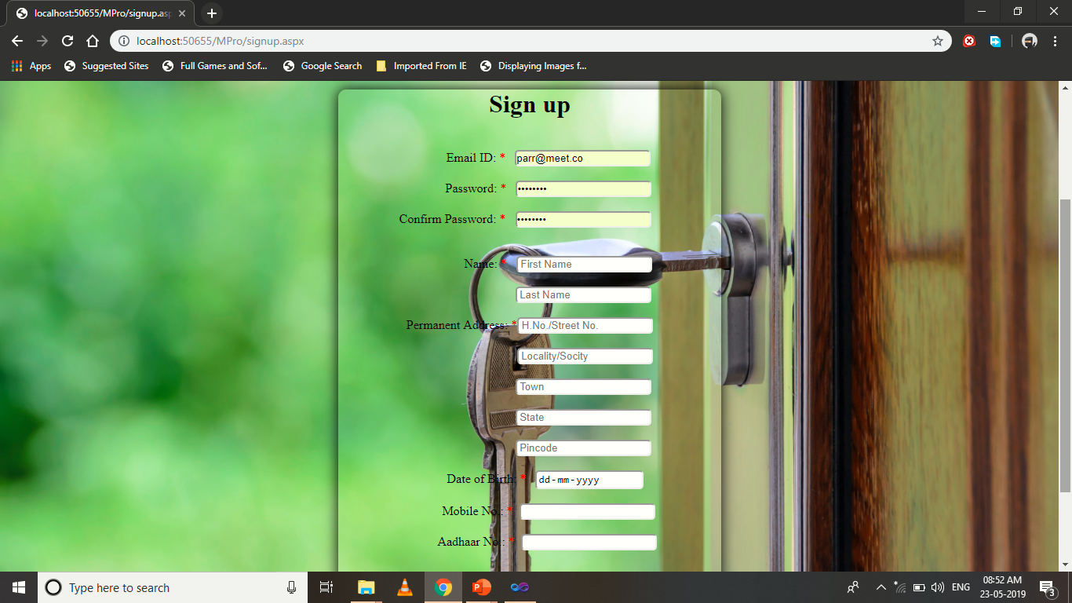

Design-

<%@ Page Language="C#" AutoEventWireup="true" CodeFile="signup.aspx.cs" Inherits="Default4" %>

<!DOCTYPE html PUBLIC "-//W3C//DTD XHTML 1.0 Transitional//EN" "http://www.w3.org/TR/xhtml1/DTD/xhtml1-transitional.dtd">

<html xmlns="http://www.w3.org/1999/xhtml">

<head runat="server">

<title></title>

<style type="text/css">

.style1

{

color: #CC0000;

}

</style>

</head>

<body background="close-up-door-focus-101808.jpg" style="background-size: cover;">

<form id="form1" runat="server">

<div>

<asp:ImageButton ID="ImageButton4" runat="server" ImageUrl="~/logo.jpg"

ToolTip="Gallery" style="border-radius:50%; height:80px; width:80px;"

BorderColor="#000066" BorderStyle="Outset" BorderWidth="2px"

AlternateText="Gallery" onclick="ImageButton4_Click" /></div>

<br/>

<br />

<div>

<asp:Panel ID="Panel1" runat="server" DefaultButton="ImageButton1"

style="-webkit-box-shadow:0px 0px 18px rgba(0,0,0,1); -webkit-border-radius:10px; top: 85px; left: 423px; position: relative; height: 245px; width: 488px;"

BorderColor="White" ClientIDMode="AutoID">

<center><h1>Sign up</h1><br /> &nbsp;&nbsp;&nbsp;&nbsp;&nbsp;&nbsp;&nbsp;&nbsp;&nbsp;&nbsp;&nbsp;&nbsp; <asp:Label ID="Label1" runat="server" Text="Email ID:"></asp:Label>

<span class="style1">*</span>&nbsp;&nbsp

<asp:TextBox ID="TextBox1" runat="server" style="-webkit-border-radius:5px;" placeholder="abc@as.com"></asp:TextBox><br />

<asp:RegularExpressionValidator ID="RegularExpressionValidator1" runat="server"

ErrorMessage="Incorrect User ID" ControlToValidate="TextBox1"

ValidationExpression="\w+([-+.']\w+)*@\w+([-.]\w+)*\.\w+([-.]\w+)*"

ForeColor="#CC0000"></asp:RegularExpressionValidator><br />&nbsp;&nbsp;&nbsp;&nbsp;&nbsp;&nbsp;&nbsp;&nbsp;&nbsp;&nbsp;&nbsp;&nbsp; <asp:Label ID="Label2" runat="server" Text="Password:"></asp:Label>

<span class="style1">*</span>&nbsp;&nbsp <asp:TextBox

ID="TextBox2" runat="server" style="-webkit-border-radius:5px;"

ontextchanged="TextBox2_TextChanged" TextMode="Password"></asp:TextBox>

<asp:ImageButton ID="ImageButton3" runat="server" ImageUrl="~/m.png"

ToolTip="Show password"

style="-webkit-border-radius:5px; position:absolute; top: 119px; left: 381px; height: 15px; width: 16px;"

BorderColor="White" onclick="ImageButton3_Click"></asp:ImageButton>

<br />

<br />

<asp:Label ID="Label3" runat="server" Text="Confirm Password:"></asp:Label>

<span class="style1">*</span>&nbsp;<asp:TextBox ID="TextBox3" runat="server"

style="-webkit-border-radius:5px;" ontextchanged="TextBox3_TextChanged"

TextMode="Password"></asp:TextBox>

<br />

<asp:ImageButton ID="ImageButton2" runat="server" ImageUrl="~/m.png"

ToolTip="Show password"

style="-webkit-border-radius:5px; position:absolute; top: 159px; left: 381px; height: 15px; width: 16px;"

BorderColor="White" onclick="ImageButton2_Click"></asp:ImageButton>

<asp:RegularExpressionValidator ID="RegularExpressionValidator2" runat="server"

ValidationExpression="^(?=.*[A-Za-z])(?=.*\d)[A-Za-z\d]{8,}$"

ErrorMessage="Password must contain: Minimum 8 characters atleast 1 Alphabet and 1 Number"

ForeColor="Red" ControlToValidate="TextBox2" EnableClientScript="False"></asp:RegularExpressionValidator>

<br />

<asp:Label ID="Label12" runat="server" ForeColor="#CC0000"></asp:Label>

<br />

<br />

</center>

</asp:Panel>

<asp:Panel ID="Panel2" runat="server" Visible="false" DefaultButton="Button2"

style="-webkit-box-shadow:0px 0px 18px rgba(0,0,0,1);-webkit-border-radius:10px; top: 87px; left: 423px; position: relative; height: 670px; width: 488px;"

BorderColor="Black">

<center><h1>Sign up</h1><br />&nbsp;&nbsp;&nbsp;&nbsp;&nbsp;&nbsp;&nbsp;&nbsp;&nbsp;&nbsp;&nbsp;&nbsp;

<asp:Label ID="Label6" runat="server" Text="Email ID:"></asp:Label>

<span class="style1">*</span>&nbsp;&nbsp;

<asp:TextBox ID="TextBox11" runat="server" style="-webkit-border-radius:5px;"

ReadOnly="True" BackColor="#FFFFCC"></asp:TextBox>

<br />

<br />

&nbsp;&nbsp;&nbsp;&nbsp;&nbsp;&nbsp;&nbsp;&nbsp;&nbsp;&nbsp;&nbsp;&nbsp;

<asp:Label ID="Label7" runat="server" Text="Password:"></asp:Label>

<span class="style1">* </span>&nbsp;&nbsp;<asp:TextBox ID="TextBox12"

runat="server" style="-webkit-border-radius:5px;" ReadOnly="True"

BackColor="#FFFFCC" TextMode="Password"></asp:TextBox>

<br />

<br />

<asp:Label ID="Label8" runat="server" Text="Confirm Password:"></asp:Label>

<span class="style1">* </span>&nbsp;&nbsp;<asp:TextBox ID="TextBox13"

runat="server" style="-webkit-border-radius:5px;" ReadOnly="True"

BackColor="#FFFFCC" TextMode="Password"></asp:TextBox>

&nbsp;

<br />

<br />

<br />

&nbsp;&nbsp;&nbsp;&nbsp;&nbsp;&nbsp;&nbsp;&nbsp;&nbsp;&nbsp;&nbsp;&nbsp;&nbsp;&nbsp;&nbsp;&nbsp;&nbsp;&nbsp;

<asp:Label ID="Label9" runat="server" Text="Name:"></asp:Label>

<span class="style1">*</span>&nbsp;&nbsp;

<asp:TextBox ID="TextBox14" runat="server" Placeholder=" First Name" style="-webkit-border-radius:5px;"></asp:TextBox>

<br />

<br/>

&nbsp;&nbsp;&nbsp;&nbsp;&nbsp;&nbsp;&nbsp;&nbsp;&nbsp;&nbsp;&nbsp;&nbsp;&nbsp;&nbsp;&nbsp;&nbsp;&nbsp;&nbsp;&nbsp;&nbsp;&nbsp;&nbsp;&nbsp;&nbsp;&nbsp;&nbsp;&nbsp;&nbsp;&nbsp;&nbsp;&nbsp;&nbsp;&nbsp;&nbsp;

<asp:TextBox ID="TextBox15" runat="server" Placeholder=" Last Name" style="-webkit-border-radius:5px;"></asp:TextBox>

<br />

<br />

&nbsp;<asp:Label ID="Label10" runat="server" Text="Permanent Address:"></asp:Label>

<span class="style1">*</span><asp:TextBox ID="TextBox16" runat="server"

Placeholder=" H.No./Street No." style="-webkit-border-radius:5px;"></asp:TextBox>

<br/>

<br/>

&nbsp;&nbsp;&nbsp;&nbsp;&nbsp;&nbsp;&nbsp;&nbsp;&nbsp;&nbsp;&nbsp;&nbsp;&nbsp;&nbsp;&nbsp;&nbsp;&nbsp;&nbsp;&nbsp;&nbsp;&nbsp;&nbsp;&nbsp;&nbsp;&nbsp;&nbsp;&nbsp;&nbsp;&nbsp;&nbsp;&nbsp;&nbsp;&nbsp;&nbsp;&nbsp;

<asp:TextBox ID="TextBox17" runat="server" Placeholder=" Locality/Socity"

style="-webkit-border-radius:5px;"></asp:TextBox>

<br/>

<br/>

&nbsp;&nbsp;&nbsp;&nbsp;&nbsp;&nbsp;&nbsp;&nbsp;&nbsp;&nbsp;&nbsp;&nbsp;&nbsp;&nbsp;&nbsp;&nbsp;&nbsp;&nbsp;&nbsp;&nbsp;&nbsp;&nbsp;&nbsp;&nbsp;&nbsp;&nbsp;&nbsp;&nbsp;&nbsp;&nbsp;&nbsp;&nbsp;&nbsp;&nbsp;

<asp:TextBox ID="TextBox18" runat="server" Placeholder=" Town" style="-webkit-border-radius:5px;"></asp:TextBox>

<br/><br/>

&nbsp;&nbsp;&nbsp;&nbsp;&nbsp;&nbsp;&nbsp;&nbsp;&nbsp;&nbsp;&nbsp;&nbsp;&nbsp;&nbsp;&nbsp;&nbsp;&nbsp;&nbsp;&nbsp;&nbsp;&nbsp;&nbsp;&nbsp;&nbsp;&nbsp;&nbsp;&nbsp;&nbsp;&nbsp;&nbsp;&nbsp;&nbsp;&nbsp; <asp:TextBox

ID="TextBox19" runat="server" Placeholder=" State" style="-webkit-border-radius:5px;"></asp:TextBox><br/><br/>

&nbsp;&nbsp;&nbsp;&nbsp;&nbsp;&nbsp;&nbsp;&nbsp;&nbsp;&nbsp;&nbsp;&nbsp;&nbsp;&nbsp;&nbsp;&nbsp;&nbsp;&nbsp;&nbsp;&nbsp;&nbsp;&nbsp;&nbsp;&nbsp;&nbsp;&nbsp;&nbsp;&nbsp;&nbsp;&nbsp;&nbsp;&nbsp;&nbsp; <asp:TextBox

ID="TextBox20" runat="server" Placeholder=" Pincode"

style="-webkit-border-radius:5px;" MaxLength="6" TextMode="Number"></asp:TextBox><br/>

<br />

&nbsp;&nbsp;&nbsp;&nbsp;&nbsp;&nbsp;&nbsp;&nbsp;&nbsp;&nbsp;

<asp:Label ID="Label4" runat="server" Text="Date of Birth:"></asp:Label>

<span class="style1">*</span>&nbsp;&nbsp;

<asp:TextBox ID="TextBox6" runat="server" TextMode="Date"

style="-webkit-border-radius:5px;" Width="133px"></asp:TextBox>

<br />

<br />

&nbsp;&nbsp;&nbsp;&nbsp;&nbsp;&nbsp;&nbsp;&nbsp;&nbsp;&nbsp;&nbsp;

<asp:Label ID="Label5" runat="server" Text="Mobile No.:"></asp:Label>

<span class="style1">*</span>&nbsp;&nbsp;<asp:TextBox

ID="TextBox4" runat="server" MaxLength="10" style="-webkit-border-radius:5px;"

TextMode="Number"></asp:TextBox><br /><br />

&nbsp;&nbsp;&nbsp;&nbsp;&nbsp;&nbsp;&nbsp;&nbsp;&nbsp;&nbsp;

<asp:Label ID="Label11" runat="server" Text="Aadhaar No.:"></asp:Label>

<span class="style1">*</span>&nbsp;&nbsp;<asp:TextBox ID="TextBox5"

runat="server" MaxLength="12" TextMode="Number"

style="-webkit-border-radius:5px;"></asp:TextBox><br />

<br/>

<asp:Label ID="Label13" runat="server" Text="" ForeColor="#CC0000"></asp:Label><br /><br />

<asp:Button ID="Button1" runat="server" Text="Reset"

style="-webkit-border-radius:2px;" onclick="Button1_Click" />&nbsp;&nbsp;<asp:Button ID="Button2"

runat="server" Text="Submit" style="-webkit-border-radius:2px;"

onclick="Button2_Click"/></center>

</asp:Panel>

<br /><br /><br/>

</div>

<br /><br /><br/><br /><br /><br/>

<asp:ImageButton ID="ImageButton1" runat="server" Height="57px"

ImageUrl="~/d.png" style="position: relative; top: -97px; left: 637px"

Width="59px" onclick="ImageButton1_Click" />

</form>

</body>

</html>

Code Snippets-

using System;

using System.Collections.Generic;

using System.Linq;

using System.Web;

using System.Web.UI;

using System.Web.UI.WebControls;

using System.Data;

using System.Net;

using System.Net.Mail;

using System.Data.SqlClient;

public partial class Default4 : System.Web.UI.Page

{

SqlConnection cn = new SqlConnection("Data Source=DESKTOP-MP67RVV\\SQLEXPRESS;Initial Catalog=niraj;Integrated Security=True;Pooling=False");

SqlCommand cmd;

SqlDataReader dr;

protected void Page_Load(object sender, EventArgs e)

{

if (this.IsPostBack)

{

TextBox2.Attributes["value"] = TextBox2.Text;

}

if (this.IsPostBack)

{

TextBox3.Attributes["value"] = TextBox3.Text;

}

}

protected void ImageButton1_Click(object sender, ImageClickEventArgs e)

{

if (TextBox1.Text == "" || TextBox2.Text == "")

{

Label12.Text = "Insert User ID/Password";}

else if (TextBox2.Text.Trim() != TextBox3.Text.Trim())

{ Label12.Text = "Password didn't matched"; }

else

{

cn.Open();

cmd = new SqlCommand("Select * from lustab where id= '" + TextBox1.Text + "'", cn);

dr = cmd.ExecuteReader();

if (dr.Read())

Label12.Text = "Insert another User ID";

else

{

if (TextBox2.Text != "")

{

RegularExpressionValidator2.EnableClientScript = Convert.ToBoolean("True");

RegularExpressionValidator2.EnableClientScript = Convert.ToBoolean("False");

}

ImageButton1.Visible = Convert.ToBoolean("False");

Panel1.Visible = Convert.ToBoolean("False");

Panel2.Visible = Convert.ToBoolean("True");

TextBox2.TextMode = TextBoxMode.SingleLine;

TextBox11.Text = TextBox1.Text;

if (this.IsPostBack)

{

TextBox12.Attributes["value"] = TextBox2.Text;

}

if (this.IsPostBack)

{

TextBox13.Attributes["value"] = TextBox3.Text;

}

}

}

cn.Close();

}

protected void TextBox2_TextChanged(object sender, EventArgs e)

{

}

protected void TextBox3_TextChanged(object sender, EventArgs e)

{

}

protected void ImageButton3_Click(object sender, ImageClickEventArgs e)

{

if (ImageButton3.ImageUrl == "~/unm.png")

{

ImageButton3.ImageUrl = "~/m.png";

TextBox2.TextMode = TextBoxMode.Password;

}

else if (ImageButton3.ImageUrl == "~/m.png")

{

ImageButton3.ImageUrl = "~/unm.png";

TextBox2.TextMode = TextBoxMode.SingleLine;

}

}

protected void ImageButton2_Click(object sender, ImageClickEventArgs e)

{

RegularExpressionValidator2.EnableClientScript = Convert.ToBoolean("False");

if (ImageButton2.ImageUrl == "~/unm.png")

{

ImageButton2.ImageUrl = "~/m.png";

TextBox3.TextMode = TextBoxMode.Password;

}

else if (ImageButton2.ImageUrl == "~/m.png")

{

ImageButton2.ImageUrl = "~/unm.png";

TextBox3.TextMode = TextBoxMode.SingleLine;

}

}

void clear()

{

TextBox4.Text = "";

TextBox5.Text = "";

TextBox6.Text = "";

TextBox14.Text = "";

TextBox15.Text = "";

TextBox16.Text = "";

TextBox17.Text = "";

TextBox18.Text = "";

TextBox19.Text = "";

TextBox20.Text = "";

}

protected void Button2_Click(object sender, EventArgs e)

{

if (TextBox4.Text == "" || TextBox5.Text == "" || TextBox6.Text == "" || TextBox14.Text == "" || TextBox15.Text == "" || TextBox16.Text == "" || TextBox17.Text == "" || TextBox18.Text == "" || TextBox19.Text == "" || TextBox20.Text == "")

{

Label13.Text = "Please fill up all the data";

}

else {

if (TextBox20.Text.Length != 6 )

Label13.Text = "Check your City Pincode";

else if (TextBox4.Text.Length != 10)

Label13.Text = "Check your Mobile Number";

else if (TextBox5.Text.Length != 12)

Label13.Text = "Check your Aadhaar Card Number";

else

{

cn.Open();

//Response.Write(Request.QueryString["n"]);

cmd = new SqlCommand("Insert into lustab values('" + TextBox11.Text + "','" + TextBox2.Text + "','" + TextBox14.Text + "','" + TextBox15.Text + "','" + TextBox16.Text + "','" + TextBox17.Text + "','" + TextBox18.Text + "','" + TextBox19.Text + "','" + TextBox20.Text + "','" + TextBox6.Text + "','" + TextBox4.Text + "','" + TextBox5.Text + "')", cn);

cmd.ExecuteNonQuery();

cn.Close();

Response.Write("<Script>alert('Thank you for joing us')</Script>");

MailMessage msg = new MailMessage("comrenters@gmail.com", TextBox1.Text.Trim());

msg.Subject = "Thank You For Joining Us";

msg.Body = string.Format("<center><h1>RENTER'S.COM</h1><br/><h2>Hi, {0} </h2><br/> Thanku for joining us <br/> Your user-id is {1}", TextBox14.Text, TextBox11.Text);

msg.IsBodyHtml = true;

SmtpClient smtp = new SmtpClient();

smtp.Host = "smtp.gmail.com";

smtp.EnableSsl = true;

NetworkCredential nc = new NetworkCredential();

nc.UserName = "comrenters@gmail.com";

nc.Password = "Rntc@123";

smtp.UseDefaultCredentials = true;

smtp.Credentials = nc;

smtp.Port = 587;

smtp.Send(msg);

Response.Write("<Script>location.href = 'login.aspx';</Script>");

}

}

}

protected void Button1_Click(object sender, EventArgs e)

{

clear();

}

protected void ImageButton4_Click(object sender, ImageClickEventArgs e)

{

Response.Redirect("Default14.aspx");

}

}

**Main_Page:**

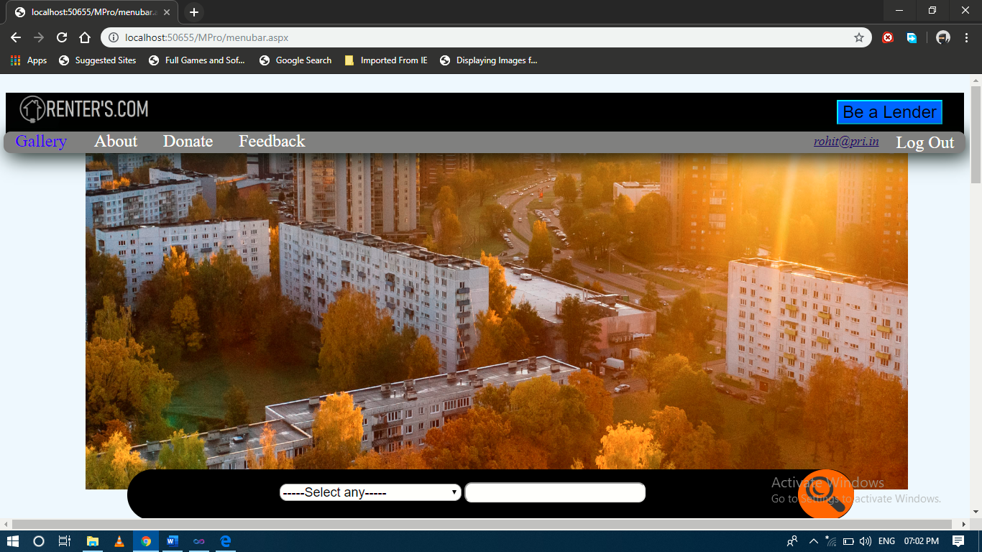



Design-

<%@ Page Language="C#" AutoEventWireup="true" CodeFile="menubar.aspx.cs" Inherits="Default6" %>

&nbsp;

<!DOCTYPE html PUBLIC "-//W3C//DTD XHTML 1.0 Transitional//EN" "http://www.w3.org/TR/xhtml1/DTD/xhtml1-transitional.dtd">

<html xmlns="http://www.w3.org/1999/xhtml">

<head runat="server">

<title></title>

<style type="text/css">

a

{

color:White;

padding:14px 16px;

text-align:center;

font-size:x-large;

text-decoration:none;

}

a:hover.s

{

color:Gray;

background-color:White;

}

a.active

{

color:Blue;

}

a.t

{

float:right;

color:White;

padding:2px 16px;

text-align:center;

font-size:x-larger;

text-decoration:none;

}

a:hover.t

{

padding:14px 16px;

color:Grey;

background-color:White;

}

a.h

{

float:right;

}

</style>

</head>

<body bgcolor="#F0F8FF" >

<form id="form1" runat="server">

<div style="background-color: Black; height: 78px; z-index: -2;">

<asp:Image ID="Image1" runat="server" ImageUrl="~/l.png" Height="50px" Width="250px" />

<div style="padding:10px 30px; float: right;"><asp:Button ID="Button1" runat="server"

Text="Be a Lender" BackColor="#0066FF"

style=" text-decoration:none; float:right; text-align:center; font-size:x-large; z-index: 2;"

BorderColor="Aqua" BorderStyle="Outset" onclick="Button1_Click"/>

</div></div>

<div style="background-color: #808080; height: 30px;-webkit-box-shadow:5px 5px 28px rgba(0,09,0,01); -webkit-border-radius:10px; z-index: 1; left: 05px; top: 80px; position: absolute; width:99.2%;">

<a class="active" href="">Gallery </a>

<a class="s" href="aboutus.aspx">About</a>

<a class="s" href="Default17.aspx">Donate</a>

<a class="s" href="Default9.aspx">Feedback</a>

<a class="t" href="Default14.aspx">Log Out</a><u>

<asp:HyperLink ID="HyperLink2" runat="server" Font-Italic="True" style="float:right;padding:3px 8px;"

Font-Underline="True" ForeColor="#000066" Font-Size="Large"

NavigateUrl="~/Default15.aspx">[HyperLink2]</asp:HyperLink></u>

</div><br />

<center>

<div style="top:78px; height:500px; width:1144px; z-index: -1; left: 119px; position: absolute;"

align="center">

<asp:Image class="mySlides" ID="Image2" runat="server" ImageUrl="~/about-img.jpg" style="width:100%;height:100%;"/>

<asp:Image class="mySlides" ID="Image3" runat="server" ImageUrl="~/close-up-door-focus-101808.jpg" style="width:100%;height:100%"/>

<asp:Image class="mySlides" ID="Image4" runat="server" ImageUrl="~/Decor-cup1.jpg" style="width:100%;height:100%"/>

<asp:Image class="mySlides" ID="Image5" runat="server" ImageUrl="~/event-venue-opt.jpg" style="width:100%;height:100%"/>

<asp:Image class="mySlides" ID="Image6" runat="server" ImageUrl="~/header-bg.jpg" style="width:100%;height:100%"/>

<asp:Image class="mySlides" ID="Image7" runat="server" ImageUrl="~/house_sky_changeling_59132_1280x720.jpg" style="width:100%;height:100%"/>

<asp:Image class="mySlides" ID="Image8" runat="server" ImageUrl="~/luxury-room-sofitel-the-palm-dubai-1200x675.jpg" style="width:100%;height:100%"/>

<asp:Image class="mySlides" ID="Image9" runat="server" ImageUrl="~/Melling_Int_9use.jpg" style="width:100%;height:100%"/>

<asp:Image class="mySlides" ID="Image10" runat="server" ImageUrl="~/nirvaan-ground-mira-road-thane-film-shooting-location-5iwbu.jpg" style="width:100%;height:100%"/>

<asp:Image class="mySlides" ID="Image11" runat="server" ImageUrl="~/park_autumn_trees_walking_paths_90924_1280x720.jpg" style="width:100%;height:100%"/>

<asp:Image class="mySlides" ID="Image12" runat="server" ImageUrl="~/service-bg.jpg" style="width:100%;height:100%"/>

<asp:Image class="mySlides" ID="Image13" runat="server" ImageUrl="~/tokyo-prince-hotel-rooms-ClubDeluxeTwinRoom-noon-01-800x520.jpg" style="width:100%;height:100%"/>

<script type="text/javascript">

var myIndex = 0;

carousel();

function carousel() {

var i;

var x = document.getElementsByClassName("mySlides");

for (i = 0; i < x.length; i++) {

x[i].style.display = "none";

}

myIndex++;

if (myIndex > x.length) { myIndex = 1 }

x[myIndex - 1].style.display = "block";

setTimeout(carousel, 5000);

}

</script>

</div></center><div style="-webkit-border-radius:190px; top: 550px; position: absolute; width: 100%;">

<center>

<asp:Panel ID="Panel1" runat="server" Height="71px" Width="75%" BackColor="Black"

style="-webkit-border-radius:190px;"

BorderColor="White">

<asp:ImageButton ID="ImageButton1" runat="server"

ImageUrl="~/Magnifying_Glass-512.png" Height="71px" ImageAlign="Bottom" style="float:right; border-radius:50%;"

Width="78px" BackColor="#FF6600" onclick="ImageButton1_Click" /><br />

<center>

<asp:DropDownList ID="DropDownList1" runat="server" Width="25%"

style="-webkit-border-radius:10px;" Font-Size="Large" AutoPostBack="True" onselectedindexchanged="DropDownList1_SelectedIndexChanged">

<asp:ListItem>-----Select any-----</asp:ListItem>

<asp:ListItem>ALL</asp:ListItem>

<asp:ListItem>HOUSE</asp:ListItem>

<asp:ListItem>ROOM</asp:ListItem>

<asp:ListItem>HALL</asp:ListItem>

<asp:ListItem>GROUND</asp:ListItem>

</asp:DropDownList>

<asp:TextBox ID="TextBox2" runat="server" Width="25%"

style="-webkit-border-radius:10px;" Font-Size="Larger"></asp:TextBox>

</center>

</asp:Panel></center></div><br /><br />

<div style="top:628px; position: absolute; left:119px;" >

<br/>

<br />

<br />

<asp:Panel ID="Panel2" runat="server">

<div style="background-color: #999999"><h2><b>House::</b></h2></div><br />

<asp:DataList ID="DataList1" runat="server" DataSourceID="SqlDataSource1"

RepeatDirection="Horizontal" onitemcommand="DataList1_ItemCommand"

RepeatColumns="5">

<ItemTemplate>

<asp:Panel ID="Panel1" runat="server" BorderColor="Black" style="-webkit-border-radius:10px;" BorderStyle="Inset" BorderWidth="1px">

<center><br />

<asp:Label ID="Label1" runat="server" Text='<%# Eval("title") %>'></asp:Label>

<br /></center><br />&nbsp;

<asp:ImageButton ID="ImageButton1" runat="server" Height="147px"

ImageUrl='<%# Eval("img1") %>' Width="210px" CommandArgument='<%# Eval("title") %>' CommandName="House" />

<br />&nbsp;

<asp:Button ID="Button2" runat="server" BackColor="Black" ForeColor="#3399FF"

style="margin-left: 0px" Text="Intrested" Width="210px" BorderStyle="Outset"

BorderColor="#000066" CommandArgument='<%# Eval("title") %>' CommandName="House" />

<br />

<br /> </asp:Panel>

</ItemTemplate>

</asp:DataList><asp:SqlDataSource ID="SqlDataSource1" runat="server"

ConnectionString="<%$ ConnectionStrings:nirajConnectionString %>"

SelectCommand="SELECT * FROM [house]"></asp:SqlDataSource>

</asp:Panel>

<asp:Panel ID="Panel6" runat="server">

<div style="background-color: #999999"><h2><b>House::</b></h2></div><br />

<asp:DataList ID="DataList5" runat="server" DataSourceID="SqlDataSource5"

RepeatDirection="Horizontal" onitemcommand="DataList1_ItemCommand"

RepeatColumns="5">

<ItemTemplate>

<asp:Panel ID="Panel1" runat="server" BorderColor="Black" style="-webkit-border-radius:10px;" BorderStyle="Inset" BorderWidth="1px">

<center><br />

<asp:Label ID="Label1" runat="server" Text='<%# Eval("title") %>'></asp:Label>

<br /></center><br />&nbsp;

<asp:ImageButton ID="ImageButton1" runat="server" Height="147px"

ImageUrl='<%# Eval("img1") %>' Width="210px" CommandArgument='<%# Eval("title") %>' CommandName="House" />

<br />&nbsp;

<asp:Button ID="Button2" runat="server" BackColor="Black" ForeColor="#3399FF"

style="margin-left: 0px" Text="Intrested" Width="210px" BorderStyle="Outset"

BorderColor="#000066" CommandArgument='<%# Eval("title") %>' CommandName="House" />

<br />

<br /> </asp:Panel>

</ItemTemplate>

</asp:DataList><asp:SqlDataSource ID="SqlDataSource5" runat="server"

ConnectionString="<%$ ConnectionStrings:nirajConnectionString %>"

></asp:SqlDataSource>

</asp:Panel>

<br/>

<br />

<br />

<asp:Panel ID="Panel3" runat="server">

<div style="background-color: #999999"><h2><b>Room::</b></h2></div><br />

<asp:DataList ID="DataList2" runat="server" DataSourceID="SqlDataSource2"

RepeatDirection="Horizontal" onitemcommand="DataList2_ItemCommand"

RepeatColumns="5">

<ItemTemplate>

<asp:Panel ID="Panel1" runat="server" BorderColor="Black" style="-webkit-border-radius:10px;" BorderStyle="Inset" BorderWidth="1px">

<center><br />

<asp:Label ID="Label1" runat="server" Text='<%# Eval("title") %>'></asp:Label>

<br /></center><br />&nbsp;

<asp:ImageButton ID="ImageButton1" runat="server" Height="147px" CommandArgument='<%# Eval("title") %>' CommandName="Room"

ImageUrl='<%# Eval("img1") %>' Width="210px" />

<br />&nbsp;

<asp:Button ID="Button2" runat="server" BackColor="Black" ForeColor="#3399FF" CommandArgument='<%# Eval("title") %>' CommandName="Room"

style="margin-left: 0px" Text="Intrested" Width="210px" BorderStyle="Outset" BorderColor="#000066" />

<br />

<br /> </asp:Panel>

</ItemTemplate>

</asp:DataList><asp:SqlDataSource ID="SqlDataSource2" runat="server"

ConnectionString="<%$ ConnectionStrings:nirajConnectionString %>"

SelectCommand="SELECT * FROM [room]"></asp:SqlDataSource>

</asp:Panel>

<asp:Panel ID="Panel7" runat="server">

<div style="background-color: #999999"><h2><b>Room::</b></h2></div><br />

<asp:DataList ID="DataList6" runat="server" DataSourceID="SqlDataSource6"

RepeatDirection="Horizontal" onitemcommand="DataList2_ItemCommand"

RepeatColumns="5">

<ItemTemplate>

<asp:Panel ID="Panel1" runat="server" BorderColor="Black" style="-webkit-border-radius:10px;" BorderStyle="Inset" BorderWidth="1px">

<center><br />

<asp:Label ID="Label1" runat="server" Text='<%# Eval("title") %>'></asp:Label>

<br /></center><br />&nbsp;

<asp:ImageButton ID="ImageButton1" runat="server" Height="147px" CommandArgument='<%# Eval("title") %>' CommandName="Room"

ImageUrl='<%# Eval("img1") %>' Width="210px" />

<br />&nbsp;

<asp:Button ID="Button2" runat="server" BackColor="Black" ForeColor="#3399FF" CommandArgument='<%# Eval("title") %>' CommandName="Room"

style="margin-left: 0px" Text="Intrested" Width="210px" BorderStyle="Outset" BorderColor="#000066" />

<br />

<br /> </asp:Panel>

</ItemTemplate>

</asp:DataList><asp:SqlDataSource ID="SqlDataSource6" runat="server"

ConnectionString="<%$ ConnectionStrings:nirajConnectionString %>"

></asp:SqlDataSource>

</asp:Panel>

<br/>

<br />

<br />

<asp:Panel ID="Panel4" runat="server">

<div style="background-color: #999999"><h2><b>Hall::</b></h2></div><br />

<asp:DataList ID="DataList3" runat="server" DataSourceID="SqlDataSource3"

RepeatDirection="Horizontal" onitemcommand="DataList3_ItemCommand"

RepeatColumns="5">

<ItemTemplate>

<asp:Panel ID="Panel1" runat="server" BorderColor="Black" style="-webkit-border-radius:10px;" BorderStyle="Inset" BorderWidth="1px">

<center><br />

<asp:Label ID="Label1" runat="server" Text='<%# Eval("title") %>'></asp:Label>

<br /></center><br />&nbsp;

<asp:ImageButton ID="ImageButton1" runat="server" Height="147px" CommandArgument='<%# Eval("title") %>' CommandName="Hall"

ImageUrl='<%# Eval("img1") %>' Width="210px" />

<br />&nbsp;

<asp:Button ID="Button2" runat="server" BackColor="Black" ForeColor="#3399FF" CommandArgument='<%# Eval("title") %>' CommandName="Hall"

style="margin-left: 0px" Text="Intrested" Width="210px" BorderStyle="Outset" BorderColor="#000066" />

<br />

<br /> </asp:Panel>

</ItemTemplate>

</asp:DataList><asp:SqlDataSource ID="SqlDataSource3" runat="server"

ConnectionString="<%$ ConnectionStrings:nirajConnectionString %>"

SelectCommand="SELECT * FROM [hall]"></asp:SqlDataSource>

</asp:Panel>

<asp:Panel ID="Panel8" runat="server">

<div style="background-color: #999999"><h2><b>Hall::</b></h2></div><br />

<asp:DataList ID="DataList7" runat="server" DataSourceID="SqlDataSource7"

RepeatDirection="Horizontal" onitemcommand="DataList3_ItemCommand" RepeatColumns="5">

<ItemTemplate>

<asp:Panel ID="Panel1" runat="server" BorderColor="Black" style="-webkit-border-radius:10px;" BorderStyle="Inset" BorderWidth="1px">

<center><br />

<asp:Label ID="Label1" runat="server" Text='<%# Eval("title") %>'></asp:Label>

<br /></center><br />&nbsp;

<asp:ImageButton ID="ImageButton1" runat="server" Height="147px" CommandArgument='<%# Eval("title") %>' CommandName="Hall"

ImageUrl='<%# Eval("img1") %>' Width="210px" />

<br />&nbsp;

<asp:Button ID="Button2" runat="server" BackColor="Black" ForeColor="#3399FF" CommandArgument='<%# Eval("title") %>' CommandName="Hall"

style="margin-left: 0px" Text="Intrested" Width="210px" BorderStyle="Outset" BorderColor="#000066" />

<br />

<br /> </asp:Panel>

</ItemTemplate>

</asp:DataList><asp:SqlDataSource ID="SqlDataSource7" runat="server"

ConnectionString="<%$ ConnectionStrings:nirajConnectionString %>"

></asp:SqlDataSource> </asp:Panel>

<br/>

<br />

<br />

<asp:Panel ID="Panel5" runat="server">

<div style="background-color: #999999"><h2><b>Ground::</b></h2></div><br />

<asp:DataList ID="DataList4" runat="server" DataSourceID="SqlDataSource4"

RepeatDirection="Horizontal" onitemcommand="DataList4_ItemCommand"

RepeatColumns="5">

<ItemTemplate>

<asp:Panel ID="Panel1" runat="server" BorderColor="Black" style="-webkit-border-radius:10px;" BorderStyle="Inset" BorderWidth="1px">

<center><br />

<asp:Label ID="Label1" runat="server" Text='<%# Eval("title") %>'></asp:Label>

<br /></center><br />&nbsp;

<asp:ImageButton ID="ImageButton1" runat="server" Height="147px" CommandArgument='<%# Eval("title") %>' CommandName="Ground"

ImageUrl='<%# Eval("img1") %>' Width="210px" />

<br />&nbsp;

<asp:Button ID="Button2" runat="server" BackColor="Black" ForeColor="#3399FF" CommandArgument='<%# Eval("title") %>' CommandName="Ground"

style="margin-left: 0px" Text="Intrested" Width="210px" BorderStyle="Outset" BorderColor="#000066" />

<br />

<br /> </asp:Panel>

</ItemTemplate>

</asp:DataList><asp:SqlDataSource ID="SqlDataSource4" runat="server"

ConnectionString="<%$ ConnectionStrings:nirajConnectionString %>"

SelectCommand="SELECT * FROM [ground]"></asp:SqlDataSource>

</asp:Panel>

<asp:Panel ID="Panel9" runat="server">

<div style="background-color: #999999"><h2><b>Ground::</b></h2></div><br />

<asp:DataList ID="DataList8" runat="server" DataSourceID="SqlDataSource8"

RepeatDirection="Horizontal" onitemcommand="DataList4_ItemCommand" RepeatColumns="5">

<ItemTemplate>

<asp:Panel ID="Panel1" runat="server" BorderColor="Black" style="-webkit-border-radius:10px;" BorderStyle="Inset" BorderWidth="1px">

<center><br />

<asp:Label ID="Label1" runat="server" Text='<%# Eval("title") %>'></asp:Label>

<br /></center><br />&nbsp;

<asp:ImageButton ID="ImageButton1" runat="server" Height="147px" CommandArgument='<%# Eval("title") %>' CommandName="Ground"

ImageUrl='<%# Eval("img1") %>' Width="210px" />

<br />&nbsp;

<asp:Button ID="Button2" runat="server" BackColor="Black" ForeColor="#3399FF" CommandArgument='<%# Eval("title") %>' CommandName="Ground"

style="margin-left: 0px" Text="Intrested" Width="210px" BorderStyle="Outset" BorderColor="#000066" />

<br />

<br /> </asp:Panel>

</ItemTemplate>

</asp:DataList><asp:SqlDataSource ID="SqlDataSource8" runat="server"

ConnectionString="<%$ ConnectionStrings:nirajConnectionString %>"

></asp:SqlDataSource> </asp:Panel>

</div>

</form>

</body>

</html>

Code Snippets-

using System;

using System.Collections.Generic;

using System.Linq;

using System.Web;

using System.Web.UI;

using System.Web.UI.WebControls;

using System.Data;

using System.Data.SqlClient;

public partial class Default6 : System.Web.UI.Page

{

SqlConnection cn = new SqlConnection("Data Source=DESKTOP-MP67RVV\\SQLEXPRESS;Initial Catalog=niraj;Integrated Security=True;Pooling=False");

SqlCommand cmd;

SqlDataReader dr;

SqlDataAdapter da;

DataSet ds;

protected void Page_Load(object sender, EventArgs e)

{

HyperLink2.Text = Session["s"].ToString();

Panel6.Visible = false;

Panel7.Visible = false;

Panel8.Visible = false;

Panel9.Visible = false;

}

protected void Button1_Click(object sender, EventArgs e)

{

Response.Redirect("Default2.aspx");

}

protected void DataList1_ItemCommand(object source, DataListCommandEventArgs e)

{

if (e.CommandName == "House")

{

Session["n"] = "House";

Response.Redirect("Default13.aspx?t1=" + e.CommandArgument.ToString());

}

}

protected void DataList2_ItemCommand(object source, DataListCommandEventArgs e)

{

if (e.CommandName == "Room")

{

Session["n"] = "Room";

Response.Redirect("Default13.aspx?t1=" + e.CommandArgument.ToString());

}

}

protected void DataList3_ItemCommand(object source, DataListCommandEventArgs e)

{

if (e.CommandName == "Hall")

{

Session["n"] = "Hall";

Response.Redirect("Default13.aspx?t1=" + e.CommandArgument.ToString());

}

}

protected void DataList4_ItemCommand(object source, DataListCommandEventArgs e)

{

if (e.CommandName == "Ground")

{

Session["n"] = "Ground";

Response.Redirect("Default13.aspx?t1=" + e.CommandArgument.ToString());

}

}

protected void DropDownList1_SelectedIndexChanged(object sender, EventArgs e)

{

if (DropDownList1.Text == "ALL")

{

Panel2.Visible = true;

Panel3.Visible = true;

Panel4.Visible = true;

Panel5.Visible = true;

Panel6.Visible = false;

Panel7.Visible = false;

Panel8.Visible = false;

Panel9.Visible = false;

}

else

{

if (DropDownList1.Text == "HOUSE")

{

Panel2.Visible = true;

Panel3.Visible = false;

Panel4.Visible = false;

Panel5.Visible = false;

Panel6.Visible = false;

Panel7.Visible = false;

Panel8.Visible = false;

Panel9.Visible = false;

}

else if (DropDownList1.Text == "ROOM")

{

Panel2.Visible = false;

Panel3.Visible = true;

Panel4.Visible = false;

Panel5.Visible = false;

Panel6.Visible = false;

Panel7.Visible = false;

Panel8.Visible = false;

Panel9.Visible = false;

}

else if (DropDownList1.Text == "HALL")

{

Panel2.Visible = false;

Panel3.Visible = false;

Panel4.Visible = true;

Panel5.Visible = false;

Panel6.Visible = false;

Panel7.Visible = false;

Panel8.Visible = false;

Panel9.Visible = false;

}

else if (DropDownList1.Text == "GROUND")

{

Panel2.Visible = false;

Panel3.Visible = false;

Panel4.Visible = false;

Panel5.Visible = true;

Panel6.Visible = false;

Panel7.Visible = false;

Panel8.Visible = false;

Panel9.Visible = false;

}

}

}

protected void ImageButton1_Click(object sender, ImageClickEventArgs e)

{

if (DropDownList1.Text == "ALL" && TextBox2.Text != "")

{

Panel2.Visible = false;

Panel3.Visible = false;

Panel4.Visible = false;

Panel5.Visible = false;

Panel6.Visible = true;

Panel7.Visible = true;

Panel8.Visible = true;

Panel9.Visible = true;

cn.Open();

da = new SqlDataAdapter("Select * from house", cn);

ds = new DataSet();

da.Fill(ds);

int colCount = ds.Tables[0].Rows.Count;

DataTable ta = new DataTable();

String abc;

for (int i = 0; i < colCount; i++)

{

for (int j = 0; j < 5; j++)

{

String s = (ds.Tables[0].Rows[i][j + 9].ToString().ToUpper()).Trim();

String l = (TextBox2.Text.ToUpper()).Trim();

for (int k = 0, a = 0; k < s.Length; k++)

{

if (l[a] == s[k] && l.Length <= s.Substring(k).Length)

{

if (String.Compare(l, (s.Substring(k, l.Length))) == 0)

{

abc = "select * from house where " + ds.Tables[0].Columns[j + 9].ColumnName + " = '" + ds.Tables[0].Rows[i][j + 9].ToString() + "'";

SqlDataSource5.SelectCommand = abc;

}

}

}

}

}

cn.Close();

cn.Open();

da = new SqlDataAdapter("Select * from room", cn);

ds = new DataSet();

da.Fill(ds);

int colC = ds.Tables[0].Rows.Count;

String aa;

for (int i = 0; i < colC; i++)

{

for (int j = 0; j < 5; j++)

{

String s = (ds.Tables[0].Rows[i][j + 9].ToString().ToUpper()).Trim();

String l = (TextBox2.Text.ToUpper()).Trim();

for (int k = 0, a = 0; k < s.Length; k++)

{

if (l[a] == s[k] && l.Length <= s.Substring(k).Length)

{

if (String.Compare(l, (s.Substring(k, l.Length))) == 0)

{

aa = "select * from room where " + ds.Tables[0].Columns[j + 9].ColumnName + " = '" + ds.Tables[0].Rows[i][j + 9].ToString() + "'";

SqlDataSource5.SelectCommand = aa;

}

}

}

}

}

cn.Close();

cn.Open();

da = new SqlDataAdapter("Select * from hall", cn);

ds = new DataSet();

da.Fill(ds);

int colCou = ds.Tables[0].Rows.Count;

String ab;

for (int i = 0; i < colCou; i++)

{

for (int j = 0; j < 5; j++)

{

String s = (ds.Tables[0].Rows[i][j + 9].ToString().ToUpper()).Trim();

String l = (TextBox2.Text.ToUpper()).Trim();

for (int k = 0, a = 0; k < s.Length; k++)

{

if (l[a] == s[k] && l.Length <= s.Substring(k).Length)

{

if (String.Compare(l, (s.Substring(k, l.Length))) == 0)

{

ab = "select * from hall where " + ds.Tables[0].Columns[j + 9].ColumnName + " = '" + ds.Tables[0].Rows[i][j + 9].ToString() + "'";

SqlDataSource5.SelectCommand = ab;

}

}

}

}

}

cn.Close();

cn.Open();

da = new SqlDataAdapter("Select * from ground", cn);

ds = new DataSet();

da.Fill(ds);

int colCoun = ds.Tables[0].Rows.Count;

String abcd;

for (int i = 0; i < colCoun; i++)

{

for (int j = 0; j < 5; j++)

{

String s = (ds.Tables[0].Rows[i][j + 9].ToString().ToUpper()).Trim();

String l = (TextBox2.Text.ToUpper()).Trim();

for (int k = 0, a = 0; k < s.Length; k++)

{

if (l[a] == s[k] && l.Length <= s.Substring(k).Length)

{

if (String.Compare(l, (s.Substring(k, l.Length))) == 0)

{

abcd = "select * from ground where " + ds.Tables[0].Columns[j + 9].ColumnName + " = '" + ds.Tables[0].Rows[i][j + 9].ToString() + "'";

SqlDataSource8.SelectCommand = abcd;

}

}

}

}

}

cn.Close();

}

else if (DropDownList1.Text == "HOUSE" && TextBox2.Text != "")

{

Panel2.Visible = false;

Panel3.Visible = false;

Panel4.Visible = false;

Panel5.Visible = false;

Panel6.Visible = true;

Panel7.Visible = false;

Panel8.Visible = false;

Panel9.Visible = false;

cn.Open();

da = new SqlDataAdapter("Select * from house", cn);

ds = new DataSet();

da.Fill(ds);

int colCount = ds.Tables[0].Rows.Count;

DataTable ta = new DataTable();

String abc;

for (int i = 0; i < colCount; i++)

{

for (int j = 0; j < 5; j++)

{

String s = (ds.Tables[0].Rows[i][j + 9].ToString().ToUpper()).Trim();

String l = (TextBox2.Text.ToUpper()).Trim();

for (int k = 0, a = 0; k < s.Length; k++)

{

if (l[a] == s[k] && l.Length <= s.Substring(k).Length)

{

if (String.Compare(l, (s.Substring(k, l.Length))) == 0)

{

abc = "select * from house where " + ds.Tables[0].Columns[j + 9].ColumnName + " = '" + ds.Tables[0].Rows[i][j + 9].ToString() + "'";

SqlDataSource5.SelectCommand = abc;

}

}

}

}

}

cn.Close();

}

else if (DropDownList1.Text == "ROOM" && TextBox2.Text != "")

{

Panel2.Visible = false;

Panel3.Visible = false;

Panel4.Visible = false;

Panel5.Visible = false;

Panel6.Visible = false;

Panel7.Visible = true;

Panel8.Visible = false;

Panel9.Visible = false;

cn.Open();

da = new SqlDataAdapter("Select * from room", cn);

ds = new DataSet();

da.Fill(ds);

int colC = ds.Tables[0].Rows.Count;

String aa;

for (int i = 0; i < colC; i++)

{

for (int j = 0; j < 5; j++)

{

String s = (ds.Tables[0].Rows[i][j + 9].ToString().ToUpper()).Trim();

String l = (TextBox2.Text.ToUpper()).Trim();

for (int k = 0, a = 0; k < s.Length; k++)

{

if (l[a] == s[k] && l.Length <= s.Substring(k).Length)

{

if (String.Compare(l, (s.Substring(k, l.Length))) == 0)

{

aa = "select * from room where " + ds.Tables[0].Columns[j + 9].ColumnName + " = '" + ds.Tables[0].Rows[i][j + 9].ToString() + "'";

SqlDataSource5.SelectCommand = aa;

}

}

}

}

}

cn.Close();

}

else if (DropDownList1.Text == "HALL" && TextBox2.Text != "")

{

Panel2.Visible = false;

Panel3.Visible = false;

Panel4.Visible = false;

Panel5.Visible = false;

Panel6.Visible = false;

Panel7.Visible = false;

Panel8.Visible = true;

Panel9.Visible = false;

cn.Open();

da = new SqlDataAdapter("Select * from hall", cn);

ds = new DataSet();

da.Fill(ds);

int colCou = ds.Tables[0].Rows.Count;

String ab;

for (int i = 0; i < colCou; i++)

{

for (int j = 0; j < 5; j++)

{

String s = (ds.Tables[0].Rows[i][j + 9].ToString().ToUpper()).Trim();

String l = (TextBox2.Text.ToUpper()).Trim();

for (int k = 0, a = 0; k < s.Length; k++)

{

if (l[a] == s[k] && l.Length <= s.Substring(k).Length)

{

if (String.Compare(l, (s.Substring(k, l.Length))) == 0)

{

ab = "select * from hall where " + ds.Tables[0].Columns[j + 9].ColumnName + " = '" + ds.Tables[0].Rows[i][j + 9].ToString() + "'";

SqlDataSource5.SelectCommand = ab;

}

}

}

}

}

cn.Close();

}

else if (DropDownList1.Text == "GROUND" && TextBox2.Text != "")

{

Panel2.Visible = false;

Panel3.Visible = false;

Panel4.Visible = false;

Panel5.Visible = false;

Panel6.Visible = false;

Panel7.Visible = false;

Panel8.Visible = false;

Panel9.Visible = true;

cn.Open();

da = new SqlDataAdapter("Select * from ground", cn);

ds = new DataSet();

da.Fill(ds);

int colCoun = ds.Tables[0].Rows.Count;

String abcd;

for (int i = 0; i < colCoun; i++)

{

for (int j = 0; j < 5; j++)

{

String s = (ds.Tables[0].Rows[i][j + 9].ToString().ToUpper()).Trim();

String l = (TextBox2.Text.ToUpper()).Trim();

for (int k = 0, a = 0; k < s.Length; k++)

{

if (l[a] == s[k] && l.Length <= s.Substring(k).Length)

{

if (String.Compare(l, (s.Substring(k, l.Length))) == 0)

{

abcd = "select * from ground where " + ds.Tables[0].Columns[j + 9].ColumnName + " = '" + ds.Tables[0].Rows[i][j + 9].ToString() + "'";

SqlDataSource8.SelectCommand = abcd;

}

}

}

}

}

cn.Close();

}

else

{

//Response.Write("<script>alert('Please fill the data to search')</script>");

}

}

}

**About_Us:**

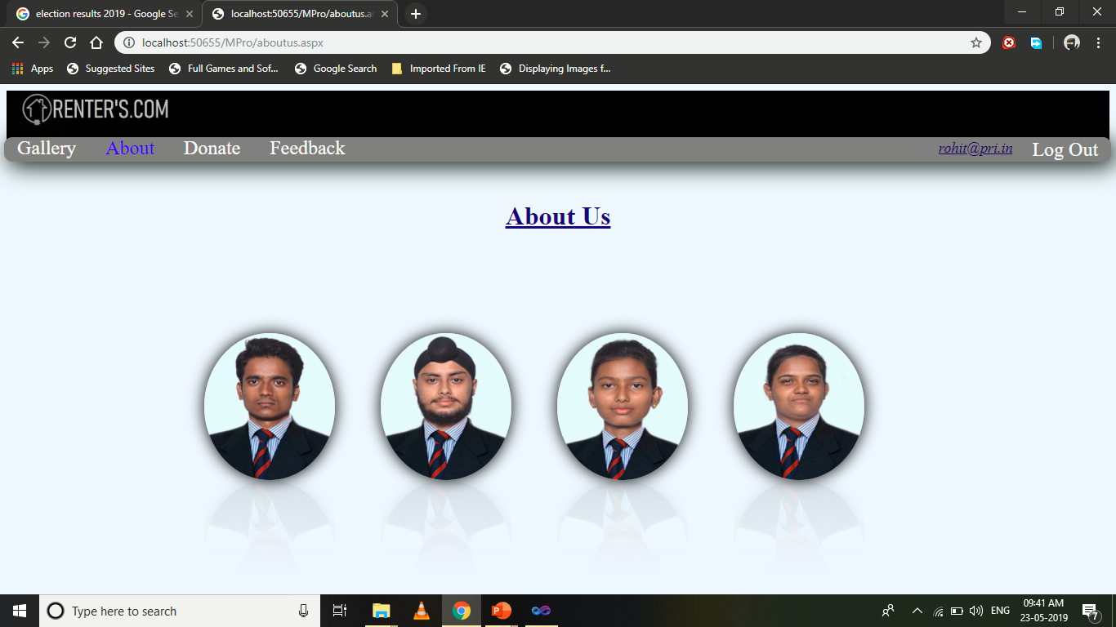

Design-

<%@ Page Language="C#" AutoEventWireup="true" CodeFile="aboutus.aspx.cs" Inherits="Default8" %>

<!DOCTYPE html PUBLIC "-//W3C//DTD XHTML 1.0 Transitional//EN" "http://www.w3.org/TR/xhtml1/DTD/xhtml1-transitional.dtd">

<html xmlns="http://www.w3.org/1999/xhtml">

<head runat="server">

<title></title>

<style type="text/css">

.z:hover

{

-webkit-transform: scale(1.5);

}

a

{

color:White;

padding:14px 16px;

text-align:center;

font-size:x-large;

text-decoration:none;

}

a:hover.s

{

color:Gray;

background-color:White;

}

a.active

{

color:Blue;

}

.style1

{

text-align: center;

}

a.t

{

float:right;

color:White;

padding:2px 16px;

text-align:center;

font-size:x-larger;

text-decoration:none;

}

a:hover.t

{

padding:14px 16px;

color:Grey;

background-color:White;

}

</style>

</head>

<body bgcolor="#F0F8FF" >

<form id="form1" runat="server">

<div style="background-color: Black; height: 78px; ">

<asp:Image ID="Image1" runat="server" ImageUrl="~/l.png" Height="50px" Width="250px" />

</div>

<div style="background-color: #808080; height: 30px;-webkit-box-shadow:5px 5px 28px rgba(0,09,0,01); -webkit-border-radius:10px; z-index: 1; left: 05px; top: 65px; position: absolute; width:99.2%;">

<a class="s" href="Default14.aspx">Gallery</a>

<a class="active" href="Default17.aspx">About</a>

<a class="s" href="Default17.aspx">Donate</a>

<a class=s href="Default9.aspx">Feedback</a>

<a class="t" href="Default14.aspx">Log Out</a><u>

<asp:HyperLink ID="HyperLink2" runat="server" Font-Italic="True" style="float:right;padding:3px 8px;"

Font-Underline="True" ForeColor="#000066" Font-Size="Large"

NavigateUrl="~/Default15.aspx"></asp:HyperLink></u>

</div>

<br>

<br />

<h1 class="style1"

style="font-size: xxx-large; color: #000080; text-decoration: underline;">About Us</h1>

<div style="top:305px; left:250px; position:absolute;" align="center">

<center>

<asp:ImageButton ID="ImageButton1" runat="server" ImageUrl="~/RNTC0816036.jpg" class="z"

style="-webkit-box-shadow:0px 0px 18px rgba(0,0,0,1); -webkit-box-reflect: below 0px -webkit-gradient(linear, left top, left bottom, from(transparent), color-stop(30%, transparent) , to(rgba(250, 250, 250, 0.1)));

border-radius:50%; height:180px; width:160px;"

onclick="ImageButton1_Click" />

&nbsp;&nbsp;&nbsp;&nbsp;&nbsp;&nbsp;&nbsp;&nbsp;&nbsp;&nbsp;&nbsp;&nbsp;

<asp:ImageButton ID="ImageButton2" runat="server" class="z" ImageUrl="~/RNTC0816038.jpg"

style="-webkit-box-reflect: below 0px -webkit-gradient(linear, left top, left bottom, from(transparent), color-stop(30%, transparent) , to(rgba(250, 250, 250, 0.1)));

-webkit-box-shadow:0px 0px 18px rgba(0,0,0,1); border-radius:50%; height:180px; width:160px;"

onclick="ImageButton2_Click" />

&nbsp;&nbsp;&nbsp;&nbsp;&nbsp;&nbsp;&nbsp;&nbsp;&nbsp;&nbsp;&nbsp;&nbsp;

<asp:ImageButton ID="ImageButton3" runat="server" class="z" ImageUrl="~/RNTC0816023.jpg"

style="-webkit-box-shadow:0px 0px 18px rgba(0,0,0,1);-webkit-box-reflect: below 0px -webkit-gradient(linear, left top, left bottom, from(transparent), color-stop(30%, transparent) , to(rgba(250, 250, 250, 0.1)));

border-radius:50%; height:180px; width:160px;"

onclick="ImageButton3_Click" />

&nbsp;&nbsp;&nbsp;&nbsp;&nbsp;&nbsp;&nbsp;&nbsp;&nbsp;&nbsp;&nbsp;&nbsp;

<asp:ImageButton ID="ImageButton4" runat="server" class="z" ImageUrl="~/RNTC0816032.jpg"

style="-webkit-box-shadow:0px 0px 18px rgba(0,0,0,1); border-radius:50%; -webkit-box-reflect: below 0px -webkit-gradient(linear, left top, left bottom, from(transparent), color-stop(30%, transparent) , to(rgba(250, 250, 250, 0.1)));

height:180px; width:160px;"

onclick="ImageButton4_Click" /> <asp:Panel ID="Panel1" runat="server"

style="-webkit-border-radius:5px; -webkit-box-reflect: below 0px -webkit-gradient(linear, left top, left bottom, from(transparent), color-stop(30%, transparent) , to(rgba(250, 250, 250, 0.1)));

position:absolute; top:96px; left: 1px; width: 156px;"

Visible="False">

<center>

<br />

<br />

<br />

<br />

<br />

<br />

<asp:Label ID="Label1" runat="server" Text="Niraj Kumar Verma" ForeColor="blue"></asp:Label><br />

<asp:Label ID="Label2"

runat="server" Text="RNTC 08 16 036" ForeColor="black"></asp:Label></center>

</asp:Panel>

&nbsp;&nbsp;

<asp:Panel ID="Panel2" runat="server"

style="-webkit-border-radius:5px; position:absolute; top:97px; width: 156px; left: 217px;"

Visible="False">

<center>

<br />

<br />

<br />

<br />

<br />

<br />

<asp:Label ID="Label3" runat="server" Text="Parmeet Singh" ForeColor="blue"></asp:Label><br />

<asp:Label ID="Label4"

runat="server" Text="RNTC 08 16 038" ForeColor="black"></asp:Label></center>

</asp:Panel>

&nbsp;&nbsp;

<asp:Panel ID="Panel3" runat="server"

style="-webkit-border-radius:5px; position:absolute; top:99px; width: 156px; left: 433px;"

Visible="False">

<center>

<br />

<br />

<br />

<br />

<br />

<br />

<asp:Label ID="Label5" runat="server" Text="Kirandeep Kaur" ForeColor="blue"></asp:Label><br />

<asp:Label ID="Label6"

runat="server" Text="RNTC 08 16 023" ForeColor="black"></asp:Label></center>

</asp:Panel>

&nbsp;&nbsp;

<asp:Panel ID="Panel4" runat="server" style="-webkit-border-radius:5px; position:absolute; top:97px; width: 156px; left: 645px;"

Visible="False">

<center>

<br />

<br />

<br />

<br />

<br />

<br />

<asp:Label ID="Label7" runat="server" Text="Neha Priya" ForeColor="blue"></asp:Label><br />

<asp:Label ID="Label8" runat="server" Text="RNTC 08 16 032" ForeColor="black"></asp:Label></center>

</asp:Panel>

</center>

</div>

</form>

</body>

</html>

Code Snippets-

using System;

using System.Collections.Generic;

using System.Linq;

using System.Web;

using System.Web.UI;

using System.Web.UI.WebControls;

public partial class Default8 : System.Web.UI.Page

{

protected void Page_Load(object sender, EventArgs e)

{

HyperLink2.Text = Session["s"].ToString();

Panel2.Visible = false;

Panel3.Visible = false;

Panel4.Visible = false;

Panel1.Visible = false;

}

protected void ImageButton1_Click(object sender, ImageClickEventArgs e)

{

Panel1.Visible = true;

Panel2.Visible = false;

Panel3.Visible = false;

Panel4.Visible = false;

}

protected void ImageButton2_Click(object sender, ImageClickEventArgs e)

{

Panel2.Visible = true;

Panel1.Visible = false;

Panel3.Visible = false;

Panel4.Visible = false;

}

protected void ImageButton3_Click(object sender, ImageClickEventArgs e)

{

Panel3.Visible = true;

Panel2.Visible = false;

Panel1.Visible = false;

Panel4.Visible = false;

}

protected void ImageButton4_Click(object sender, ImageClickEventArgs e)

{

Panel4.Visible = true;

Panel2.Visible = false;

Panel3.Visible = false;

Panel1.Visible = false;

}

}

**Donate:**

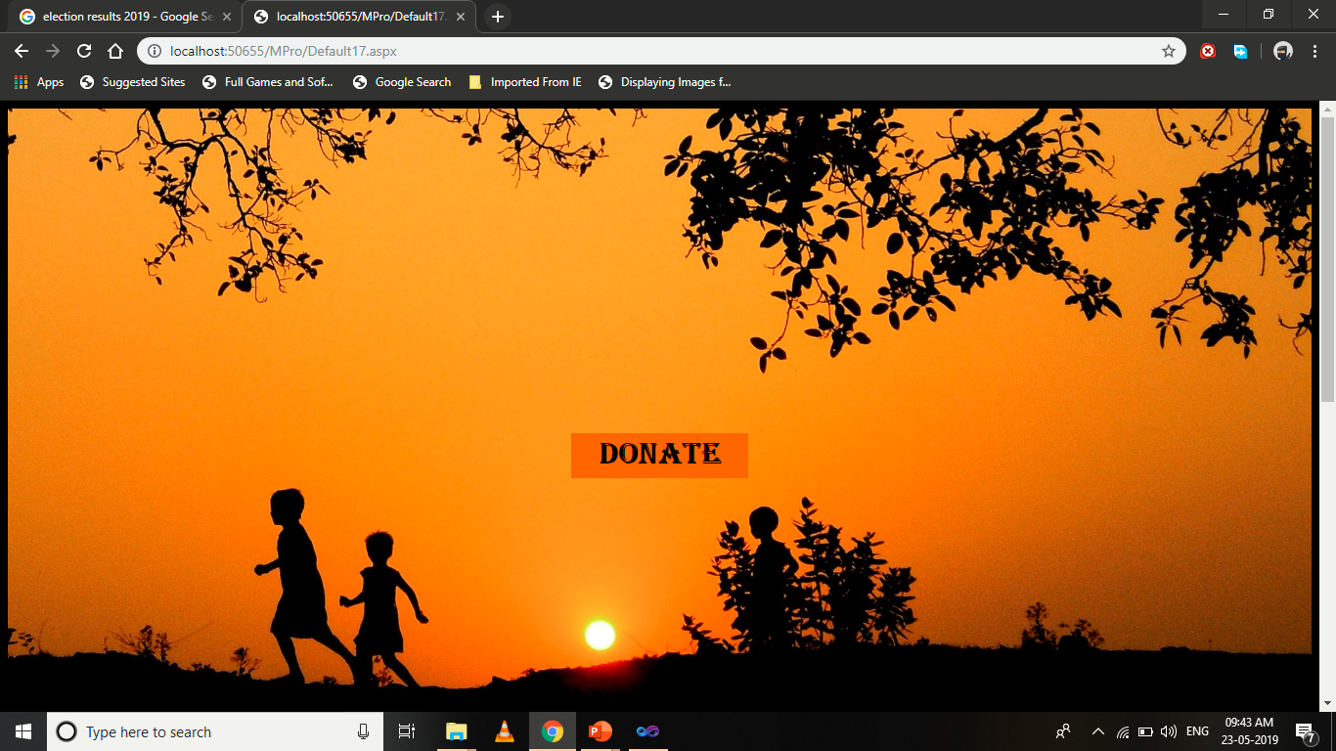

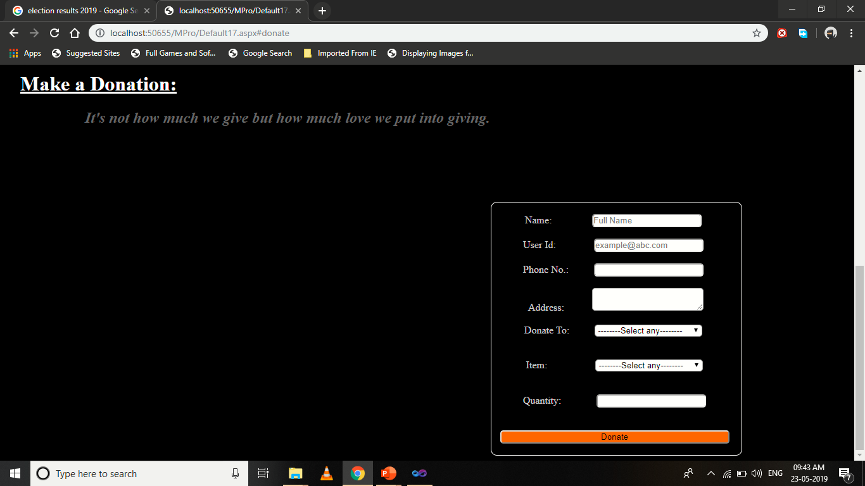

Design-

<%@ Page Language="C#" AutoEventWireup="true" CodeFile="Default17.aspx.cs" Inherits="Default17" %>

<!DOCTYPE html PUBLIC "-//W3C//DTD XHTML 1.0 Transitional//EN" "http://www.w3.org/TR/xhtml1/DTD/xhtml1-transitional.dtd">

<html xmlns="http://www.w3.org/1999/xhtml">

<head runat="server">

<title></title>

<style type="text/css">

.style1

{

color: #666666;

}

.style2

{

font-size: xx-large;

font-family: Algerian;

color: #000000;

}

a:hover.t

{

background-color:White;

border-color:Black;

}

.style3

{

color: #FFFFFF;

font-size: xx-large;

}

.style4

{

text-decoration: underline;

}

</style>

</head>

<body bgcolor="Black">

<form id="form1" runat="server">

<div style=" min-height: 50vh; padding-top: 50vh; background-size: 100% 100%; background-image: url('430049-Kycb.jpg');"><center>

<h2>

<a class="t" href="#donate" style="background-color: #FF6600; text-decoration:none; padding:10px;"><span class="style1">&nbsp;&nbsp;&nbsp;</span><span

class="style2">Donate</span><span class="style1">&nbsp;&nbsp;&nbsp;</span></a></h2>

</center>

</div>

<div id="donate" style="background-color: #000000">

<h1 class="style3">

&nbsp;&nbsp; <span class="style4">Make a Donation:</span>

</h1>

<h2><em style="color: #666666">&nbsp;&nbsp;&nbsp;&nbsp;&nbsp;&nbsp;&nbsp;&nbsp;&nbsp;&nbsp;&nbsp;&nbsp;&nbsp;&nbsp;&nbsp;&nbsp;&nbsp;&nbsp;&nbsp;&nbsp; It's not how much we give but how much love we put into giving.</em></h2>

<p class="style3">

&nbsp;</p><br />

<asp:Panel ID="Panel1" runat="server" style="-webkit-border-radius:10px; color: #CCCCCC; margin-left: 767px; margin-right: 75px;"

Width="395px" BorderColor="White" BorderStyle="Solid" BorderWidth="1px"><center style="width: 381px; margin-left: 0px">

&nbsp;

<br />

&nbsp; Name:&nbsp;&nbsp;&nbsp;&nbsp;&nbsp;&nbsp;&nbsp;&nbsp;&nbsp;&nbsp;&nbsp;&nbsp;&nbsp;&nbsp;&nbsp;

<asp:TextBox ID="TextBox1" runat="server" placeholder="Full Name" style="-webkit-border-radius:5px;"></asp:TextBox>

<br />

<br />

&nbsp; User Id:&nbsp;&nbsp;&nbsp;&nbsp;&nbsp;&nbsp;&nbsp;&nbsp;&nbsp;&nbsp;&nbsp;&nbsp;&nbsp;&nbsp;

<asp:TextBox ID="TextBox2" runat="server" placeholder="example@abc.com" style="-webkit-border-radius:5px;"></asp:TextBox>

<br />

<br />

&nbsp; Phone No.:&nbsp;&nbsp;&nbsp;&nbsp;&nbsp;&nbsp;&nbsp;&nbsp;&nbsp;

<asp:TextBox ID="TextBox3" runat="server" MaxLength="10" placeholder="" style="-webkit-border-radius:5px;"

TextMode="Phone"></asp:TextBox>

<br />

<br />

&nbsp;&nbsp;&nbsp; Address:&nbsp;&nbsp;&nbsp;&nbsp;&nbsp;&nbsp;&nbsp;&nbsp;&nbsp;&nbsp;

<asp:TextBox ID="TextBox7" runat="server" TextMode="MultiLine" Width="170px" style="-webkit-border-radius:5px;"></asp:TextBox>

<br />

<br />

&nbsp; Donate To:&nbsp;&nbsp;&nbsp;&nbsp; &nbsp;&nbsp;&nbsp;&nbsp;

<asp:DropDownList ID="DropDownList1" runat="server" Width="170px"

style="-webkit-border-radius:5px;" AutoPostBack="True"

onselectedindexchanged="DropDownList1_SelectedIndexChanged">

<asp:ListItem>--------Select any--------</asp:ListItem>

<asp:ListItem>Old Age Home</asp:ListItem>

<asp:ListItem>Mother Teressa Foundation</asp:ListItem>

<asp:ListItem>Aanath Aasaram</asp:ListItem>

<asp:ListItem>Child Home</asp:ListItem>

<asp:ListItem>Other</asp:ListItem>

</asp:DropDownList>

<br />

<br />

<asp:Panel ID="Panel2" runat="server" Visible="False">

&nbsp; Name of Sanstha:<asp:TextBox ID="TextBox4" runat="server" style="-webkit-border-radius:5px;"></asp:TextBox>

</asp:Panel>

<br />

&nbsp; Item:&nbsp;&nbsp;&nbsp;&nbsp;&nbsp;&nbsp;&nbsp;&nbsp;&nbsp;&nbsp; &nbsp;&nbsp;&nbsp;&nbsp;&nbsp;&nbsp;&nbsp;

<asp:DropDownList ID="DropDownList2" style="-webkit-border-radius:5px;"

Width="170px" runat="server" AutoPostBack="True"

onselectedindexchanged="DropDownList2_SelectedIndexChanged">

<asp:ListItem>--------Select any--------</asp:ListItem>

<asp:ListItem>Food</asp:ListItem>

<asp:ListItem>Clothe</asp:ListItem>

<asp:ListItem>Book</asp:ListItem>

<asp:ListItem>Money</asp:ListItem>

<asp:ListItem>Other</asp:ListItem>

</asp:DropDownList><br /><br />

<asp:Panel ID="Panel3" runat="server" Visible="False">

&nbsp; Name of Item:&nbsp;&nbsp;&nbsp;&nbsp;&nbsp; <asp:TextBox ID="TextBox5" style="-webkit-border-radius:5px;" runat="server"></asp:TextBox>

</asp:Panel>

<br />

&nbsp;&nbsp; Quantity:&nbsp;&nbsp;&nbsp;&nbsp;&nbsp;&nbsp;&nbsp;&nbsp; &nbsp;&nbsp;&nbsp;&nbsp; <asp:TextBox ID="TextBox6" runat="server" style="-webkit-border-radius:5px;"></asp:TextBox>

<br />

<br />

<br />

&nbsp; <asp:Button ID="Button1" runat="server" Text="Donate" Width="362px"

style="-webkit-border-radius:5px;" BackColor="#FF6600"

onclick="Button1_Click" /><br /><br /></center>

</asp:Panel>

</div>

</form>

</body>

</html>

Code Snippets-

using System;

using System.Collections.Generic;

using System.Linq;

using System.Web;

using System.Web.UI;

using System.Web.UI.WebControls;

using System.Data;

using System.Data.SqlClient;

public partial class Default17 : System.Web.UI.Page

{

SqlConnection cn = new SqlConnection("Data Source=DESKTOP-MP67RVV\\SQLEXPRESS;Initial Catalog=niraj;Integrated Security=True;Pooling=False");

SqlCommand cmd;

protected void Page_Load(object sender, EventArgs e)

{

}

protected void DropDownList1_SelectedIndexChanged(object sender, EventArgs e)

{

if (DropDownList1.Text == "Other")

{ Panel2.Visible = true; }

}

protected void DropDownList2_SelectedIndexChanged(object sender, EventArgs e)

{

if (DropDownList2.Text == "Other")

{ Panel3.Visible = true; }

}

protected void Button1_Click(object sender, EventArgs e)

{

cn.Open();

if(DropDownList1.Text == "Other" && DropDownList2.Text =="Other")

{

if (TextBox6.Text != "" && TextBox1.Text != "" && TextBox2.Text != "" && TextBox3.Text != "" && TextBox4.Text != "" && TextBox7.Text != "" && TextBox5.Text !="")

{

cmd = new SqlCommand("Insert into donate values('" + TextBox1.Text + "','" + TextBox2.Text + "','" + TextBox3.Text + "','" + TextBox7.Text + "','" + TextBox4.Text + "','" + TextBox5.Text + "','" + TextBox6.Text + "')", cn);

cmd.ExecuteNonQuery();

Response.Write("<script>alert('Thank you for your contribution. We will contact you soon...')</script>");

cn.Close();

Response.Write("<script>location.href='Default17.aspx';</script>");

}

else

Response.Write("<script>alert('Please fill all the data')</script>");

}

else if (DropDownList1.Text == "Other" && DropDownList2.Text !="Other" )

{

if (TextBox6.Text != "" && TextBox1.Text != "" && TextBox2.Text != "" && TextBox3.Text != "" && TextBox4.Text != "" && TextBox7.Text != "" && DropDownList2.Text != "--------Select any--------")

{

cmd = new SqlCommand("Insert into donate values('" + TextBox1.Text + "','" + TextBox2.Text + "','" + TextBox3.Text + "','" + TextBox7.Text + "','" + TextBox4.Text + "','" + DropDownList2.Text + "','" + TextBox6.Text + "')", cn);

cmd.ExecuteNonQuery();

Response.Write("<script>alert('Thank you for your contribution. We will contact you soon...')</script>");

cn.Close();

Response.Write("<script>location.href='Default17.aspx';</script>");

}

else

Response.Write("<script>alert('Please fill all the data')</script>");

}

else if (DropDownList1.Text != "Other" && DropDownList2.Text == "Other")

{

if (TextBox6.Text != "" && TextBox1.Text != "" && TextBox2.Text != "" && TextBox3.Text != "" && TextBox5.Text != "" && TextBox7.Text != "" && DropDownList1.Text != "--------Select any--------")

{

cmd = new SqlCommand("Insert into donate values('" + TextBox1.Text + "','" + TextBox2.Text + "','" + TextBox3.Text + "','" + TextBox7.Text + "','" + DropDownList1.Text + "','" + TextBox5.Text + "','" + TextBox6.Text + "')", cn);

cmd.ExecuteNonQuery();

Response.Write("<script>alert('Thank you for your contribution. We will contact you soon...')</script>");

cn.Close();

Response.Write("<script>location.href='Default17.aspx';</script>");

}

else

Response.Write("<script>alert('Please fill all the data')</script>");

}

else

{

if (TextBox6.Text != "" && TextBox1.Text != "" && TextBox2.Text != "" && TextBox3.Text != "" && DropDownList1.Text != "--------Select any--------" && TextBox7.Text != "" && DropDownList2.Text != "--------Select any--------")

{

cmd = new SqlCommand("Insert into donate values('" + TextBox1.Text + "','" + TextBox2.Text + "','" + TextBox3.Text + "','" + TextBox7.Text + "','" + DropDownList1.Text + "','" + DropDownList2.Text + "','" + TextBox6.Text + "')", cn);

cmd.ExecuteNonQuery();

Response.Write("<script>alert('Thank you for your contribution. We will contact you soon...')</script>");

cn.Close();

Response.Write("<script>location.href='Default17.aspx';</script>");

}

else

Response.Write("<script>alert('Please fill all the data')</script>");

}

}

}

**Feedback:**

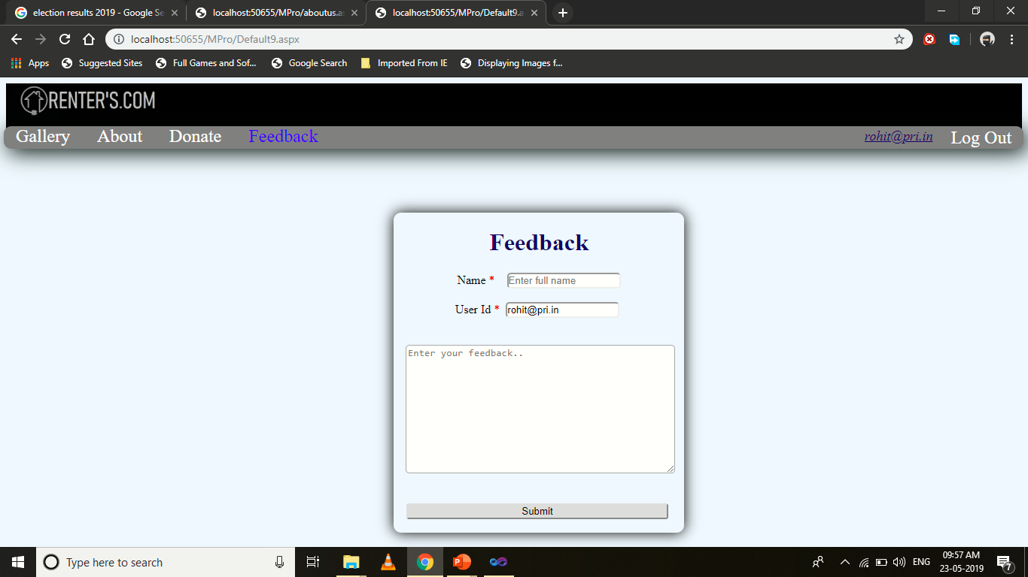

Design-

<%@ Page Language="C#" AutoEventWireup="true" CodeFile="Default9.aspx.cs" Inherits="Default9" %>

<!DOCTYPE html PUBLIC "-//W3C//DTD XHTML 1.0 Transitional//EN" "http://www.w3.org/TR/xhtml1/DTD/xhtml1-transitional.dtd">

<html xmlns="http://www.w3.org/1999/xhtml">

<head runat="server">

<title></title>

<style type="text/css">

a

{

color:White;

padding:14px 16px;

text-align:center;

font-size:x-large;

text-decoration:none;

}

a:hover.s

{

color:Gray;

background-color:White;

}

a.active

{

color:Blue;

}

a.t

{

float:right;

color:White;

padding:2px 16px;

text-align:center;

font-size:x-larger;

text-decoration:none;

}

a:hover.t

{

padding:14px 16px;

color:Grey;

background-color:White;

}

.style1

{

color: #CC0000;

}

</style>

</head>

<body bgcolor="#F0F8FF" >

<form id="form1" runat="server">

<div style="background-color: Black; height: 78px; ">

<asp:Image ID="Image1" runat="server" ImageUrl="~/l.png" Height="50px" Width="250px" />

</div>

<div style="background-color: #808080; height: 30px;-webkit-box-shadow:5px 5px 28px rgba(0,09,0,01); -webkit-border-radius:10px; z-index: 1; left: 05px; top: 65px; position: absolute; width:99.2%;">

<a class="s" href="menubar.aspx">Gallery</a>

<a class="s" href="aboutus.aspx">About</a>

<a class="s" href="">Donate</a>

<a class="active" href="Default9.aspx">Feedback</a>

<a class="t" href="Default14.aspx">Log Out</a><u>

<asp:HyperLink ID="HyperLink2" runat="server" Font-Italic="True" style="float:right;padding:3px 8px;"

Font-Underline="True" ForeColor="#000066" Font-Size="Large"

NavigateUrl="~/Default15.aspx">[HyperLink2]</asp:HyperLink></u>

</div><center>

<div style=" top: 180px; left: 523px;-webkit-box-shadow:0px 0px 18px rgba(0,0,0,1);-webkit-border-radius:10px; position:absolute;">

<center><h1 style="color: #000066; text-decoration: blink;">Feedback </h1></center>

<center>

<asp:Label ID="Label1" runat="server" Text="Name" ForeColor="black"></asp:Label>

<span class="style1">*</span>&nbsp;&nbsp;&nbsp;&nbsp;<asp:TextBox ID="TextBox1"

runat="server" Placeholder="Enter full name"

style="-webkit-border-radius:5px;" Width="147px"></asp:TextBox><br />

<asp:RequiredFieldValidator ID="RequiredFieldValidator1" runat="server"

ErrorMessage="Inset your Name" ControlToValidate="TextBox1" ForeColor="#CC0000"></asp:RequiredFieldValidator><br />

<asp:Label ID="Label2" runat="server" Text="User Id" ForeColor="black"></asp:Label>

<span class="style1">*</span>&nbsp;&nbsp;<asp:TextBox ID="TextBox2"

runat="server" Width="147px" style="-webkit-border-radius:5px;"></asp:TextBox> <br />

<asp:RequiredFieldValidator ID="RequiredFieldValidator2" runat="server"

ErrorMessage="Inset your User ID" ControlToValidate="TextBox2"

ForeColor="#CC0000"></asp:RequiredFieldValidator><asp:RegularExpressionValidator ID="RegularExpressionValidator1" runat="server"

ErrorMessage="Incorrect Email ID" ControlToValidate="TextBox2"

ValidationExpression="\w+([-+.']\w+)*@\w+([-.]\w+)*\.\w+([-.]\w+)*"

ForeColor="#CC0000"></asp:RegularExpressionValidator><br /><br />

&nbsp;&nbsp;&nbsp;

<asp:TextBox ID="TextBox3" runat="server" Placeholder="Enter your feedback.."

TextMode="MultiLine" Width="352px"

style="-webkit-border-radius:5px;"

Height="165px"></asp:TextBox>&nbsp;&nbsp;

<br />

<asp:Label ID="Label3" runat="server" style="color: #CC0000" ></asp:Label>

<br /> <br />

<asp:Button ID="Button1" runat="server" Text="Submit"

style="-webkit-border-radius:3px;" Width="348px" onclick="Button1_Click"/>

<br /><br />

</center>

</div>

</center>

</form>

</body>

</html>

Code Snippets-

using System;

using System.Collections.Generic;

using System.Linq;

using System.Web;

using System.Web.UI;

using System.Web.UI.WebControls;

using System.Data;

using System.Data.SqlClient;

public partial class Default9 : System.Web.UI.Page

{

SqlConnection cn = new SqlConnection("Data Source=DESKTOP-MP67RVV\\SQLEXPRESS;Initial Catalog=niraj;Integrated Security=True;Pooling=False");

SqlCommand cmd;

SqlDataReader dr;

protected void Page_Load(object sender, EventArgs e)

{

TextBox2.Text = Session["s"].ToString();

HyperLink2.Text = Session["s"].ToString();

}

protected void Button1_Click(object sender, EventArgs e)

{

cn.Open();

int x = TextBox3.Text.Length;

if ((x < 25) || (x.Equals("")))

{

Label3.Text = "Inset atleast 25 words";

}

else {

Label3.Text = "";

cmd= new SqlCommand("Insert into feedback values('" + TextBox1.Text + "','" + TextBox2.Text + "','" + TextBox3.Text + "')",cn);

dr = cmd.ExecuteReader();

cn.Close();

Response.Write("<script>alert('Thank you for your Feedback')</script>");

TextBox1.Text="";

TextBox2.Text="";

TextBox3.Text="";

}

}

}

**User_Data:**

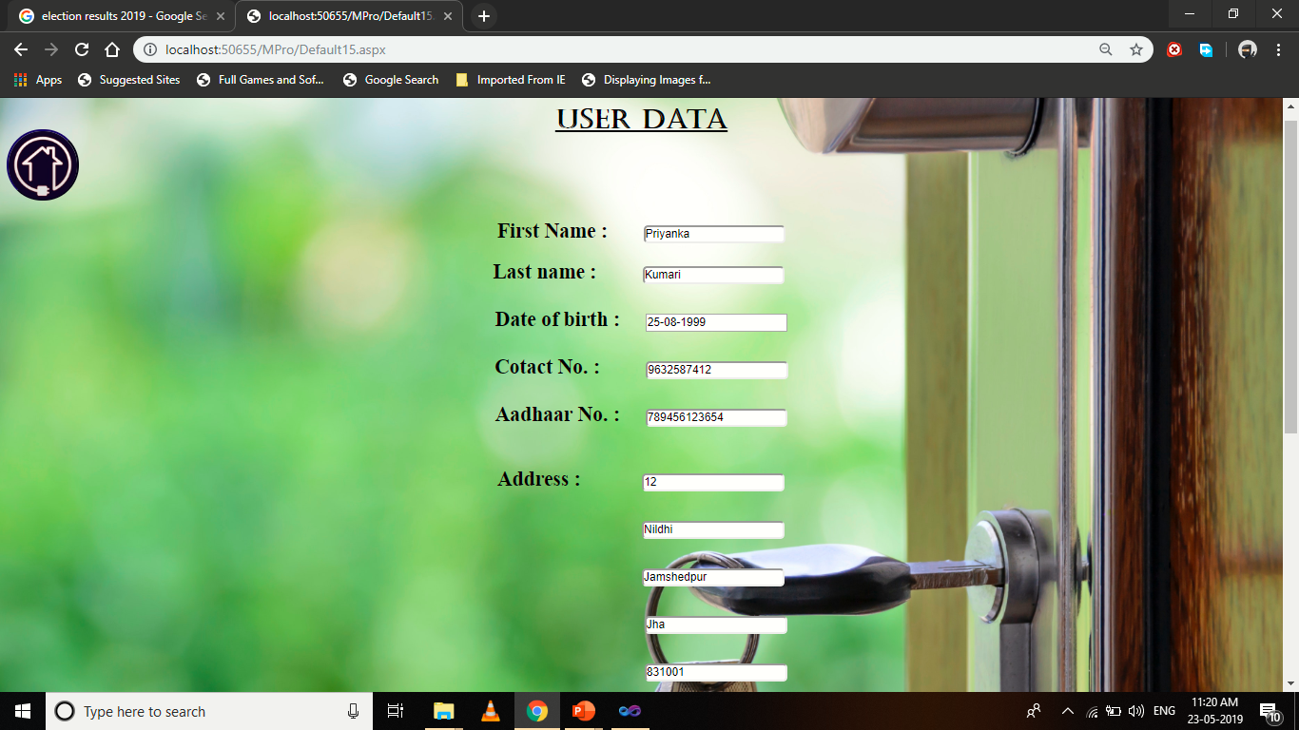

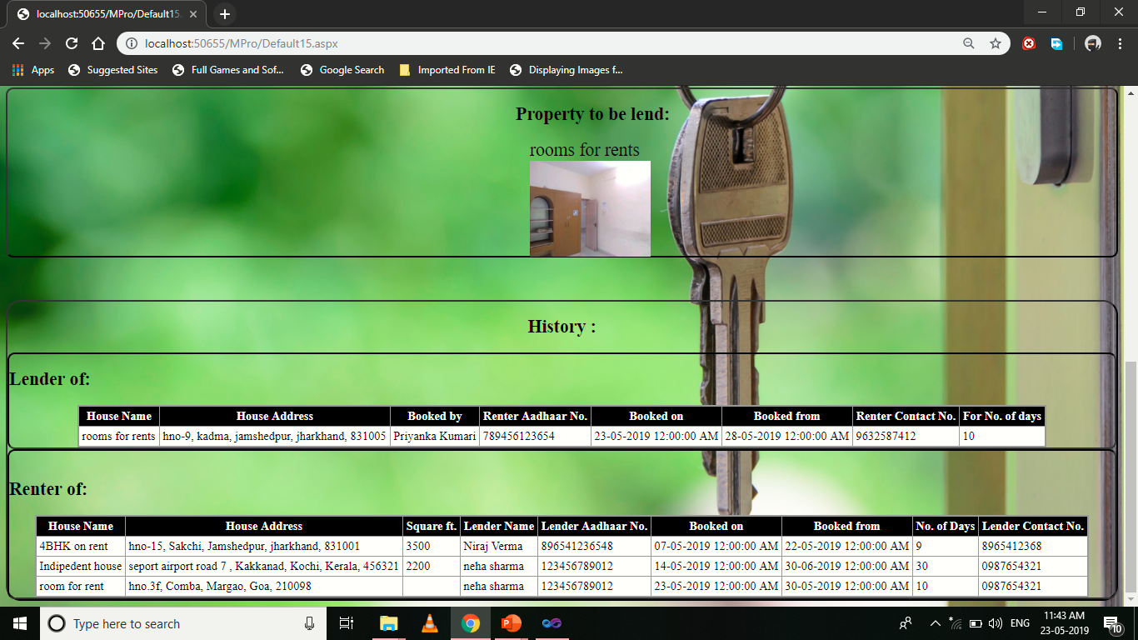

Design-

<%@ Page Language="C#" AutoEventWireup="true" CodeFile="Default15.aspx.cs" Inherits="Default15" %>

<!DOCTYPE html PUBLIC "-//W3C//DTD XHTML 1.0 Transitional//EN" "http://www.w3.org/TR/xhtml1/DTD/xhtml1-transitional.dtd">

<html xmlns="http://www.w3.org/1999/xhtml">

<head runat="server">

<title></title>

<style type="text/css">

.style1

{

text-decoration: underline;

}

.style2

{

text-align: left;

}

.style3

{

font-weight: normal;

text-align: left;

}

</style>

</head>

<body background="close-up-door-focus-101808.jpg" style="background-size: cover;">

<form id="form1" runat="server">

<div>

<center>

<h1 class="style1" style="font-family: Castellar">User Data

</h1>

<br /><br /><br /><h2>

First

Name :&nbsp;&nbsp;&nbsp;&nbsp;&nbsp;&nbsp; <asp:TextBox ID="TextBox1" style="-webkit-border-radius:5px;"

runat="server" ReadOnly="True"></asp:TextBox>

</h2>

<h2>

Last name :&nbsp;&nbsp;&nbsp;&nbsp;&nbsp;&nbsp;&nbsp;&nbsp;

<asp:TextBox ID="TextBox6" runat="server" ReadOnly="True" style="-webkit-border-radius:5px;"></asp:TextBox>

<br /><br />

Date of birth :&nbsp;&nbsp;&nbsp;&nbsp;

<asp:TextBox ID="TextBox2" runat="server"

ReadOnly="True"></asp:TextBox><br /><br />

Cotact No. :&nbsp;&nbsp;&nbsp;&nbsp;&nbsp;&nbsp;&nbsp;&nbsp; <asp:TextBox ID="TextBox3" style="-webkit-border-radius:5px;"

runat="server" ReadOnly="True"></asp:TextBox><br /><br />

Aadhaar No. :&nbsp;&nbsp;&nbsp;&nbsp; <asp:TextBox ID="TextBox4" runat="server" style="-webkit-border-radius:5px;"

ReadOnly="True"></asp:TextBox>

</h2>

<h2>

<br />

&nbsp;Address :&nbsp;&nbsp;&nbsp;&nbsp;&nbsp;&nbsp;&nbsp;&nbsp;&nbsp;&nbsp;&nbsp;

<asp:TextBox ID="TextBox5" runat="server" Placeholder=" H.No./Street No." style="-webkit-border-radius:5px;"></asp:TextBox>

<br/>

<br/>

&nbsp;&nbsp;&nbsp;&nbsp;&nbsp;&nbsp;&nbsp;&nbsp;&nbsp;&nbsp;&nbsp;&nbsp;&nbsp;&nbsp;&nbsp;&nbsp;&nbsp;&nbsp;&nbsp;&nbsp;&nbsp;&nbsp;&nbsp;&nbsp;&nbsp;&nbsp;&nbsp;&nbsp;

<asp:TextBox ID="TextBox7" runat="server" Placeholder=" Locality/Socity" style="-webkit-border-radius:5px;"></asp:TextBox>

<br/>

<br/>

&nbsp;&nbsp;&nbsp;&nbsp;&nbsp;&nbsp;&nbsp;&nbsp;&nbsp;&nbsp;&nbsp;&nbsp;&nbsp;&nbsp;&nbsp;&nbsp;&nbsp;&nbsp;&nbsp;&nbsp;&nbsp;&nbsp;&nbsp;&nbsp;&nbsp;&nbsp;&nbsp;&nbsp;

<asp:TextBox ID="TextBox8" runat="server" Placeholder=" Town" style="-webkit-border-radius:5px;"></asp:TextBox>

<br/><br/> &nbsp;&nbsp;&nbsp;&nbsp;&nbsp;&nbsp;&nbsp;&nbsp;&nbsp;&nbsp;&nbsp;&nbsp;&nbsp;&nbsp;&nbsp;&nbsp;&nbsp;&nbsp;&nbsp;&nbsp;&nbsp;&nbsp;&nbsp;&nbsp;&nbsp;&nbsp;&nbsp;&nbsp;

<asp:TextBox

ID="TextBox9" runat="server" Placeholder=" State" style="-webkit-border-radius:5px;"></asp:TextBox><br/>

<br/> &nbsp;&nbsp;&nbsp;&nbsp;&nbsp;&nbsp;&nbsp;&nbsp;&nbsp;&nbsp;&nbsp;&nbsp;&nbsp;&nbsp;&nbsp;&nbsp;&nbsp;&nbsp;&nbsp;&nbsp;&nbsp;&nbsp;&nbsp;&nbsp;&nbsp;&nbsp;&nbsp;&nbsp;

<asp:TextBox

ID="TextBox10" runat="server" Placeholder=" Pincode" style="-webkit-border-radius:5px;"></asp:TextBox>

</h2>

<p>

&nbsp;</p>

<p>

&nbsp;</p>

<asp:ImageButton ID="ImageButton1" runat="server" ImageUrl="~/logo.jpg"

ToolTip="Gallery" style="border-radius:50%; height:80px; width:80px; position: relative;top:-666px; float: left; left: 0px;"

BorderColor="#000066" BorderStyle="Outset" BorderWidth="2px"

AlternateText="Gallery" onclick="ImageButton1_Click" />

<asp:Panel ID="Panel1" runat="server" style="-webkit-border-radius:10px;" BorderColor="#333333" BorderWidth="2px" BorderStyle="Outset">

<h2> Property to be lend:</h2>

<asp:DataList ID="DataList1" runat="server" DataSourceID="SqlDataSource1"

RepeatColumns="4" RepeatDirection="Horizontal">

<ItemTemplate>

<br />

<asp:Label ID="titleLabel" runat="server" style="font-size: x-large"

Text='<%# Eval("title") %>' />

<br />

<asp:Image ID="Image1" runat="server" Height="128px"

ImageUrl='<%# Eval("img1") %>' Width="161px" />

<br />

<br />

</ItemTemplate>

</asp:DataList><asp:SqlDataSource ID="SqlDataSource1" runat="server"

ConnectionString="<%$ ConnectionStrings:nirajConnectionString %>"

SelectCommand="SELECT [img1], [title] FROM [house] WHERE ([id] = @id)">

<SelectParameters>

<asp:SessionParameter Name="id" SessionField="s" Type="String" />

</SelectParameters>

</asp:SqlDataSource>

<asp:DataList ID="DataList2" runat="server" DataSourceID="SqlDataSource2"

RepeatColumns="4" RepeatDirection="Horizontal">

<ItemTemplate>

<asp:Label ID="Label1" runat="server" style="font-size: x-large"

Text='<%# Eval("title") %>'></asp:Label>

<br />

<asp:Image ID="Image2" runat="server" Height="128px"

ImageUrl='<%# Eval("img1") %>' Width="161px" />

</ItemTemplate>

</asp:DataList><asp:SqlDataSource ID="SqlDataSource2" runat="server"

ConnectionString="<%$ ConnectionStrings:nirajConnectionString %>"

SelectCommand="SELECT [img1], [title] FROM [room] WHERE ([id] = @id)">

<SelectParameters>

<asp:SessionParameter Name="id" SessionField="s" Type="String" />

</SelectParameters>

</asp:SqlDataSource>

<asp:DataList ID="DataList3" runat="server" DataSourceID="SqlDataSource3"

RepeatColumns="4" RepeatDirection="Horizontal">

<ItemTemplate>

<br />

<asp:Label ID="titleLabel" runat="server" style="font-size: x-large"

Text='<%# Eval("title") %>' />

<br />

<asp:Image ID="Image3" runat="server" Height="128px"

ImageUrl='<%# Eval("img1") %>' Width="161px" />

<br />

<br />

</ItemTemplate>

</asp:DataList><asp:SqlDataSource ID="SqlDataSource3" runat="server"

ConnectionString="<%$ ConnectionStrings:nirajConnectionString %>"

SelectCommand="SELECT [img1], [title] FROM [hall] WHERE ([id] = @id)">

<SelectParameters>

<asp:SessionParameter Name="id" SessionField="s" Type="String" />

</SelectParameters>

</asp:SqlDataSource>

<asp:DataList ID="DataList4" runat="server" DataSourceID="SqlDataSource4"

RepeatColumns="4" RepeatDirection="Horizontal">

<ItemTemplate>

<br />

<asp:Label ID="titleLabel" runat="server" Text='<%# Eval("title") %>' />

<br />

<asp:Image ID="Image4" runat="server" Height="128px"

ImageUrl='<%# Eval("img1") %>' Width="161px" />

<br />

<br />

</ItemTemplate>

</asp:DataList><asp:SqlDataSource ID="SqlDataSource4" runat="server"

ConnectionString="<%$ ConnectionStrings:nirajConnectionString %>"

SelectCommand="SELECT [img1], [title] FROM [ground] WHERE ([id] = @id)">

<SelectParameters>

<asp:SessionParameter Name="id" SessionField="s" Type="String" />

</SelectParameters>

</asp:SqlDataSource>

</asp:Panel><br /><br /><br />

<asp:Panel ID="Panel2" runat="server" BorderColor="#333333" BorderWidth="2px" style="-webkit-border-radius:20px;" BorderStyle="Outset">

<h2>History : </h2>

<asp:Panel ID="Panel3" style="-webkit-border-radius:10px;" runat="server" BorderColor="#333333" BorderWidth="2px" BorderStyle="Inset">

<h2 class="style2">Lender of:</h2>

<center>

<asp:GridView ID="GridView1" runat="server" AutoGenerateColumns="False"

BackColor="#CCCCCC" BorderColor="#999999" BorderStyle="Solid" BorderWidth="3px"

CellPadding="4" CellSpacing="2" DataSourceID="SqlDataSource5" ForeColor="Black">

<Columns>

<asp:BoundField DataField="title" HeaderText="House Name"

SortExpression="title" />

<asp:BoundField DataField="ha1" HeaderText="House Address"

SortExpression="ha1" />

<asp:BoundField DataField="rname" HeaderText="Booked by"

SortExpression="rname" />

<asp:BoundField DataField="rano" HeaderText="Renter Aadhaar No."

SortExpression="rano" />

<asp:BoundField DataField="bd" HeaderText="Booked on" SortExpression="bd" />

<asp:BoundField DataField="fd" HeaderText="Booked from" SortExpression="fd" />

<asp:BoundField DataField="rmno" HeaderText="Renter Contact No."

SortExpression="rmno" />

<asp:BoundField DataField="nod" HeaderText="For No. of days"

SortExpression="nod" />

</Columns>

<FooterStyle BackColor="#CCCCCC" />

<HeaderStyle BackColor="Black" Font-Bold="True" ForeColor="White" />

<PagerStyle BackColor="#CCCCCC" ForeColor="Black" HorizontalAlign="Left" />

<RowStyle BackColor="White" />

<SelectedRowStyle BackColor="#000099" Font-Bold="True" ForeColor="White" />

<SortedAscendingCellStyle BackColor="#F1F1F1" />

<SortedAscendingHeaderStyle BackColor="#808080" />

<SortedDescendingCellStyle BackColor="#CAC9C9" />

<SortedDescendingHeaderStyle BackColor="#383838" />

</asp:GridView>

<asp:SqlDataSource ID="SqlDataSource5" runat="server"

ConnectionString="<%$ ConnectionStrings:nirajConnectionString %>"

SelectCommand="SELECT [title], [ha1], [rname], [rmno], [rano], [bd], [fd], [nod] FROM [book] WHERE ([lid] = @lid)">

<SelectParameters>

<asp:SessionParameter Name="lid" SessionField="s" Type="String" />

</SelectParameters>

</asp:SqlDataSource>

</center>

</asp:Panel>

<asp:Panel ID="Panel4" runat="server" style="-webkit-border-radius:10px;" BorderColor="#333333" BorderWidth="2px" BorderStyle="Inset">

<br />

<h2 class="style3">

<strong>Renter of:</strong></h2>

<center>

<asp:GridView ID="GridView2" runat="server" AutoGenerateColumns="False"

BackColor="#CCCCCC" BorderColor="#999999" BorderStyle="Solid" BorderWidth="3px"

CellPadding="4" CellSpacing="2" DataSourceID="SqlDataSource6" ForeColor="Black">

<Columns>

<asp:BoundField DataField="title" HeaderText="House Name"

SortExpression="title" />

<asp:BoundField DataField="ha1" HeaderText="House Address"

SortExpression="ha1" />

<asp:BoundField DataField="area" HeaderText="Square ft."

SortExpression="area" />

<asp:BoundField DataField="lname" HeaderText="Lender Name"

SortExpression="lname" />

<asp:BoundField DataField="lano" HeaderText="Lender Aadhaar No."

SortExpression="lano" />

<asp:BoundField DataField="bd" HeaderText="Booked on" SortExpression="bd" />

<asp:BoundField DataField="fd" HeaderText="Booked from" SortExpression="fd" />

<asp:BoundField DataField="nod" HeaderText="No. of Days" SortExpression="nod" />

<asp:BoundField DataField="lmno" HeaderText="Lender Contact No."

SortExpression="lmno" />

</Columns>

<FooterStyle BackColor="#CCCCCC" />

<HeaderStyle BackColor="Black" Font-Bold="True" ForeColor="White" />

<PagerStyle BackColor="#CCCCCC" ForeColor="Black" HorizontalAlign="Left" />

<RowStyle BackColor="White" />

<SelectedRowStyle BackColor="#000099" Font-Bold="True" ForeColor="White" />

<SortedAscendingCellStyle BackColor="#F1F1F1" />

<SortedAscendingHeaderStyle BackColor="#808080" />

<SortedDescendingCellStyle BackColor="#CAC9C9" />

<SortedDescendingHeaderStyle BackColor="#383838" />

</asp:GridView>

<asp:SqlDataSource ID="SqlDataSource6" runat="server"

ConnectionString="<%$ ConnectionStrings:nirajConnectionString %>"

SelectCommand="SELECT [lname], [lmno], [lano], [title], [ha1], [bd], [fd], [nod], [area] FROM [book] WHERE ([rid] = @rid)">

<SelectParameters>

<asp:SessionParameter Name="rid" SessionField="s" Type="String" />

</SelectParameters>

</asp:SqlDataSource>

</center>

</asp:Panel>

</asp:Panel>

</div>

</form>

</body>

</html>

Code Snippets-

using System;

using System.Collections.Generic;

using System.Linq;

using System.Web;

using System.Web.UI;

using System.Web.UI.WebControls;

using System.Data;

using System.Data.SqlClient;

public partial class Default15 : System.Web.UI.Page

{

SqlConnection cn = new SqlConnection("Data Source=DESKTOP-MP67RVV\\SQLEXPRESS;Initial Catalog=niraj;Integrated Security=True;Pooling=False");

SqlCommand cmd;

SqlDataReader dr;

protected void Page_Load(object sender, EventArgs e)

{

cn.Open();

cmd= new SqlCommand("Select * from lustab where id='" + Session["s"] + "'",cn);

dr=cmd.ExecuteReader();

dr.Read();

TextBox1.Text=dr["fname"].ToString();

TextBox6.Text=dr["lname"].ToString();

DateTime As = Convert.ToDateTime(dr["DOB"].ToString());

TextBox2.Text = String.Format("{0:dd-MM-yyyy}", As);

TextBox3.Text=dr["mno"].ToString();

TextBox4.Text=dr["ano"].ToString();

TextBox5.Text=dr["a1"].ToString();

TextBox7.Text=dr["a2"].ToString();

TextBox8.Text=dr["a3"].ToString();

TextBox9.Text=dr["a4"].ToString();

TextBox10.Text=dr["a5"].ToString();

cn.Close();

}

protected void ImageButton1_Click(object sender, ImageClickEventArgs e)

{

Response.Redirect("menubar.aspx");

}

protected void Button3_Click(object sender, EventArgs e)

{

Response.Redirect("Default15.aspx");

}

protected void Button4_Click(object sender, EventArgs e)

{

Response.Redirect("Default16.aspx");

}

protected void TextBox11_TextChanged(object sender, EventArgs e)

{

}

}

**F_Password:**

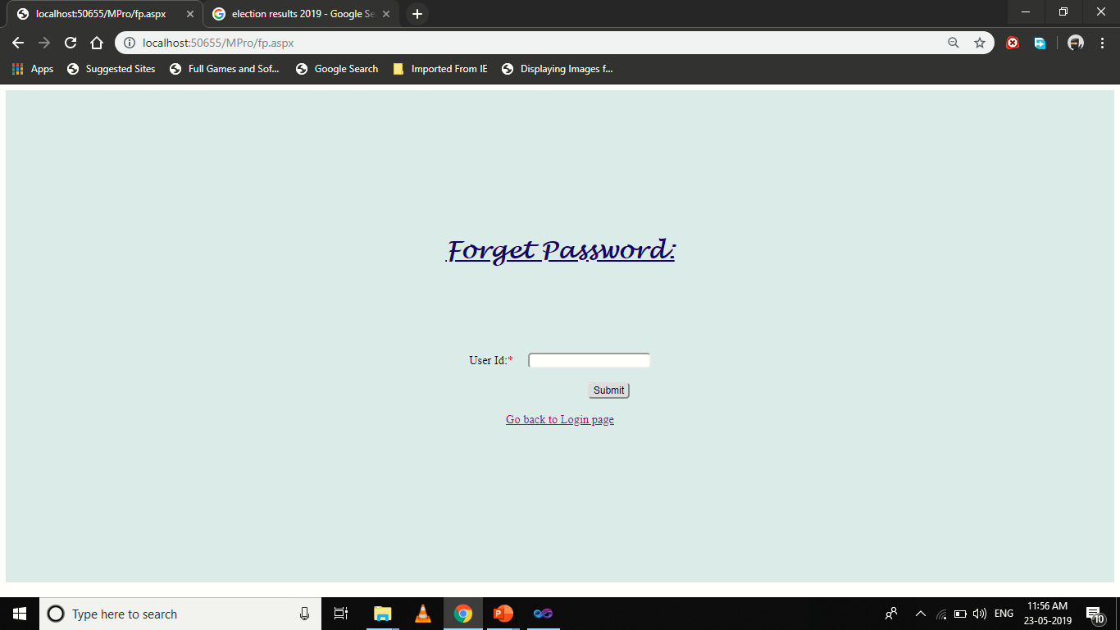

Design-

<%@ Page Language="C#" AutoEventWireup="true" CodeFile="fp.aspx.cs" Inherits="fp" %>

<!DOCTYPE html PUBLIC "-//W3C//DTD XHTML 1.0 Transitional//EN" "http://www.w3.org/TR/xhtml1/DTD/xhtml1-transitional.dtd">

<html xmlns="http://www.w3.org/1999/xhtml">

<head runat="server">

<title></title>

<style type="text/css">

.style1

{

text-decoration: underline;

color: #000066;

font-family: "Lucida Handwriting";

}

.style2

{

color: #CC0000;

}

</style>

</head>

<body>

<form id="form1" runat="server">

<div style="min-height: 71vh; padding-top:25vh;background: #e0ebe8;">

<center>

<h1 class="style1">

<strong>Forget Password:</strong></h1>

<br /><br /><br /><br />

<br />User Id:<span class="style2">*</span>&nbsp;&nbsp;&nbsp;&nbsp;

<asp:TextBox ID="TextBox1" runat="server" style="-webkit-border-radius:5px;"></asp:TextBox><br />

<asp:Label ID="Label1" runat="server"

style="color: #CC0000; background-color: #FFFF66"></asp:Label>

<br />

&nbsp;&nbsp;&nbsp;&nbsp;&nbsp;&nbsp;&nbsp;&nbsp;&nbsp;&nbsp;&nbsp;&nbsp;&nbsp;&nbsp;&nbsp;&nbsp;&nbsp;&nbsp;&nbsp;&nbsp;&nbsp;&nbsp;&nbsp;&nbsp;&nbsp;&nbsp;&nbsp;&nbsp;&nbsp;&nbsp;&nbsp;&nbsp;&nbsp;

<asp:Button ID="Button1" runat="server" Text="Submit"

style="-webkit-border-radius:5px;" onclick="Button1_Click"/>

<br />

<br />

<asp:HyperLink ID="HyperLink1" runat="server" NavigateUrl="~/login.aspx">Go back to Login page</asp:HyperLink></center>

</div>

</form>

</body>

</html>

Code Snippets-

using System;

using System.Collections.Generic;

using System.Linq;

using System.Web;

using System.Web.UI;

using System.Web.UI.WebControls;

using System.Net;

using System.Net.Mail;

using System.Data;

using System.Data.SqlClient;

public partial class fp : System.Web.UI.Page

{

SqlConnection cn = new SqlConnection("Data Source=DESKTOP-MP67RVV\\SQLEXPRESS;Initial Catalog=niraj;Integrated Security=True;Pooling=False");

SqlCommand cmd;

SqlDataReader dr;

protected void Page_Load(object sender, EventArgs e)

{

}

protected void Button1_Click(object sender, EventArgs e)

{

if (TextBox1.Text != "")

{

cn.Open();

cmd = new SqlCommand("select * from lustab where id='" + TextBox1.Text.Trim() + "'", cn);

dr = cmd.ExecuteReader();

if (dr.Read())

{

Response.Write(Request.QueryString["n"]);

MailMessage msg = new MailMessage("nkverma6644477725@gmail.com", TextBox1.Text.Trim());

msg.Subject = "Password Recovery";

msg.Body = string.Format("<h1>Hi, {0} {1}</h1><br/> Your Password is {2}",dr["fname"],dr["lname"],dr["pwd"]);

msg.IsBodyHtml = true;

SmtpClient smtp = new SmtpClient();

smtp.Host = "smtp.gmail.com";

smtp.EnableSsl = true;

NetworkCredential nc = new NetworkCredential();

nc.UserName = "comrenters@gmail.com";

nc.Password = "Rntc@123";

smtp.UseDefaultCredentials = true;

smtp.Credentials = nc;

smtp.Port = 587;

smtp.Send(msg);

Response.Write("<script>alert('Please check your Mail')</script>");

}

else

{

Label1.Text = "Incorrect User Id";

}

}

else

{

Label1.Text = "Enter the User id";

}

}

}

**Detail_Page and Payment_Page:**

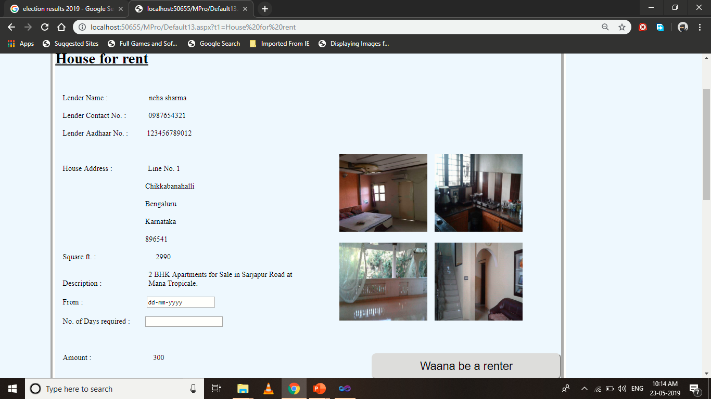

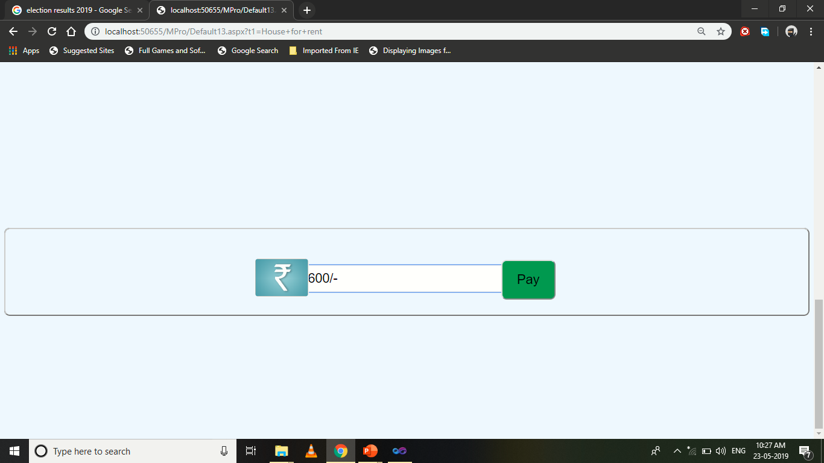

Design-

<%@ Page Language="C#" AutoEventWireup="true" CodeFile="Default13.aspx.cs" Inherits="Default13" %>

<!DOCTYPE html PUBLIC "-//W3C//DTD XHTML 1.0 Transitional//EN" "http://www.w3.org/TR/xhtml1/DTD/xhtml1-transitional.dtd">

<html xmlns="http://www.w3.org/1999/xhtml">

<head runat="server">

<title></title>

</head>

<body bgcolor="#F0F8FF">

<form id="form1" runat="server">

<div>

<asp:ImageButton ID="ImageButton4" runat="server" ImageUrl="~/logo.jpg"

ToolTip="Gallery" style="border-radius:50%; height:80px; width:80px;"

BorderColor="#000066" BorderStyle="Outset" BorderWidth="2px"

AlternateText="Gallery" onclick="ImageButton4_Click" /><br /><br />

&nbsp;&nbsp;&nbsp;&nbsp;&nbsp;&nbsp;&nbsp;&nbsp;&nbsp;&nbsp;&nbsp;&nbsp;&nbsp;&nbsp;&nbsp;&nbsp;&nbsp;&nbsp;&nbsp;&nbsp;&nbsp;&nbsp;&nbsp;&nbsp;&nbsp;

<asp:Label ID="Label22" runat="server" Text="" style="color: #FF0066"></asp:Label>

<asp:Panel ID="Panel1" runat="server" BorderColor="White" BorderStyle="Groove"

BorderWidth="10px" BackColor="AliceBlue"

style="position:relative; left:100px;width:1080px; top: 0px;-webkit-border-radius:10px;" >

<br />

<asp:Label ID="Label1" runat="server" Text="" Font-Bold="True" Font-Size="XX-Large"

style="text-decoration: underline"></asp:Label><br /><br /><br /><br />&nbsp;&nbsp;&nbsp;&nbsp;<asp:Label ID="Label13" runat="server" Text="Lender Name : "></asp:Label>&nbsp;&nbsp;&nbsp;&nbsp;&nbsp;&nbsp;&nbsp;&nbsp;&nbsp;&nbsp;&nbsp;&nbsp;&nbsp;&nbsp;&nbsp;&nbsp;&nbsp;&nbsp;&nbsp;&nbsp;

<asp:Label ID="Label2" runat="server" Text=""></asp:Label>

<br /><br />&nbsp;&nbsp;&nbsp;&nbsp;<asp:Label ID="Label14" runat="server" Text="Lender Contact No. : "></asp:Label>&nbsp;&nbsp;&nbsp;&nbsp;&nbsp;&nbsp;&nbsp;&nbsp;

&nbsp;&nbsp;<asp:Label ID="Label3" runat="server" Text=""></asp:Label>

<br /><br />&nbsp;&nbsp;&nbsp;&nbsp;<asp:Label ID="Label15" runat="server" Text="Lender Aadhaar No. : "></asp:Label>

&nbsp;&nbsp;&nbsp;&nbsp;

&nbsp;&nbsp;&nbsp;&nbsp;<asp:Label ID="Label4" runat="server" ></asp:Label>

<br />

<br />

&nbsp;&nbsp;&nbsp;

<asp:Label ID="Label23" runat="server" Text="Type :"></asp:Label>

&nbsp;&nbsp;&nbsp;&nbsp;&nbsp;&nbsp;&nbsp;&nbsp;&nbsp;&nbsp;&nbsp;&nbsp;&nbsp;&nbsp;&nbsp;&nbsp;&nbsp;&nbsp;&nbsp;&nbsp;&nbsp;&nbsp;&nbsp;&nbsp;&nbsp;&nbsp;&nbsp;&nbsp;&nbsp;&nbsp;&nbsp;&nbsp;&nbsp;

<asp:Label ID="Label24" runat="server"></asp:Label>

<br />

<br />

&nbsp;&nbsp;&nbsp;&nbsp;<asp:Label ID="Label16" runat="server" Text="House Address : "></asp:Label>

&nbsp;&nbsp;&nbsp;&nbsp; &nbsp;&nbsp;&nbsp;&nbsp;&nbsp;&nbsp;&nbsp;&nbsp; &nbsp;&nbsp;&nbsp;&nbsp;<asp:Label ID="Label5" runat="server"></asp:Label>

<br />

<br />

&nbsp;&nbsp;&nbsp;&nbsp; &nbsp;&nbsp;&nbsp;&nbsp;&nbsp;&nbsp;&nbsp;&nbsp;&nbsp;&nbsp;&nbsp;&nbsp;&nbsp;&nbsp;&nbsp;&nbsp; &nbsp;&nbsp;&nbsp;&nbsp;&nbsp;&nbsp;&nbsp;&nbsp;&nbsp;&nbsp;&nbsp;&nbsp;&nbsp;&nbsp;&nbsp;&nbsp; &nbsp;&nbsp;&nbsp;&nbsp; &nbsp;&nbsp;&nbsp;&nbsp;<asp:Label ID="Label8"

runat="server" Text=" "></asp:Label>

<br />

<br />

&nbsp;&nbsp;&nbsp;&nbsp; &nbsp;&nbsp;&nbsp;&nbsp;&nbsp;&nbsp;&nbsp;&nbsp;&nbsp;&nbsp;&nbsp;&nbsp;&nbsp;&nbsp;&nbsp;&nbsp; &nbsp;&nbsp;&nbsp;&nbsp;&nbsp;&nbsp;&nbsp;&nbsp;&nbsp;&nbsp;&nbsp;&nbsp;&nbsp;&nbsp;&nbsp;&nbsp; &nbsp;&nbsp;&nbsp;&nbsp; &nbsp;&nbsp;&nbsp;&nbsp;<asp:Label ID="Label9"

runat="server" Text=" "></asp:Label>

<br />

<br />

&nbsp;&nbsp;&nbsp;&nbsp; &nbsp;&nbsp;&nbsp;&nbsp;&nbsp;&nbsp;&nbsp;&nbsp;&nbsp;&nbsp;&nbsp;&nbsp;&nbsp;&nbsp;&nbsp;&nbsp; &nbsp;&nbsp;&nbsp;&nbsp;&nbsp;&nbsp;&nbsp;&nbsp;&nbsp;&nbsp;&nbsp;&nbsp;&nbsp;&nbsp;&nbsp;&nbsp; &nbsp;&nbsp;&nbsp;&nbsp; &nbsp;&nbsp;&nbsp;&nbsp;<asp:Label ID="Label10"

runat="server" Text=" "></asp:Label>

<br />

<br />

&nbsp;&nbsp;&nbsp;&nbsp;&nbsp;&nbsp;&nbsp;&nbsp; &nbsp;&nbsp;&nbsp;&nbsp;&nbsp;&nbsp;&nbsp;&nbsp;&nbsp;&nbsp;&nbsp;&nbsp; &nbsp;&nbsp;&nbsp;&nbsp;&nbsp;&nbsp;&nbsp;&nbsp;&nbsp;&nbsp;&nbsp;&nbsp;&nbsp;&nbsp;&nbsp;&nbsp; &nbsp;&nbsp;&nbsp;&nbsp; &nbsp;&nbsp;&nbsp;&nbsp;<asp:Label ID="Label11"

runat="server" Text=" "></asp:Label>

<br />

<br />

&nbsp;&nbsp;&nbsp;&nbsp;<asp:Label ID="Label19" runat="server" Text="Square ft. : "></asp:Label>

&nbsp;&nbsp;&nbsp;&nbsp;&nbsp;&nbsp;&nbsp;&nbsp;&nbsp;&nbsp;&nbsp;&nbsp;&nbsp;&nbsp;&nbsp;&nbsp;&nbsp;&nbsp;&nbsp;&nbsp;&nbsp;&nbsp;&nbsp;&nbsp;&nbsp;&nbsp;&nbsp;&nbsp;&nbsp;&nbsp;&nbsp;<asp:TextBox

ID="TextBox4" runat="server"

style="position: relative; top: 0px; left: -21px"></asp:TextBox><asp:Label ID="Label12" runat="server" Text=" "></asp:Label>

<br />

<br />

&nbsp;&nbsp;&nbsp;&nbsp;<asp:Label ID="Label17" runat="server" Text="Description : "></asp:Label>

&nbsp;&nbsp;&nbsp;&nbsp;&nbsp;&nbsp;&nbsp;&nbsp;&nbsp;&nbsp;&nbsp;&nbsp;&nbsp;&nbsp;&nbsp;&nbsp;&nbsp;&nbsp;&nbsp;&nbsp;&nbsp;&nbsp;&nbsp;&nbsp;<asp:Label

ID="Label6" runat="server" Width="314px"></asp:Label>

<br />

<br />

&nbsp;&nbsp;&nbsp;&nbsp;<asp:Label ID="Label20" runat="server" Text="From :"></asp:Label>

&nbsp;&nbsp;&nbsp;&nbsp;&nbsp;&nbsp;&nbsp;&nbsp;&nbsp;&nbsp;&nbsp;&nbsp;&nbsp;&nbsp;&nbsp;&nbsp;&nbsp;&nbsp;&nbsp;&nbsp;&nbsp;&nbsp;&nbsp;&nbsp;&nbsp;&nbsp;&nbsp;&nbsp;&nbsp;&nbsp;&nbsp;&nbsp;

<asp:TextBox ID="TextBox2" runat="server" TextMode="Date"></asp:TextBox>

<br />

<br />

&nbsp;&nbsp;&nbsp;&nbsp;<asp:Label ID="Label21" runat="server" Text="No. of Days required :"></asp:Label>

&nbsp;&nbsp;&nbsp;&nbsp;&nbsp;&nbsp;

<asp:TextBox ID="TextBox3" runat="server" TextMode="Number"></asp:TextBox>

<br />

<br />

<br />

<br />&nbsp;&nbsp;&nbsp;&nbsp;<asp:Label ID="Label18" runat="server" Text="Amount : "></asp:Label>

&nbsp;&nbsp;&nbsp;&nbsp;&nbsp;&nbsp;&nbsp;&nbsp;&nbsp;&nbsp;&nbsp;&nbsp;&nbsp;&nbsp;&nbsp;&nbsp;&nbsp;&nbsp;&nbsp;&nbsp;&nbsp;&nbsp;&nbsp;&nbsp;&nbsp;&nbsp;&nbsp;&nbsp;&nbsp;&nbsp;&nbsp;&nbsp;<asp:Label ID="Label7" runat="server" ></asp:Label>

<asp:Button ID="Button1" runat="server" Text="Waana be a renter"

style="float:right; font-size: x-large; margin-left: 15px;-webkit-border-radius:10px;" Height="56px"

Width="405px" onclick="Button1_Click"/>&nbsp;&nbsp;&nbsp; &nbsp;&nbsp;

<br />

<br /><br /><br />

</asp:Panel>

<asp:Panel ID="Panel4" runat="server"

style="position:relative;top:-550px; left:700px; width: 450px;">

<br />

<br />&nbsp; &nbsp;

<asp:Image ID="Image1" runat="server" Height="167px"

Width="188px" />

&nbsp; &nbsp;<asp:Image ID="Image2" runat="server" Height="167px"

Width="188px" /> &nbsp; &nbsp;

<br /><br /> &nbsp; &nbsp;

<asp:Image ID="Image3" runat="server" Height="167px"

Width="188px" />

&nbsp; &nbsp;<asp:Image ID="Image4" runat="server" Height="167px"

Width="188px" /> &nbsp; &nbsp;<br /><br />

</asp:Panel>

<br/>

<br /> <div style="-webkit-border-radius:10px; position:relative; top:180px; padding-bottom:40vh; min-height: 50vh; padding-top: 40vh;">

<center>

<asp:Panel ID="Panel2" runat="server"

style="-webkit-border-radius:10px;" BorderColor="#CCCCCC"

BorderStyle="Groove" BorderWidth="2px" DefaultButton="Button2">

<br /><br />

<asp:Image ID="Image5" runat="server" ImageUrl="~/RupeeSymbol.gif" width="100px"

style="-webkit-border-radius:10px;left: 6px; position: relative; top: 15px; z-index: 1;"

Height="73px"/>

<asp:TextBox ID="TextBox1" runat="server" Height="46px"

style="left: -2px;top:-12px; position: relative; width: 357px; font-size: x-large;"

ReadOnly="True"></asp:TextBox>

<asp:Button ID="Button2" runat="server" Text="Pay" BackColor="#009933"

style="-webkit-border-radius:10px; left: -9px; position: relative; font-size: x-large; top: -10px;" Height="73px"

Width="100px" onclick="Button2_Click" />

<br /><br />

</asp:Panel></center><br /><br /><br /><br /><br /><br /><br /><br /><br /><br /><br /><br />

<asp:Panel ID="Panel3" runat="server">

</asp:Panel>

</div>

</div>

<br/>

<br />

</form>

</body>

</html>

Code Snippets-

using System;

using System.Collections.Generic;

using System.Linq;

using System.Web;

using System.Web.UI;

using System.Web.UI.WebControls;

using System.Data.Sql;

using System.Data.SqlClient;

public partial class Default13 : System.Web.UI.Page

{

String lid,ladd,rn,rmno,rano,radd,nor;

int c;

SqlConnection cn= new SqlConnection("Data Source=DESKTOP-MP67RVV\\SQLEXPRESS;Initial Catalog=niraj;Integrated Security=True;Pooling=False");

protected void Page_Load(object sender, EventArgs e)

{

if (String.Compare(Session["n"].ToString(),"House")==0)

{

Label23.Visible = false;

Label24.Visible = false;

TextBox4.Visible = false;

cn.Open();

SqlCommand cmd = new SqlCommand("SELECT house.title,house.id,lustab.id, house.area, house.des, house.amt, house.img1, house.img2, house.img3, house.img4, house.a1, house.a2, house.a3, house.a4, house.a5, lustab.fname, lustab.lname, lustab.mno, lustab.ano FROM house INNER JOIN lustab ON lustab.id = house.id where house.title='" + Request.QueryString["t1"] + "'", cn);

SqlDataReader dr = cmd.ExecuteReader();

dr.Read();

lid = dr["id"].ToString();

Label1.Text = dr["title"].ToString();

Image1.ImageUrl=dr["img1"].ToString();

Image2.ImageUrl = dr["img2"].ToString();

Image3.ImageUrl = dr["img3"].ToString();

Image4.ImageUrl = dr["img4"].ToString();

Label2.Text = dr["fname"].ToString() + " " + dr["lname"].ToString();

Label3.Text = dr["mno"].ToString();

Label4.Text = dr["ano"].ToString();

Label5.Text = dr["a1"].ToString();

Label8.Text = dr["a2"].ToString();

Label9.Text = dr["a3"].ToString();

Label10.Text = dr["a4"].ToString(); Label11.Text = dr["a5"].ToString();

Label12.Text = dr["area"].ToString();

Label6.Text = dr["des"].ToString();

Label7.Text = dr["amt"].ToString();

radd = dr["a1"].ToString() + ", " + dr["a2"].ToString() + ", " + dr["a3"].ToString() + ", " + dr["a4"].ToString() + ", " + dr["a5"].ToString();

cn.Close();

}

else if (String.Compare(Session["n"].ToString(), "Room") == 0)

{

Label19.Text = "Number of Rooms :";

Label12.Visible = false;

cn.Open();

SqlCommand cmd = new SqlCommand("SELECT house.title,house.id,lustab.id, house.nor,house.type, house.des, house.amt, house.img1, house.img2, house.img3, house.img4, house.a1, house.a2, house.a3, house.a4, house.a5, lustab.fname, lustab.lname, lustab.mno, lustab.ano FROM room house INNER JOIN lustab ON lustab.id = house.id where house.title='" + Request.QueryString["t1"] + "'", cn);

SqlDataReader dr = cmd.ExecuteReader();

dr.Read();

lid = dr["id"].ToString();

Image1.ImageUrl = dr["img1"].ToString();

Image2.ImageUrl = dr["img2"].ToString();

Image3.ImageUrl = dr["img3"].ToString();

Image4.ImageUrl = dr["img4"].ToString();

Label1.Text = dr["title"].ToString();

Label24.Text = dr["type"].ToString();

Label2.Text = dr["fname"].ToString() + " " + dr["lname"].ToString();

Label3.Text = dr["mno"].ToString();

Label4.Text = dr["ano"].ToString();

Label5.Text = dr["a1"].ToString();

Label8.Text = dr["a2"].ToString();

Label9.Text = dr["a3"].ToString();

Label10.Text = dr["a4"].ToString(); Label11.Text = dr["a5"].ToString();

nor = dr["nor"].ToString();

Label6.Text = dr["des"].ToString();

Label7.Text = dr["amt"].ToString();

radd = dr["a1"].ToString() + ", " + dr["a2"].ToString() + ", " + dr["a3"].ToString() + ", " + dr["a4"].ToString() + ", " + dr["a5"].ToString();

cn.Close();

}

else if (String.Compare(Session["n"].ToString(), "Hall") == 0)

{

TextBox4.Visible = false;

cn.Open();

SqlCommand cmd = new SqlCommand("SELECT house.title,house.area,house.id,lustab.id, house.type, house.des, house.amt, house.img1, house.img2, house.img3, house.img4, house.a1, house.a2, house.a3, house.a4, house.a5, lustab.fname, lustab.lname, lustab.mno, lustab.ano FROM hall house INNER JOIN lustab ON lustab.id = house.id where house.title='" + Request.QueryString["t1"] + "'", cn);

SqlDataReader dr = cmd.ExecuteReader();

dr.Read();

lid = dr["id"].ToString();

Image1.ImageUrl = dr["img1"].ToString();

Image2.ImageUrl = dr["img2"].ToString();

Image3.ImageUrl = dr["img3"].ToString();

Image4.ImageUrl = dr["img4"].ToString();

Label1.Text = dr["title"].ToString();

Label24.Text = dr["type"].ToString();

Label2.Text = dr["fname"].ToString() + " " + dr["lname"].ToString();

Label3.Text = dr["mno"].ToString();

Label4.Text = dr["ano"].ToString();

Label5.Text = dr["a1"].ToString();

Label8.Text = dr["a2"].ToString();

Label9.Text = dr["a3"].ToString();

Label10.Text = dr["a4"].ToString();

Label11.Text = dr["a5"].ToString();

Label12.Text = dr["area"].ToString();

Label6.Text = dr["des"].ToString();

Label7.Text = dr["amt"].ToString();

radd = dr["a1"].ToString() + ", " + dr["a2"].ToString() + ", " + dr["a3"].ToString() + ", " + dr["a4"].ToString() + ", " + dr["a5"].ToString();

cn.Close();

}

else if (String.Compare(Session["n"].ToString(), "Ground") == 0)

{

Label23.Visible = false;

Label24.Visible = false;

TextBox4.Visible = false;

cn.Open();

SqlCommand cmd = new SqlCommand("SELECT house.title,house.area,house.id,lustab.id, house.des, house.amt, house.img1, house.img2, house.img3, house.img4, house.a1, house.a2, house.a3, house.a4, house.a5, lustab.fname, lustab.lname, lustab.mno, lustab.ano FROM ground house INNER JOIN lustab ON lustab.id = house.id where house.title='" + Request.QueryString["t1"] + "'", cn);

SqlDataReader dr = cmd.ExecuteReader();

dr.Read();

lid = dr["id"].ToString();

Image1.ImageUrl = dr["img1"].ToString();

Image2.ImageUrl = dr["img2"].ToString();

Image3.ImageUrl = dr["img3"].ToString();

Image4.ImageUrl = dr["img4"].ToString();

Label1.Text = dr["title"].ToString();

Label2.Text = dr["fname"].ToString() + " " + dr["lname"].ToString();

Label3.Text = dr["mno"].ToString();

Label4.Text = dr["ano"].ToString();

Label5.Text = dr["a1"].ToString();

Label8.Text = dr["a2"].ToString();

Label9.Text = dr["a3"].ToString();

Label10.Text = dr["a4"].ToString();

Label11.Text = dr["a5"].ToString();

Label12.Text = dr["area"].ToString();

Label6.Text = dr["des"].ToString();

Label7.Text = dr["amt"].ToString();

radd = dr["a1"].ToString() + ", " + dr["a2"].ToString() + ", " + dr["a3"].ToString() + ", " + dr["a4"].ToString() + ", " + dr["a5"].ToString();

cn.Close();

}

}

protected void ImageButton4_Click(object sender, ImageClickEventArgs e)

{

Response.Redirect("menubar.aspx");

}

protected void Button2_Click(object sender, EventArgs e)

{

cn.Open();

SqlCommand cmd = new SqlCommand("Select * from book", cn);

SqlDataReader dr = cmd.ExecuteReader();

if (dr.Read())

{

while (dr.Read())

{

c = Convert.ToInt32(dr["sno"]);

}

c++;

}

else

{

c = 1;

}

cn.Close();

cn.Open();

cmd = new SqlCommand("select * from lustab where id='" + Session["s"] + "'", cn);

dr=cmd.ExecuteReader();

dr.Read();

rn = dr["fname"].ToString() + " " + dr["lname"].ToString();

rmno = dr["mno"].ToString();

rano = dr["ano"].ToString();

ladd = dr["a1"].ToString() + ", " + dr["a2"].ToString() + ", " + dr["a3"].ToString() + ", " + dr["a4"].ToString() + ", " + dr["a5"].ToString();

cn.Close();

cn.Open();

cmd = new SqlCommand("Insert into book values('" + c + "','" + lid + "','" + Label2.Text + "','" + Label3.Text + "','" + Label4.Text + "','" + Label1.Text + "','" + radd + "','" + Label12.Text + "','" + Label6.Text + "','" + System.DateTime.Now.ToString("MM/dd/yyyy") + "','" + TextBox2.Text + "','" + TextBox3.Text + "','" + TextBox1.Text + "','" + Session["s"].ToString() + "','" + rn + "','" + rmno + "','" + rano + "','" + ladd + "')", cn);

cmd.ExecuteNonQuery();

cn.Close(); cn.Open();

if (String.Compare(Session["n"].ToString(), "House") == 0)

cmd = new SqlCommand("delete from house where title='" + Request.QueryString["t1"] + "'",cn);

else if (String.Compare(Session["n"].ToString(), "Room") == 0)

cmd = new SqlCommand("delete from room where title='" + Request.QueryString["t1"] + "'", cn);

else if (String.Compare(Session["n"].ToString(), "Hall") == 0)

cmd = new SqlCommand("delete from hall where title='" + Request.QueryString["t1"] + "'", cn);

else

cmd = new SqlCommand("delete from ground where title='" + Request.QueryString["t1"] + "'", cn);

cmd.ExecuteNonQuery();

cn.Close();

Response.Redirect("Default3.aspx?t=" + c);

}

protected void Button1_Click(object sender, EventArgs e)

{

if (TextBox1.Text == "" && TextBox2.Text == "" )

{

Label22.Text = "*Please insert all data properly";

}

else

{

if (Session["n"] == "Room")

{

if (TextBox4.Text == "")

Label22.Text = "*Please insert all data properly";

else

{

Label22.Text = " ";

TextBox1.Text = (Convert.ToInt32(TextBox3.Text) * Convert.ToInt32(Label7.Text) * Convert.ToInt32(TextBox4.Text)).ToString() + "/-";

Page.SetFocus(Panel2.ClientID);

}

}

else

{

Label22.Text = " ";

TextBox1.Text = (Convert.ToInt32(TextBox3.Text) * Convert.ToInt32(Label7.Text)).ToString() + "/-";

Page.SetFocus(Panel2.ClientID);

}

}

}

}

**Billing_Page:**

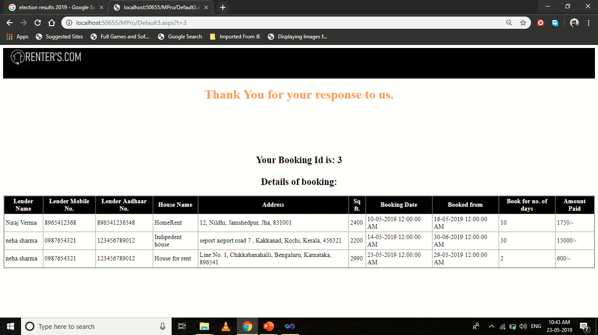

Design-

<%@ Page Language="C#" AutoEventWireup="true" CodeFile="Default3.aspx.cs" Inherits="Default3" %>

<!DOCTYPE html PUBLIC "-//W3C//DTD XHTML 1.0 Transitional//EN" "http://www.w3.org/TR/xhtml1/DTD/xhtml1-transitional.dtd">

<html xmlns="http://www.w3.org/1999/xhtml">

<head runat="server">

<title></title>

<style type="text/css">

.style1

{

color: #FF9966;

}

</style>

</head>

<body>

<form id="form1" runat="server">

<div>

<div style="background-color: Black; height: 78px; z-index: -2;">

<asp:Image ID="Image1" runat="server" ImageUrl="~/l.png" Height="50px" Width="250px" /></div>

<center><h1 class="style1">Thank You for your response to us.</h1><br /><br /><br /><br />

<br /><h2><b>Your Booking Id is: </b>

<asp:Label ID="Label1" runat="server" Text="Label"></asp:Label><br />

<br /> Details of booking:</h2>

<asp:GridView ID="GridView1" runat="server" AutoGenerateColumns="False"

BackColor="#CCCCCC" BorderColor="#999999" BorderStyle="Solid" BorderWidth="3px"

CellPadding="4" CellSpacing="2" DataSourceID="SqlDataSource1" ForeColor="Black">

<Columns>

<asp:BoundField DataField="lname" HeaderText="Lender Name"

SortExpression="lname" />

<asp:BoundField DataField="lmno" HeaderText="Lender Mobile No."

SortExpression="lmno" />

<asp:BoundField DataField="lano" HeaderText="Lender Aadhaar No."

SortExpression="lano" />

<asp:BoundField DataField="title" HeaderText="House Name"

SortExpression="title" />

<asp:BoundField DataField="ha1" HeaderText="Address" SortExpression="ha1" />

<asp:BoundField DataField="area" HeaderText="Sq ft." SortExpression="area" />

<asp:BoundField DataField="bd" HeaderText="Booking Date" SortExpression="bd" />

<asp:BoundField DataField="fd" HeaderText="Booked from" />

<asp:BoundField DataField="nod" HeaderText="Book for no. of days" />

<asp:BoundField DataField="amt" HeaderText="Amount Paid" />

</Columns>

<FooterStyle BackColor="#CCCCCC" />

<HeaderStyle BackColor="Black" Font-Bold="True" ForeColor="White" />

<PagerStyle BackColor="#CCCCCC" ForeColor="Black" HorizontalAlign="Left" />

<RowStyle BackColor="White" />

<SelectedRowStyle BackColor="#000099" Font-Bold="True" ForeColor="White" />

<SortedAscendingCellStyle BackColor="#F1F1F1" />

<SortedAscendingHeaderStyle BackColor="#808080" />

<SortedDescendingCellStyle BackColor="#CAC9C9" />

<SortedDescendingHeaderStyle BackColor="#383838" />

</asp:GridView>

<asp:SqlDataSource ID="SqlDataSource1" runat="server"

ConnectionString="<%$ ConnectionStrings:nirajConnectionString %>"

SelectCommand="SELECT [lname], [lmno], [lano], [title], [ha1], [area], [bd], [fd], [nod], [amt] FROM [book] WHERE ([sno] = @sno)">

<SelectParameters>

<asp:QueryStringParameter Name="sno" QueryStringField="t" Type="String" />

</SelectParameters>

</asp:SqlDataSource>

<br />

<br />

<asp:HyperLink ID="HyperLink1" runat="server" NavigateUrl="~/menubar.aspx">Continue back to website</asp:HyperLink>

</center>

</div>

</form>

</body>

</html>

Code Snippets-

using System;

using System.Collections.Generic;

using System.Linq;

using System.Web;

using System.Web.UI;

using System.Web.UI.WebControls;

using System.Data;

using System.Net;

using System.Net.Mail;

using System.Data.SqlClient;

public partial class Default3 : System.Web.UI.Page

{

SqlConnection cn = new SqlConnection("Data Source=DESKTOP-MP67RVV\\SQLEXPRESS;Initial Catalog=niraj;Integrated Security=True;Pooling=False");

SqlCommand cmd;

SqlDataReader dr;

protected void Page_Load(object sender, EventArgs e)

{

Label1.Text = Request.QueryString["t"];

cn.Open();

cmd = new SqlCommand("Select * from book where sno='" + Label1.Text + "'", cn);

dr = cmd.ExecuteReader();

MailMessage msg = new MailMessage("comrenters@gmail.com", dr["lid"].ToString());

msg.Subject = "Booking";

msg.Body = string.Format("<center><h1>RENTER'S.COM</h1><br/><h2>Hi, {0} </h2><br/>A booking is made at your property <br/><h2>Details:<br/></h2> Name of property: {1}<br/> Renter Name:{2}<br/>Contact No.:{3}<br/>Aadhaar No.:{4}", dr["lname"].ToString(), dr["title"].ToString(), dr["rname"].ToString(), dr["rmno"].ToString(), dr["rano"].ToString());

msg.IsBodyHtml = true;

SmtpClient smtp = new SmtpClient();

smtp.Host = "smtp.gmail.com";

smtp.EnableSsl = true;

NetworkCredential nc = new NetworkCredential();

nc.UserName = "comrenters@gmail.com";

nc.Password = "Rntc@123";

smtp.UseDefaultCredentials = true;

smtp.Credentials = nc;

smtp.Port = 587;

smtp.Send(msg);

msg = new MailMessage("comrenters@gmail.com", dr["rid"].ToString());

msg.Subject = "Thank You For Joining Us";

msg.Body = string.Format("<center><h1>RENTER'S.COM</h1><br/><h2>Hi, {0} <br/> Thanku for your response <br/> Booking Details:</h2><br/>Property Name: {1}<br/>Lender Name: {2} Contact No.: {3}", dr["rname"].ToString(), dr["title"].ToString(),dr["lname"].ToString(),dr["lmno"].ToString());

msg.IsBodyHtml = true;

smtp = new SmtpClient();

smtp.Host = "smtp.gmail.com";

smtp.EnableSsl = true;

nc = new NetworkCredential();

nc.UserName = "comrenters@gmail.com";

nc.Password = "Rntc@123";

smtp.UseDefaultCredentials = true;

smtp.Credentials = nc;

smtp.Port = 587;

smtp.Send(msg);

}

}

**Lender_Page:**

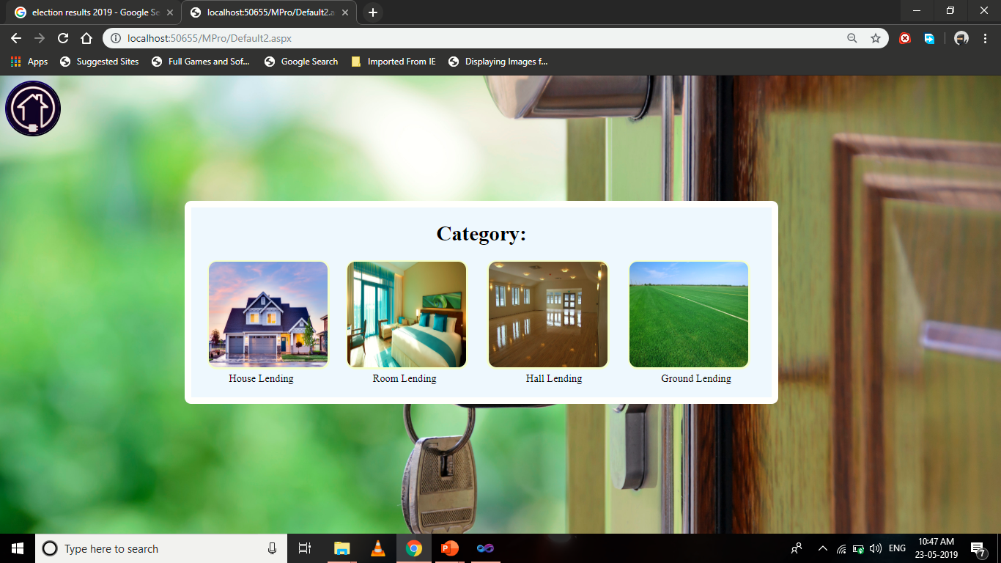

Design-

<%@ Page Language="C#" AutoEventWireup="true" CodeFile="Default2.aspx.cs" Inherits="Default2" %>

<!DOCTYPE html PUBLIC "-//W3C//DTD XHTML 1.0 Transitional//EN" "http://www.w3.org/TR/xhtml1/DTD/xhtml1-transitional.dtd">

<html xmlns="http://www.w3.org/1999/xhtml">

<head runat="server">

<title></title>

</head>

<body background="close-up-door-focus-101808.jpg" style="Background-size:cover;">

<form id="form1" runat="server">

<asp:ImageButton ID="ImageButton5" runat="server" ImageUrl="~/logo.jpg"

ToolTip="Gallery" style="border-radius:50%; height:80px; width:80px;"

BorderColor="#000066" BorderStyle="Outset" BorderWidth="2px"

AlternateText="Gallery" onclick="ImageButton4_Click" />

<div align="center">

<asp:Panel ID="Panel1" runat="server" BorderColor="White" BorderStyle="Solid"

BorderWidth="10px"

style="position:absolute; -webkit-border-radius:10px;top:190px;left:280px;"

BackColor="AliceBlue">

<center><h1>Category:</h1></center>

&nbsp;&nbsp;&nbsp;&nbsp;&nbsp;&nbsp;<asp:ImageButton ID="ImageButton1"

runat="server" BorderColor="#FFFFCC"

BorderStyle="Solid" BorderWidth="3px"

ImageUrl="~/architecture-beautiful-exterior-106399.jpg"

style=" height:160px; width:180px; -webkit-border-radius:15px;"

onclick="ImageButton1_Click" />

&nbsp;&nbsp;&nbsp;&nbsp;

<asp:ImageButton ID="ImageButton2" runat="server" BorderColor="#FFFFCC"

BorderStyle="Solid" BorderWidth="3px"

ImageUrl="~/luxury-room-sofitel-the-palm-dubai-1200x675.jpg"

style=" height:160px; width:180px; -webkit-border-radius:15px;"

onclick="ImageButton2_Click" />

&nbsp;&nbsp;&nbsp;&nbsp;&nbsp;

<asp:ImageButton ID="ImageButton3" runat="server" BorderColor="#FFFFCC"

BorderStyle="Solid" BorderWidth="3px"

ImageUrl="~/Interior2015-01-2610.31.11.jpg"

style=" height:160px; width:180px; -webkit-border-radius:15px;"

onclick="ImageButton3_Click" />

&nbsp;&nbsp;&nbsp;&nbsp;&nbsp;

<asp:ImageButton ID="ImageButton4" runat="server" BorderColor="#FFFFCC"

BorderStyle="Solid" BorderWidth="3px" ImageUrl="~/farmfield.jpg"

style=" height:160px; width:180px; -webkit-border-radius:15px;"

onclick="ImageButton4_Click1" />

&nbsp;&nbsp;&nbsp;&nbsp;&nbsp;&nbsp;

<br />

House Lending&nbsp;&nbsp;&nbsp;&nbsp;&nbsp;&nbsp;&nbsp;&nbsp;&nbsp;&nbsp;&nbsp;&nbsp;&nbsp;&nbsp;&nbsp;&nbsp;&nbsp; &nbsp;&nbsp;&nbsp;&nbsp;&nbsp;&nbsp;&nbsp;&nbsp;&nbsp;&nbsp; &nbsp;Room Lending&nbsp;&nbsp;&nbsp;&nbsp;&nbsp;&nbsp;&nbsp;&nbsp;&nbsp;&nbsp;&nbsp;&nbsp;&nbsp;&nbsp;&nbsp;&nbsp;&nbsp;&nbsp;&nbsp;

&nbsp;&nbsp;&nbsp;&nbsp;&nbsp;&nbsp;&nbsp;&nbsp;&nbsp;&nbsp;&nbsp;&nbsp;&nbsp; Hall Lending&nbsp;&nbsp;&nbsp;&nbsp;&nbsp;&nbsp;&nbsp;&nbsp;&nbsp;&nbsp;&nbsp;&nbsp;&nbsp;&nbsp;&nbsp;&nbsp;&nbsp;&nbsp;&nbsp;&nbsp; &nbsp;&nbsp;&nbsp;&nbsp;&nbsp;&nbsp;&nbsp;&nbsp; Ground Lending

<br />

<br />

</asp:Panel>

</div>

</form>

</body>

</html>

Code Snippets-

using System;

using System.Collections.Generic;

using System.Linq;

using System.Web;

using System.Web.UI;

using System.Web.UI.WebControls;

public partial class Default2 : System.Web.UI.Page

{

protected void Page_Load(object sender, EventArgs e)

{

}

protected void ImageButton4_Click(object sender, ImageClickEventArgs e)

{

Response.Redirect("menubar.aspx");

}

protected void ImageButton1_Click(object sender, ImageClickEventArgs e)

{

Response.Redirect("Default4.aspx");

}

protected void ImageButton2_Click(object sender, ImageClickEventArgs e)

{

Response.Redirect("Default6.aspx");

}

protected void ImageButton3_Click(object sender, ImageClickEventArgs e)

{

Response.Redirect("Default8.aspx");

}

protected void ImageButton4_Click1(object sender, ImageClickEventArgs e)

{

Response.Redirect("Default10.aspx");

}

}

**House_Lending:**

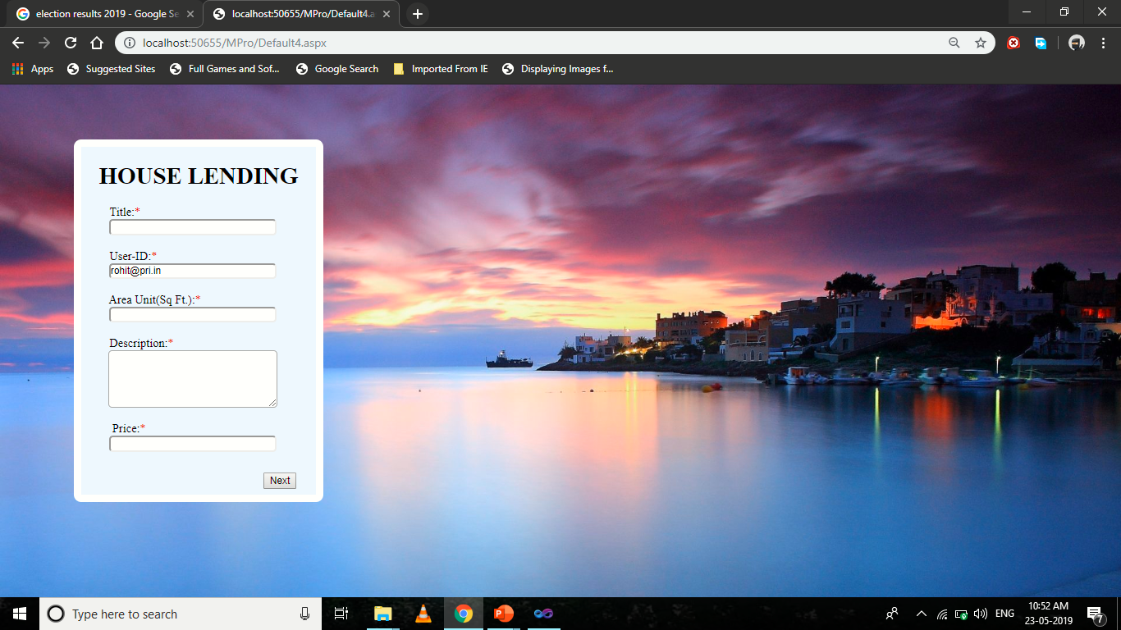

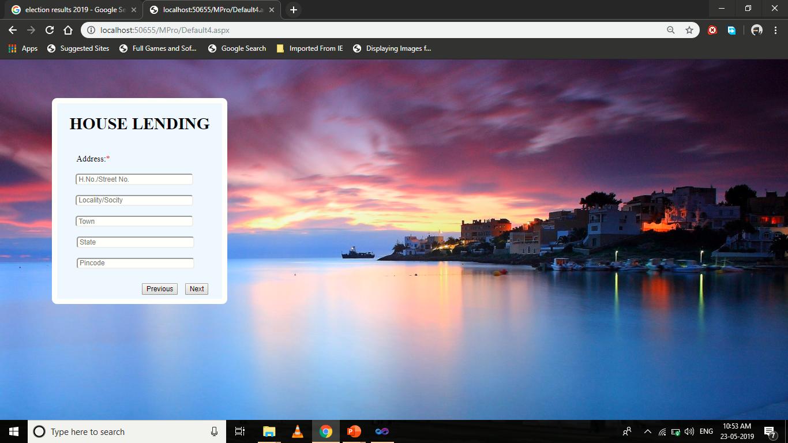

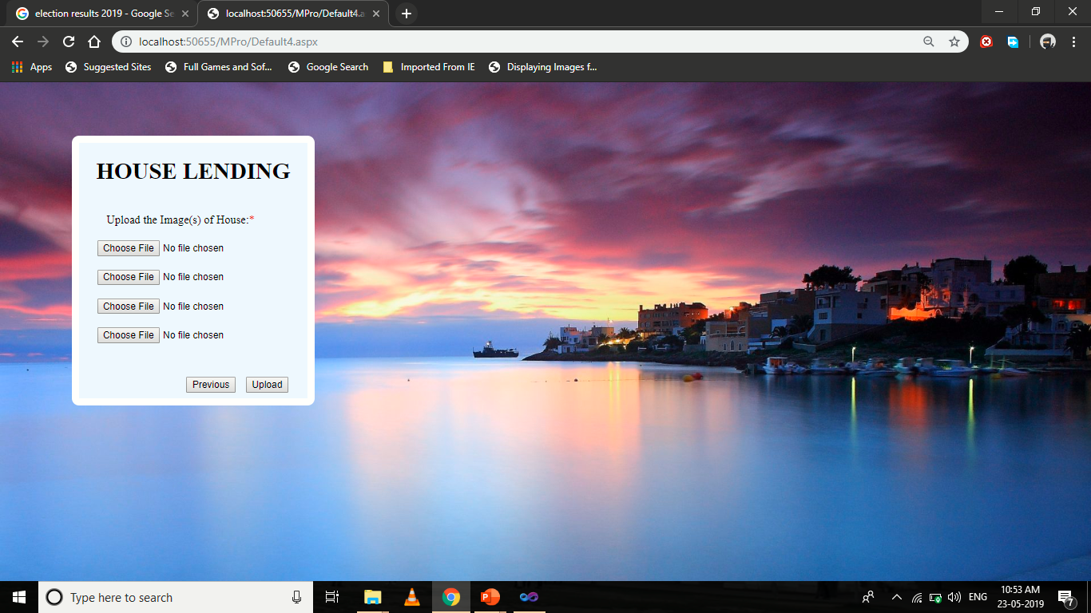

Design-

<%@ Page Language="C#" AutoEventWireup="true" CodeFile="Default4.aspx.cs" Inherits="Default4" %>

<!DOCTYPE html PUBLIC "-//W3C//DTD XHTML 1.0 Transitional//EN" "http://www.w3.org/TR/xhtml1/DTD/xhtml1-transitional.dtd">

<html xmlns="http://www.w3.org/1999/xhtml">

<head runat="server">

<title></title>

<style type="text/css">

.style1

{

color: #CC0000;

}

</style>

</head>

<body style="background-size:cover;" background="sky-boat-beach-sea-sunrise-lights-town-purple-blue-architecture-view-boats-trees-sunset-beautiful-ocean-sand-nature-colorful-house-colors-houses-peaceful-night-wallpaper-4k-1920x1080.jpg">

<form id="form1" runat="server">

<div>

<asp:Panel ID="Panel1" runat="server" BorderColor="White" BorderStyle="Solid"

BorderWidth="10px"

style="position:absolute; -webkit-border-radius:10px;top:74px; left:100px;"

BackColor="AliceBlue">

<center><h1>&nbsp;&nbsp; HOUSE LENDING&nbsp; &nbsp; </h1></center>

<asp:Wizard ID="Wizard1" runat="server" ActiveStepIndex="0" Width="301px"

FinishCompleteButtonText="Upload"

onfinishbuttonclick="Wizard1_FinishButtonClick" >

<WizardSteps>

<asp:WizardStep ID="WizardStep1" runat="server" Title=" " StepType="Start">

&nbsp;&nbsp;&nbsp;&nbsp;&nbsp;&nbsp;&nbsp;&nbsp; Title:<span class="style1">*</span><br /><center>

<asp:TextBox ID="TextBox1" runat="server" Width="223px" style="-webkit-border-radius:5px;"

></asp:TextBox></center><br />

&nbsp;&nbsp;&nbsp;&nbsp;&nbsp;&nbsp;&nbsp; &nbsp;User-ID:<span class="style1">*</span><br /><center>

<asp:TextBox ID="TextBox2" runat="server" Width="223px" style="-webkit-border-radius:5px;" ReadOnly="True"></asp:TextBox></center><br />

&nbsp;&nbsp;&nbsp;&nbsp;&nbsp;&nbsp;&nbsp;&nbsp;&nbsp;Area Unit(Sq Ft.):<span class="style1">*</span><br /><center>

<asp:TextBox ID="TextBox5" runat="server" Width="223px" style="-webkit-border-radius:5px;"></asp:TextBox><br /><br />

</center>

&nbsp;&nbsp;&nbsp;&nbsp;&nbsp;&nbsp;&nbsp; &nbsp;Description:<span class="style1">*</span><br /><center>

<asp:TextBox ID="TextBox3" runat="server" TextMode="MultiLine" style="-webkit-border-radius:5px;" Height="72px"

Width="223px"></asp:TextBox></center> <br />

&nbsp;&nbsp;&nbsp;&nbsp;&nbsp;&nbsp;&nbsp; &nbsp; Price:<span class="style1">*</span><br /><center>

<asp:TextBox ID="TextBox4" runat="server" Width="223px" placeholder="Enter charges as per day" style="-webkit-border-radius:5px;"></asp:TextBox></center><br />

</asp:WizardStep>

<asp:WizardStep ID="WizardStep2" runat="server" Title=" ">

<br />

&nbsp;&nbsp;&nbsp;&nbsp;&nbsp;&nbsp;&nbsp; &nbsp;Address:<span class="style1">*</span><br /><br />

<center>

<asp:TextBox ID="TextBox16" runat="server" Placeholder=" H.No./Street No." style="-webkit-border-radius:5px;" Width="223px"></asp:TextBox>

<br/>

<br/>

<asp:TextBox ID="TextBox17" runat="server" Width="223px" Placeholder=" Locality/Socity" style="-webkit-border-radius:5px;"></asp:TextBox>

<br/>

<br/>

<asp:TextBox ID="TextBox18" runat="server" Width="223px" Placeholder=" Town" style="-webkit-border-radius:5px;"></asp:TextBox>

<br/><br/> <asp:TextBox

ID="TextBox19" runat="server" Width="223px" Placeholder=" State" style="-webkit-border-radius:5px;"></asp:TextBox><br /><br /> <asp:TextBox

ID="TextBox20" runat="server" Width="223px" Placeholder=" Pincode" style="-webkit-border-radius:5px;"></asp:TextBox><br/>

<br /></center>

</asp:WizardStep>

<asp:WizardStep ID="WizardStep3" runat="server" Title=" ">

<br />&nbsp;&nbsp;&nbsp;&nbsp;&nbsp;&nbsp;&nbsp; &nbsp;Upload the Image(s) of House:<span class="style1">*</span><br /><br />

<center> <asp:FileUpload ID="FileUpload1" runat="server" /><br /><br />

<asp:FileUpload ID="FileUpload2" runat="server" /><br /><br />

<asp:FileUpload ID="FileUpload3" runat="server" /><br /><br />

<asp:FileUpload ID="FileUpload4" runat="server" /><br /><br />

<asp:Label ID="Label1" runat="server" Text=""></asp:Label>

<br /></center>

</asp:WizardStep>

</WizardSteps>

</asp:Wizard>

</asp:Panel>

</div>

</form>

</body>

</html>

Code Snippets-

using System;

using System.Collections.Generic;

using System.Linq;

using System.Web;

using System.Web.UI;

using System.Web.UI.WebControls;

using System.Data;

using System.Data.SqlClient;

public partial class Default4 : System.Web.UI.Page

{

SqlConnection cn = new SqlConnection("Data Source=DESKTOP-MP67RVV\\SQLEXPRESS;Initial Catalog=niraj;Integrated Security=True;Pooling=False");

SqlCommand cmd;

protected void Page_Load(object sender, EventArgs e)

{

TextBox2.Text = Session["s"].ToString();

}

protected void Wizard1_FinishButtonClick(object sender, WizardNavigationEventArgs e)

{

if (TextBox1.Text == "" || TextBox2.Text == "" || TextBox3.Text == "" || TextBox4.Text == "" || !FileUpload1.HasFile || !FileUpload2.HasFile || !FileUpload3.HasFile || !FileUpload4.HasFile || TextBox16.Text == "" || TextBox17.Text == "" || TextBox18.Text == "" || TextBox19.Text == "" || TextBox20.Text == "")

{

Label1.Text = "Please innput all the data";

}

else

{

String pic1,pic2,pic3,pic4;

cn.Open();

pic1 = "~/post/" + FileUpload1.FileName;

FileUpload1.SaveAs(MapPath(pic1));

pic2 = "~/post/" + FileUpload2.FileName;

FileUpload2.SaveAs(MapPath(pic2));

pic3 = "~/post/" + FileUpload3.FileName;

FileUpload3.SaveAs(MapPath(pic3));

pic4 = "~/post/" + FileUpload4.FileName;

FileUpload4.SaveAs(MapPath(pic4));

cmd = new SqlCommand("Insert into house values('" + TextBox1.Text + "','" + TextBox2.Text + "','" + TextBox5.Text + "','" + TextBox3.Text + "','" + TextBox4.Text + "','" + pic1 + "','" + pic2 + "','" + pic3 + "','" + pic4 + "','" + TextBox16.Text + "','" + TextBox17.Text + "','" + TextBox18.Text + "','" + TextBox19.Text + "','" + TextBox20.Text + "')", cn);

cmd.ExecuteNonQuery();

cn.Close();

Response.Write("<Script>alert('Thank you for joing us')</Script>");

Response.Write("<Script>location.href = 'menubar.aspx';</Script>");

}

}

}

**Room_Lending:**

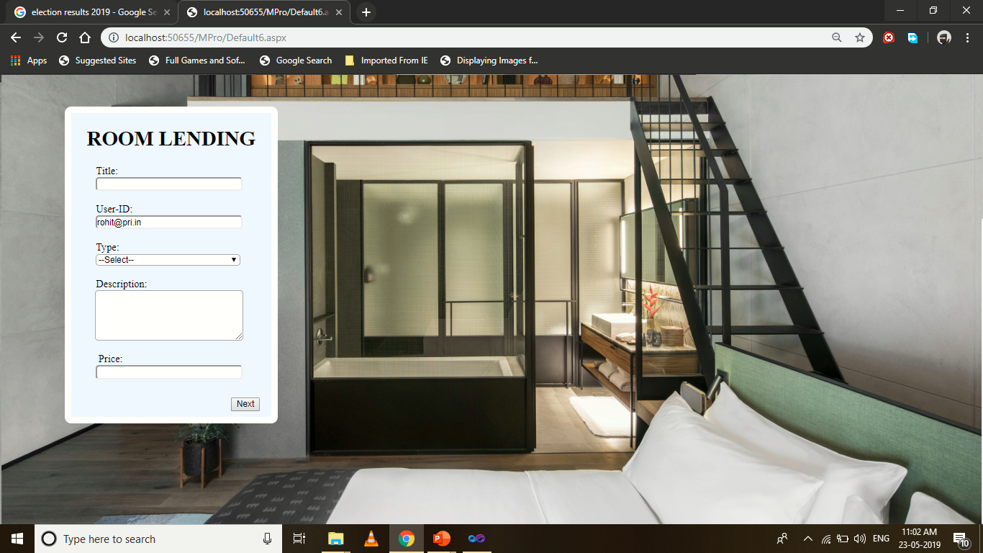

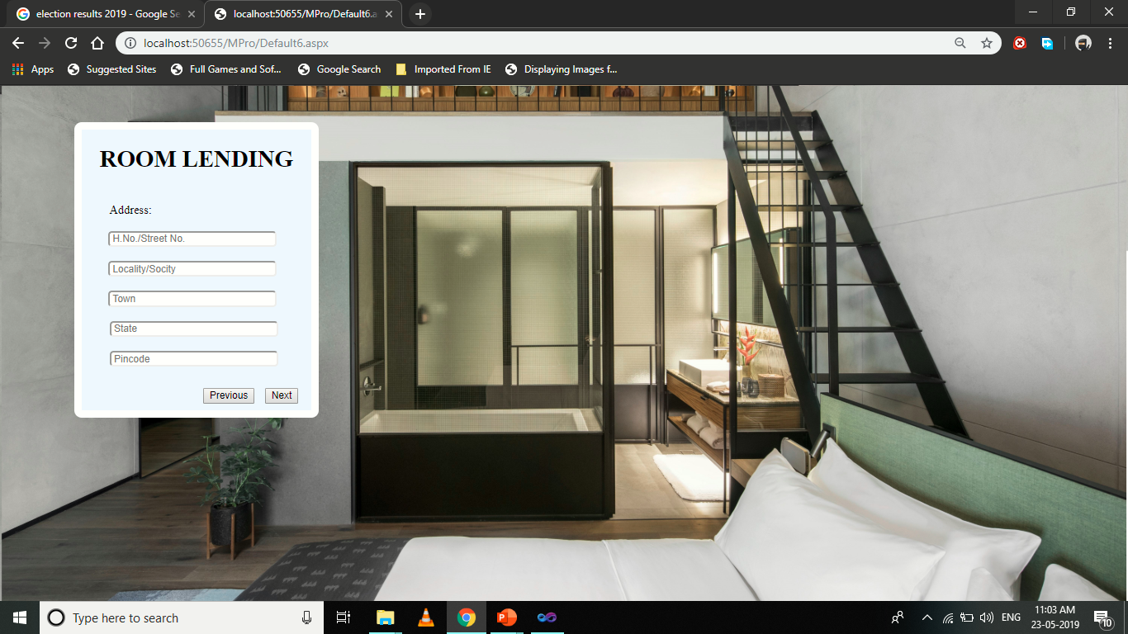

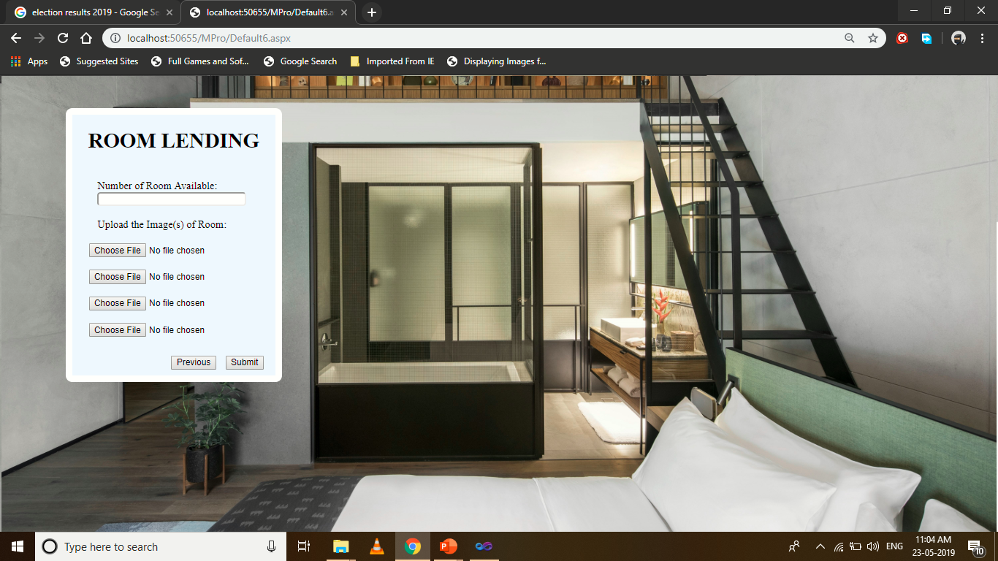

Design-

<%@ Page Language="C#" AutoEventWireup="true" CodeFile="Default6.aspx.cs" Inherits="Default6" %>

<!DOCTYPE html PUBLIC "-//W3C//DTD XHTML 1.0 Transitional//EN" "http://www.w3.org/TR/xhtml1/DTD/xhtml1-transitional.dtd">

<html xmlns="http://www.w3.org/1999/xhtml">

<head runat="server">

<title></title>

</head>

<body background="59536d78622a4-twh4-riverview-mezzanine-261-hires-6000px-20june2017.jpg" style="background-size:cover;">

<form id="form1" runat="server">

<div >

<br />

<br />

<asp:Panel ID="Panel1" runat="server" BorderColor="White" BorderStyle="Solid"

BorderWidth="10px"

style="position:absolute; -webkit-border-radius:10px;top:50px;left:100px;"

BackColor="AliceBlue">

<center><h1>&nbsp;&nbsp; ROOM LENDING&nbsp; &nbsp; </h1></center>

<asp:Wizard ID="Wizard1" runat="server" ActiveStepIndex="0" Width="301px"

FinishCompleteButtonText="Submit"

onfinishbuttonclick="Wizard1_FinishButtonClick" >

<WizardSteps>

<asp:WizardStep ID="WizardStep1" runat="server" Title=" " StepType="Start">

&nbsp;&nbsp;&nbsp;&nbsp;&nbsp;&nbsp;&nbsp;&nbsp; Title:<br /><center>

<asp:TextBox ID="TextBox1" runat="server" Width="223px" style="-webkit-border-radius:5px;"

></asp:TextBox></center><br />

&nbsp;&nbsp;&nbsp;&nbsp;&nbsp;&nbsp;&nbsp; &nbsp;User-ID:<br /><center>

<asp:TextBox ID="TextBox2" runat="server" Width="223px" style="-webkit-border-radius:5px;" ReadOnly="True"></asp:TextBox></center><br />

&nbsp;&nbsp;&nbsp;&nbsp;&nbsp;&nbsp;&nbsp;&nbsp;&nbsp;Type:<br /><center>

<asp:DropDownList ID="DropDownList1" runat="server" Width="223px" style="-webkit-border-radius:5px;">

<asp:ListItem>--Select--</asp:ListItem>

<asp:ListItem>Paying Guest</asp:ListItem>

<asp:ListItem>Rent a room</asp:ListItem>

</asp:DropDownList>

<br /><br />

</center>

&nbsp;&nbsp;&nbsp;&nbsp;&nbsp;&nbsp;&nbsp; &nbsp;Description:<br /><center>

<asp:TextBox ID="TextBox3" runat="server" TextMode="MultiLine" style="-webkit-border-radius:5px;" Height="72px"

Width="223px"></asp:TextBox></center> <br />

&nbsp;&nbsp;&nbsp;&nbsp;&nbsp;&nbsp;&nbsp; &nbsp; Price:<br /><center>

<asp:TextBox ID="TextBox4" runat="server" Width="223px" placeholder="Enter charges as per day" style="-webkit-border-radius:5px;"></asp:TextBox></center><br />

</asp:WizardStep>

<asp:WizardStep ID="WizardStep2" runat="server" Title=" ">

<br />

&nbsp;&nbsp;&nbsp;&nbsp;&nbsp;&nbsp;&nbsp; &nbsp;Address:<br /><br />

<center>

<asp:TextBox ID="TextBox16" runat="server" Placeholder=" H.No./Street No." style="-webkit-border-radius:5px;" Width="223px"></asp:TextBox>

<br/>

<br/>

<asp:TextBox ID="TextBox17" runat="server" Width="223px" Placeholder=" Locality/Socity" style="-webkit-border-radius:5px;"></asp:TextBox>

<br/>

<br/>

<asp:TextBox ID="TextBox18" runat="server" Width="223px" Placeholder=" Town" style="-webkit-border-radius:5px;"></asp:TextBox>

<br/><br/> <asp:TextBox

ID="TextBox19" runat="server" Width="223px" Placeholder=" State" style="-webkit-border-radius:5px;"></asp:TextBox><br/><br/> <asp:TextBox

ID="TextBox20" runat="server" Width="223px" Placeholder=" Pincode" style="-webkit-border-radius:5px;"></asp:TextBox><br/>

<br /></center>

</asp:WizardStep>

<asp:WizardStep ID="WizardStep3" runat="server" Title=" ">

<br />

&nbsp;&nbsp;&nbsp;&nbsp;&nbsp;&nbsp;&nbsp; &nbsp;Number of Room Available:<br />

<center> <asp:TextBox ID="TextBox5" runat="server" Width="223px" style="-webkit-border-radius:5px;" TextMode="SingleLine"></asp:TextBox></center><br />

&nbsp;&nbsp;&nbsp;&nbsp;&nbsp;&nbsp;&nbsp; &nbsp;Upload the Image(s) of Room:<br /><br />

<center> <asp:FileUpload ID="FileUpload1" runat="server" /><br /><br />

<asp:FileUpload ID="FileUpload2" runat="server" /><br /><br />

<asp:FileUpload ID="FileUpload3" runat="server" /><br /><br />

<asp:FileUpload ID="FileUpload4" runat="server" /><br /><br />

<asp:Label ID="Label1" runat="server" Text=""></asp:Label>

</center>

</asp:WizardStep>

</WizardSteps>

</asp:Wizard>

</asp:Panel>

</div>

</form>

</body>

</html>

Code Snippets-

using System;

using System.Collections.Generic;

using System.Linq;

using System.Web;

using System.Web.UI;

using System.Web.UI.WebControls;

using System.Data;

using System.Data.SqlClient;

public partial class Default6 : System.Web.UI.Page

{

SqlConnection cn = new SqlConnection("Data Source=DESKTOP-MP67RVV\\SQLEXPRESS;Initial Catalog=niraj;Integrated Security=True;Pooling=False");

SqlCommand cmd;

protected void Page_Load(object sender, EventArgs e)

{

TextBox2.Text = Session["s"].ToString();

}

protected void Wizard1_FinishButtonClick(object sender, WizardNavigationEventArgs e)

{

if (TextBox1.Text == "" || TextBox2.Text == "" || DropDownList1.Text == ""||TextBox5.Text==""||TextBox3.Text == "" ||TextBox4.Text == "" || !FileUpload1.HasFile || !FileUpload2.HasFile || !FileUpload3.HasFile || !FileUpload4.HasFile || TextBox16.Text == "" || TextBox17.Text == "" || TextBox18.Text == "" || TextBox19.Text == "" || TextBox20.Text == "")

{

Label1.Text = "Please innput all the data";

}

else

{

String pic1, pic2, pic3, pic4;

cn.Open();

pic1 = "~/post/" + FileUpload1.FileName;

FileUpload1.SaveAs(MapPath(pic1));

pic2 = "~/post/" + FileUpload2.FileName;

FileUpload2.SaveAs(MapPath(pic2));

pic3 = "~/post/" + FileUpload3.FileName;

FileUpload3.SaveAs(MapPath(pic3));

pic4 = "~/post/" + FileUpload4.FileName;

FileUpload4.SaveAs(MapPath(pic4));

cmd = new SqlCommand("Insert into room (title,id,type,des,amt,img1,img2,img3,img4,a1,a2,a3,a4,a5,nor) values('" + TextBox1.Text + "','" + TextBox2.Text + "','" + DropDownList1.Text + "','" + TextBox3.Text + "','" + TextBox4.Text + "','" + pic1 + "','" + pic2 + "','" + pic3 + "','" + pic4 + "','" + TextBox16.Text + "','" + TextBox17.Text + "','" + TextBox18.Text + "','" + TextBox19.Text + "','" + TextBox20.Text + "','" + TextBox5.Text + "')", cn);

cmd.ExecuteNonQuery();

cn.Close();

Response.Write("<Script>alert('Thank you for joining us')</Script>");

Response.Write("<Script>location.href = 'menubar.aspx';</Script>");

}

}

}

**Hall_Lending:**

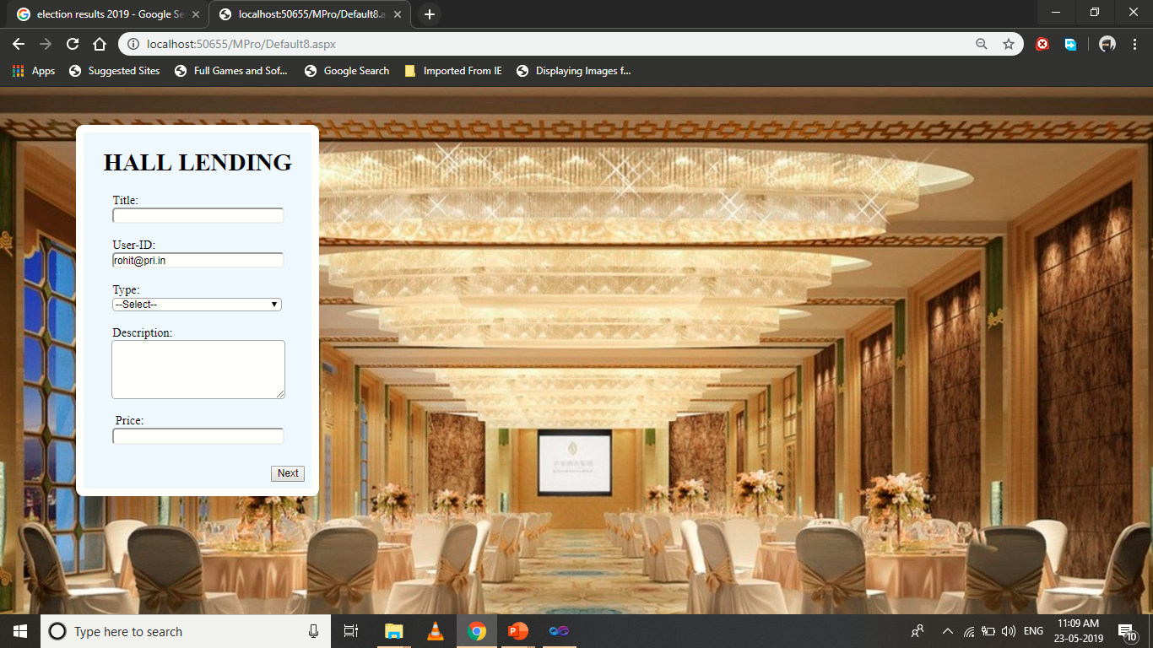

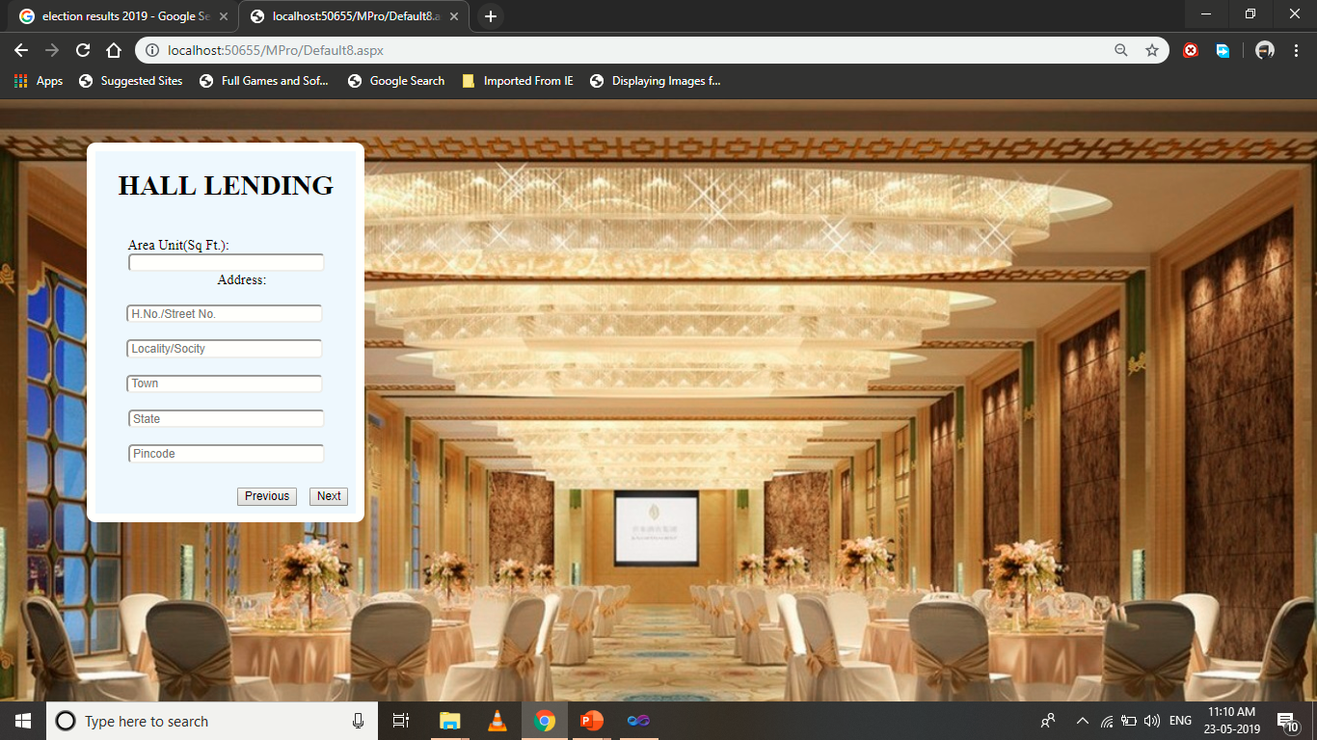

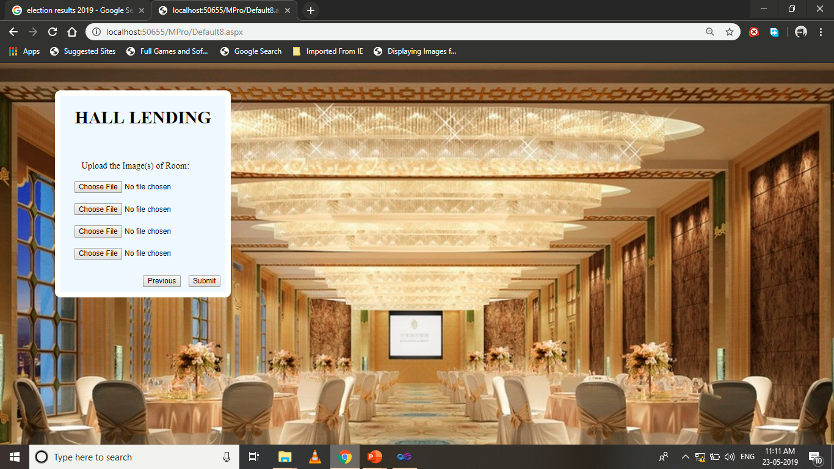

Design-

<%@ Page Language="C#" AutoEventWireup="true" CodeFile="Default8.aspx.cs" Inherits="Default8" %>

<!DOCTYPE html PUBLIC "-//W3C//DTD XHTML 1.0 Transitional//EN" "http://www.w3.org/TR/xhtml1/DTD/xhtml1-transitional.dtd">

<html xmlns="http://www.w3.org/1999/xhtml">

<head runat="server">

<title></title>

</head>

<body background="Wedding-room-interior-decoration-plus-marriage-theme-decoration-plus-funny-wedding-decorations-plus-wedding-venue-design.jpg" style="background-size:cover;">

<form id="form1" runat="server">

<div>

<asp:Panel ID="Panel1" runat="server" BorderColor="White" BorderStyle="Solid"

BorderWidth="10px"

style="position:absolute; -webkit-border-radius:10px;top:50px;left:100px;"

BackColor="AliceBlue">

<center><h1>&nbsp;&nbsp; HALL LENDING&nbsp; &nbsp; </h1></center>

<asp:Wizard ID="Wizard1" runat="server" ActiveStepIndex="0" Width="301px"

FinishCompleteButtonText="Submit"

onfinishbuttonclick="Wizard1_FinishButtonClick" >

<WizardSteps>

<asp:WizardStep ID="WizardStep1" runat="server" Title=" " StepType="Start">

&nbsp;&nbsp;&nbsp;&nbsp;&nbsp;&nbsp;&nbsp;&nbsp; Title:<br /><center>

<asp:TextBox ID="TextBox1" runat="server" Width="223px" style="-webkit-border-radius:5px;"

></asp:TextBox></center><br />

&nbsp;&nbsp;&nbsp;&nbsp;&nbsp;&nbsp;&nbsp; &nbsp;User-ID:<br /><center>

<asp:TextBox ID="TextBox2" runat="server" Width="223px" style="-webkit-border-radius:5px;" ReadOnly="True"></asp:TextBox></center><br />

&nbsp;&nbsp;&nbsp;&nbsp;&nbsp;&nbsp;&nbsp;&nbsp;&nbsp;Type:<br /><center>

<asp:DropDownList ID="DropDownList1" runat="server" Width="223px" style="-webkit-border-radius:5px;">

<asp:ListItem>--Select--</asp:ListItem>

<asp:ListItem>Marriage Hall</asp:ListItem>

<asp:ListItem>Conferance Hall</asp:ListItem>

<asp:ListItem>Auditorium</asp:ListItem>

</asp:DropDownList>

<br /><br />

</center>

&nbsp;&nbsp;&nbsp;&nbsp;&nbsp;&nbsp;&nbsp; &nbsp;Description:<br /><center>

<asp:TextBox ID="TextBox3" runat="server" TextMode="MultiLine" style="-webkit-border-radius:5px;" Height="72px"

Width="223px"></asp:TextBox></center> <br />

&nbsp;&nbsp;&nbsp;&nbsp;&nbsp;&nbsp;&nbsp; &nbsp; Price:<br /><center>

<asp:TextBox ID="TextBox4" runat="server" Width="223px" placeholder="Enter charges as per day" style="-webkit-border-radius:5px;"></asp:TextBox></center><br />

</asp:WizardStep>

<asp:WizardStep ID="WizardStep2" runat="server" Title=" ">

<br />

&nbsp;&nbsp;&nbsp;&nbsp;&nbsp;&nbsp;&nbsp;&nbsp;&nbsp;Area Unit(Sq Ft.):<br /><center>

<asp:TextBox ID="TextBox5" runat="server" Width="223px" style="-webkit-border-radius:5px;"></asp:TextBox><br /> &nbsp;&nbsp;&nbsp;&nbsp;&nbsp;&nbsp;&nbsp; &nbsp;Address:<br /><br />

<asp:TextBox ID="TextBox16" runat="server" Placeholder=" H.No./Street No." style="-webkit-border-radius:5px;" Width="223px"></asp:TextBox>

<br/>

<br/>

<asp:TextBox ID="TextBox17" runat="server" Width="223px" Placeholder=" Locality/Socity" style="-webkit-border-radius:5px;"></asp:TextBox>

<br/>

<br/>

<asp:TextBox ID="TextBox18" runat="server" Width="223px" Placeholder=" Town" style="-webkit-border-radius:5px;"></asp:TextBox>

<br/><br/> <asp:TextBox

ID="TextBox19" runat="server" Width="223px" Placeholder=" State" style="-webkit-border-radius:5px;"></asp:TextBox><br/><br/> <asp:TextBox

ID="TextBox20" runat="server" Width="223px" Placeholder=" Pincode" style="-webkit-border-radius:5px;"></asp:TextBox><br/>

<br />

</center>

</asp:WizardStep>

<asp:WizardStep ID="WizardStep3" runat="server" Title=" "> <br /><br />

&nbsp;&nbsp;&nbsp;&nbsp;&nbsp;&nbsp;&nbsp; &nbsp;Upload the Image(s) of Room:<br /><br />

<center> <asp:FileUpload ID="FileUpload1" runat="server" /><br /><br />

<asp:FileUpload ID="FileUpload2" runat="server" /><br /><br />

<asp:FileUpload ID="FileUpload3" runat="server" /><br /><br />

<asp:FileUpload ID="FileUpload4" runat="server" /><br /><br /><asp:Label ID="Label1" runat="server" Text=""></asp:Label>

</center>

</asp:WizardStep>

</WizardSteps>

</asp:Wizard>

</asp:Panel>

</div>

</form>

</body>

</html>

Code Snippets-

using System;

using System.Collections.Generic;

using System.Linq;

using System.Web;

using System.Web.UI;

using System.Web.UI.WebControls;

using System.Data;

using System.Data.SqlClient;

public partial class Default8 : System.Web.UI.Page

{

SqlConnection cn = new SqlConnection("Data Source=DESKTOP-MP67RVV\\SQLEXPRESS;Initial Catalog=niraj;Integrated Security=True;Pooling=False");

SqlCommand cmd;

protected void Page_Load(object sender, EventArgs e)

{

TextBox2.Text = Session["s"].ToString();

}

protected void Wizard1_FinishButtonClick(object sender, WizardNavigationEventArgs e)

{

if (TextBox1.Text == "" || TextBox2.Text == "" || DropDownList1.Text == "" || TextBox5.Text == "" || TextBox3.Text == "" || TextBox4.Text == "" || !FileUpload1.HasFile || !FileUpload2.HasFile || !FileUpload3.HasFile || !FileUpload4.HasFile || TextBox16.Text == "" || TextBox17.Text == "" || TextBox18.Text == "" || TextBox19.Text == "" || TextBox20.Text == "")

{

Label1.Text = "Please innput all the data";

}

else

{

String pic1, pic2, pic3, pic4;

cn.Open();

pic1 = "~/post/" + FileUpload1.FileName;

FileUpload1.SaveAs(MapPath(pic1));

pic2 = "~/post/" + FileUpload2.FileName;

FileUpload2.SaveAs(MapPath(pic2));

pic3 = "~/post/" + FileUpload3.FileName;

FileUpload3.SaveAs(MapPath(pic3));

pic4 = "~/post/" + FileUpload4.FileName;

FileUpload4.SaveAs(MapPath(pic4));

cmd = new SqlCommand("Insert into hall values('" + TextBox1.Text + "','" + TextBox2.Text + "','" + DropDownList1.Text + "','" + TextBox3.Text + "','" + TextBox4.Text + "','" + pic1 + "','" + pic2 + "','" + pic3 + "','" + pic4 + "','" + TextBox5.Text + "','" + TextBox16.Text + "','" + TextBox17.Text + "','" + TextBox18.Text + "','" + TextBox19.Text + "','" + TextBox20.Text + "')", cn);

cmd.ExecuteNonQuery();

cn.Close();

Response.Write("<Script>alert('Thank you for joining us')</Script>");

Response.Write("<Script>location.href = 'menubar.aspx';</Script>");

}

}

}

**Ground_Lending:**

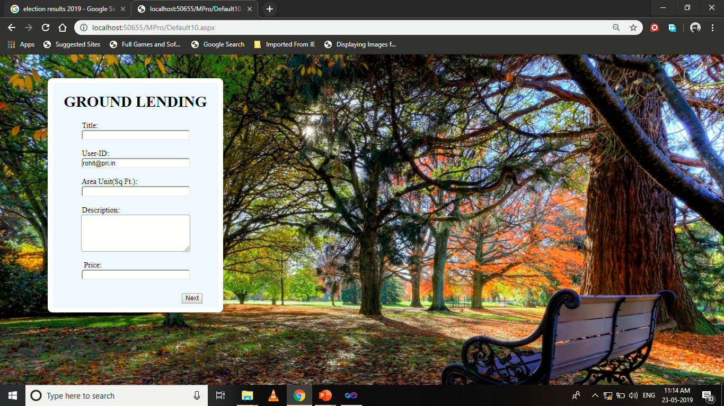

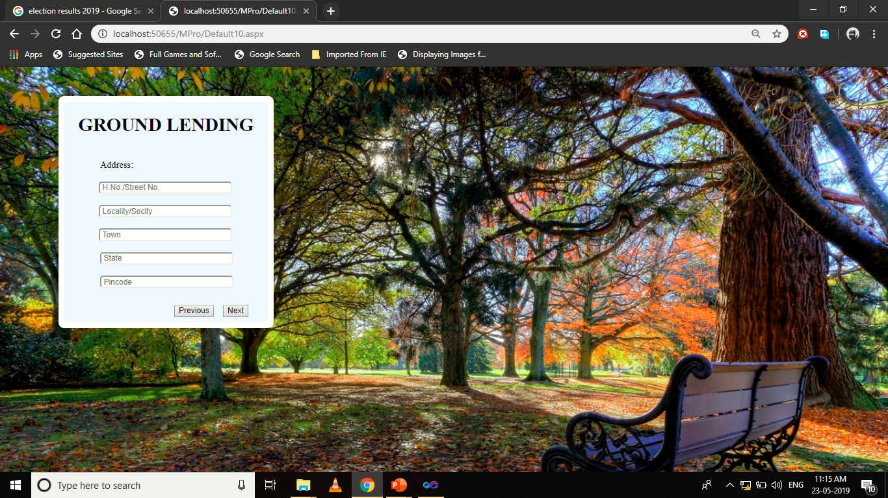



Design-

<%@ Page Language="C#" AutoEventWireup="true" CodeFile="Default10.aspx.cs" Inherits="Default10" %>

<!DOCTYPE html PUBLIC "-//W3C//DTD XHTML 1.0 Transitional//EN" "http://www.w3.org/TR/xhtml1/DTD/xhtml1-transitional.dtd">

<html xmlns="http://www.w3.org/1999/xhtml">

<head runat="server">

<title></title>

</head>

<body background="park_autumn_bench_88029_1280x720.jpg" style="background-size:cover;">

<form id="form1" runat="server">

<div>

<asp:Panel ID="Panel1" runat="server" BorderColor="White" BorderStyle="Solid"

BorderWidth="10px"

style="position:absolute; -webkit-border-radius:10px;top:50px;left:100px;"

BackColor="AliceBlue">

<center><h1>&nbsp;&nbsp; GROUND LENDING&nbsp; &nbsp; </h1></center><center>

<asp:Wizard ID="Wizard1" runat="server" ActiveStepIndex="0" Width="301px"

FinishCompleteButtonText="Submit"

onfinishbuttonclick="Wizard1_FinishButtonClick" >

<WizardSteps>

<asp:WizardStep ID="WizardStep1" runat="server" Title=" " StepType="Start">

&nbsp;&nbsp;&nbsp;&nbsp;&nbsp;&nbsp;&nbsp;&nbsp; Title:<br /><center>

<asp:TextBox ID="TextBox1" runat="server" Width="223px" style="-webkit-border-radius:5px;"

></asp:TextBox></center><br />

&nbsp;&nbsp;&nbsp;&nbsp;&nbsp;&nbsp;&nbsp; &nbsp;User-ID:<br /><center>

<asp:TextBox ID="TextBox2" runat="server" Width="223px" style="-webkit-border-radius:5px;" ReadOnly="True"></asp:TextBox></center><br />

&nbsp;&nbsp;&nbsp;&nbsp;&nbsp;&nbsp;&nbsp;&nbsp;&nbsp;Area Unit(Sq Ft.):<br /><center>

<asp:TextBox ID="TextBox5" runat="server" Width="223px" style="-webkit-border-radius:5px;"></asp:TextBox></center><br />

&nbsp;&nbsp;&nbsp;&nbsp;&nbsp;&nbsp;&nbsp; &nbsp;Description:<br /><center>

<asp:TextBox ID="TextBox3" runat="server" TextMode="MultiLine" style="-webkit-border-radius:5px;" Height="72px"

Width="223px"></asp:TextBox></center> <br />

&nbsp;&nbsp;&nbsp;&nbsp;&nbsp;&nbsp;&nbsp; &nbsp; Price:<br /><center>

<asp:TextBox ID="TextBox4" runat="server" Width="223px" placeholder="Enter charges as per day" style="-webkit-border-radius:5px;"></asp:TextBox></center><br />

</asp:WizardStep>

<asp:WizardStep ID="WizardStep2" runat="server" Title=" ">

<br />

&nbsp;&nbsp;&nbsp;&nbsp;&nbsp;&nbsp;&nbsp; &nbsp;Address:<br /><br />

<center>

<asp:TextBox ID="TextBox16" runat="server" Placeholder=" H.No./Street No." style="-webkit-border-radius:5px;" Width="223px"></asp:TextBox>

<br/>

<br/>

<asp:TextBox ID="TextBox17" runat="server" Width="223px" Placeholder=" Locality/Socity" style="-webkit-border-radius:5px;"></asp:TextBox>

<br/>

<br/>

<asp:TextBox ID="TextBox18" runat="server" Width="223px" Placeholder=" Town" style="-webkit-border-radius:5px;"></asp:TextBox>

<br/><br/> <asp:TextBox

ID="TextBox19" runat="server" Width="223px" Placeholder=" State" style="-webkit-border-radius:5px;"></asp:TextBox><br/><br/> <asp:TextBox

ID="TextBox20" runat="server" Width="223px" Placeholder=" Pincode" style="-webkit-border-radius:5px;"></asp:TextBox><br/>

<br /></center>

</asp:WizardStep>

<asp:WizardStep ID="WizardStep3" runat="server" Title=" ">

&nbsp;&nbsp;&nbsp;&nbsp;&nbsp;&nbsp;&nbsp; &nbsp;Upload the Image(s) of Ground:<br /><br />

<center> <asp:FileUpload ID="FileUpload1" runat="server" /><br /><br />

<asp:FileUpload ID="FileUpload2" runat="server" /><br /><br />

<asp:FileUpload ID="FileUpload3" runat="server" /><br /><br />

<asp:FileUpload ID="FileUpload4" runat="server" /><br /><br />

<asp:Label ID="Label1" runat="server" Text="" ForeColor="#FF0066"></asp:Label>

</center>

</asp:WizardStep>

</WizardSteps>

</asp:Wizard></center>

</asp:Panel>

</div>

</form>

</body>

</html>

Code Snippets-

using System;

using System.Collections.Generic;

using System.Linq;

using System.Web;

using System.Web.UI;

using System.Web.UI.WebControls;

using System.Data;

using System.Data.SqlClient;

public partial class Default10 : System.Web.UI.Page

{

SqlConnection cn = new SqlConnection("Data Source=DESKTOP-MP67RVV\\SQLEXPRESS;Initial Catalog=niraj;Integrated Security=True;Pooling=False");

SqlCommand cmd;

protected void Page_Load(object sender, EventArgs e)

{

TextBox2.Text = Session["s"].ToString();

}

protected void Wizard1_FinishButtonClick(object sender, WizardNavigationEventArgs e)

{

if (TextBox1.Text == "" || TextBox2.Text == "" || TextBox5.Text == "" || TextBox3.Text == "" || TextBox4.Text == "" || !FileUpload1.HasFile || !FileUpload2.HasFile || !FileUpload3.HasFile || !FileUpload4.HasFile || TextBox16.Text == "" || TextBox17.Text == "" || TextBox18.Text == "" || TextBox19.Text == "" || TextBox20.Text == "")

{

Label1.Text = "Please innput all the data";

}

else

{

String pic1, pic2, pic3, pic4;

cn.Open();

pic1 = "~/post/" + FileUpload1.FileName;

FileUpload1.SaveAs(MapPath(pic1));

pic2 = "~/post/" + FileUpload2.FileName;

FileUpload2.SaveAs(MapPath(pic2));

pic3 = "~/post/" + FileUpload3.FileName;

FileUpload3.SaveAs(MapPath(pic3));

pic4 = "~/post/" + FileUpload4.FileName;

FileUpload4.SaveAs(MapPath(pic4));

cmd = new SqlCommand("Insert into ground values('" + TextBox1.Text + "','" + TextBox2.Text + "','" + TextBox5.Text + "','" + TextBox3.Text + "','" + TextBox4.Text + "','" + pic1 + "','" + pic2 + "','" + pic3 + "','" + pic4 + "','" + TextBox16.Text + "','" + TextBox17.Text + "','" + TextBox18.Text + "','" + TextBox19.Text + "','" + TextBox20.Text + "')", cn);

cmd.ExecuteNonQuery();

cn.Close();

Response.Write("<Script>alert('Thank you for joining us')</Script>");

Response.Write("<Script>location.href = 'menubar.aspx';</Script>");

}

}

}

**Amin_Page:**

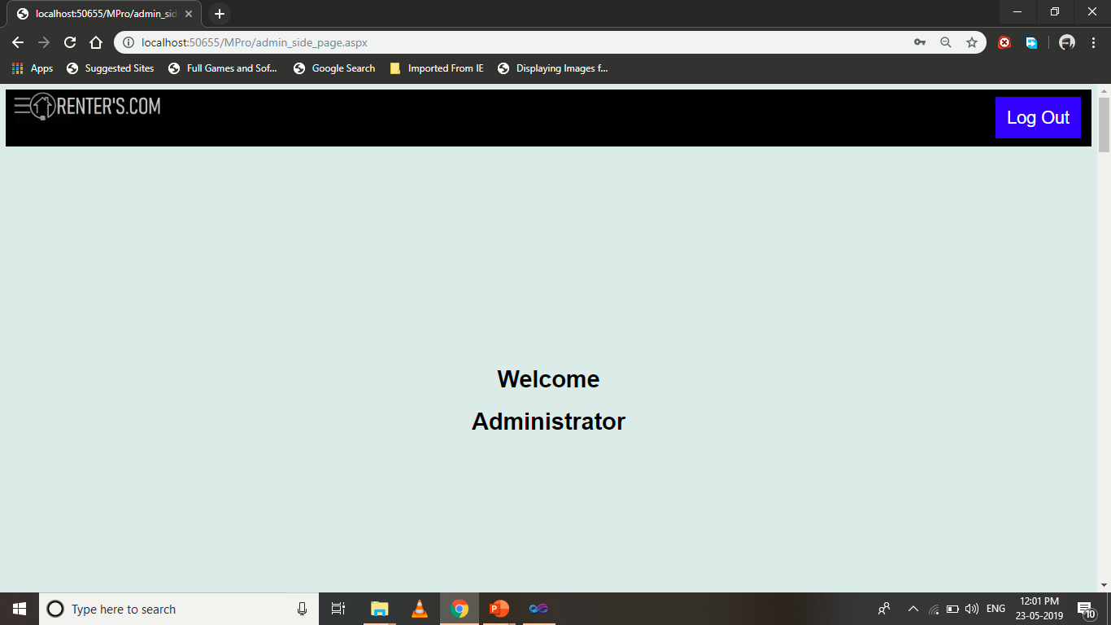

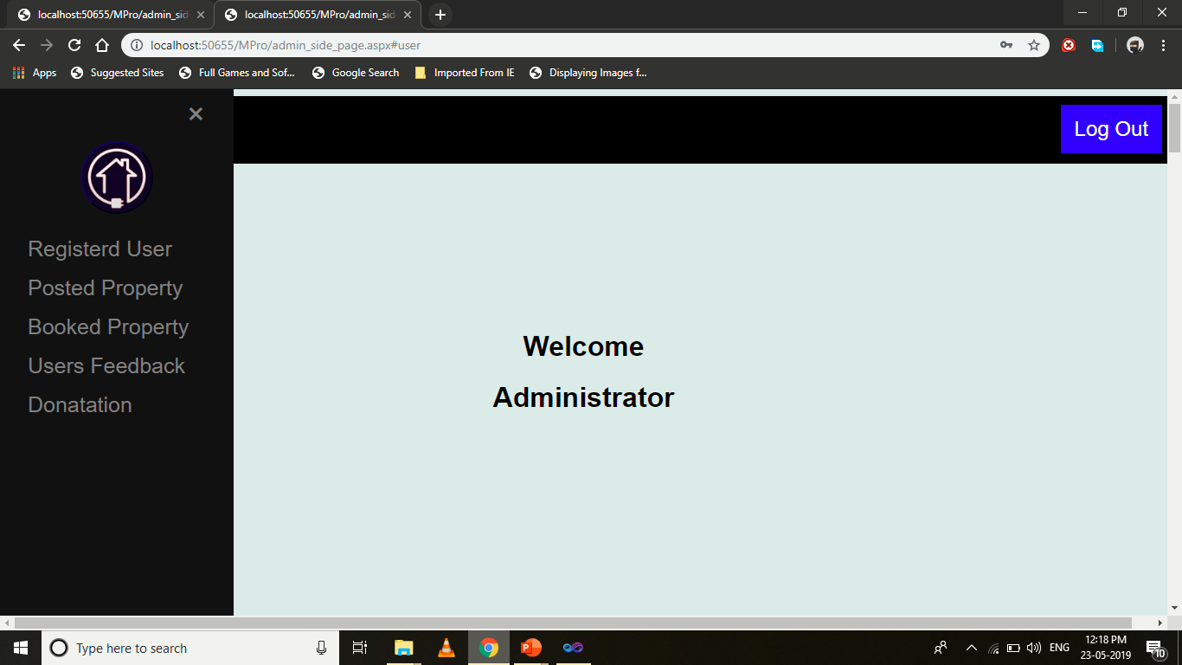

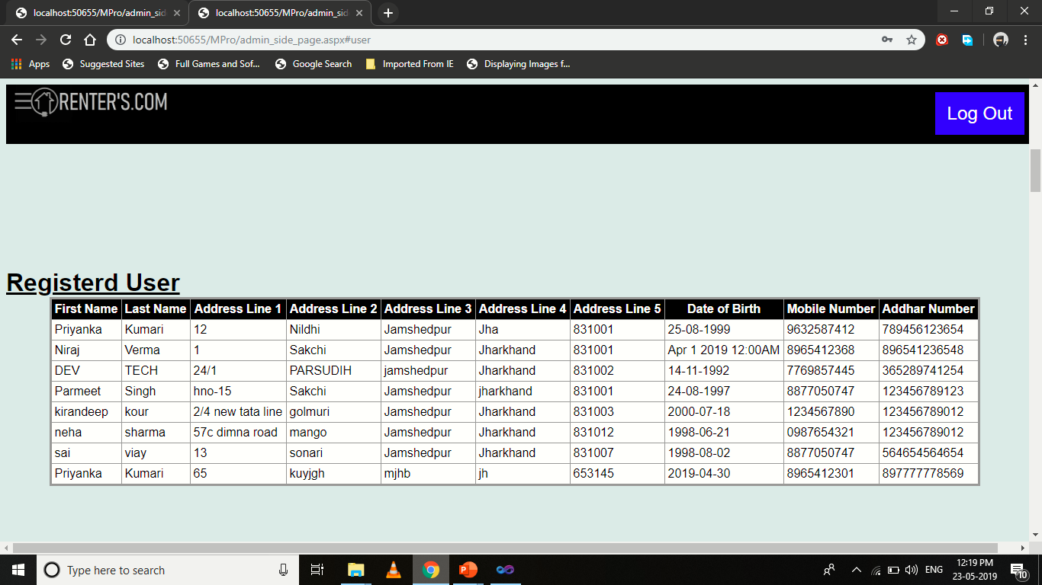

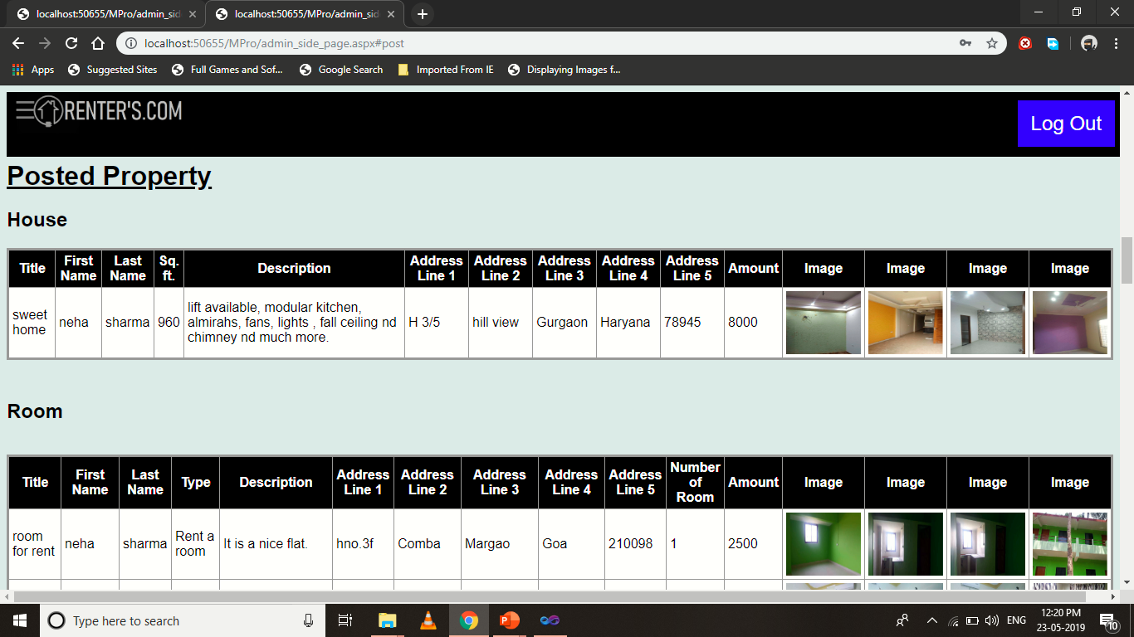

Design-

<%@ Page Language="C#" AutoEventWireup="true" CodeFile="admin_side_page.aspx.cs" Inherits="admin_side_page" %>

<!DOCTYPE html PUBLIC "-//W3C//DTD XHTML 1.0 Transitional//EN" "http://www.w3.org/TR/xhtml1/DTD/xhtml1-transitional.dtd">

<html xmlns="http://www.w3.org/1999/xhtml">

<head runat="server">

<title></title>

<style>

body {

font-family: "Lato", sans-serif;

}

.sidenav {

height: 100%;

width: 0;

position: fixed;

z-index: 1;

top: 0;

left: 0;

background-color: #111;

overflow-x: hidden;

transition: 0.5s;

padding-top: 60px;

}

.sidenav a {

padding: 8px 8px 8px 32px;

text-decoration: none;

font-size: 25px;

color: #818181;

display: block;

transition: 0.3s;

}

.sidenav a:hover {

color: #f1f1f1;

}

.sidenav .closebtn {

position: absolute;

top: 0;

right: 25px;

font-size: 36px;

margin-left: 50px;

}

.style1

{

text-decoration: underline;

font-size: xx-large;

}

.style2

{

text-decoration: underline;

}

</style>

<script type="text/javascript">

function openNav() {

document.getElementById("mySidenav").style.width = "20%";

}

function closeNav() {

document.getElementById("mySidenav").style.width = "0";

}

</script>

</head>

<body style=" background: #e0ebe8;">

<form id="form1" runat="server">

<div style="background-color: Black; height: 78px; position:fixed; width:100%;">

&nbsp;&nbsp;<span style="position:fixed; font-size:30px; cursor:pointer; color:Gray;"

onclick="openNav()" >&#9776;</span>

<asp:Image ID="Image1" runat="server" ImageUrl="~/l.png" Height="50px" Width="250px" />

<a href="Default14.aspx"

style= "background-color:Blue; float:right; text-decoration:none;color:White; padding:14px 16px;

text-align:center;font-size:x-large; position: relative; top: 10px; left: -14px;">Log Out</a></div>

<div id="mySidenav" class="sidenav">

<a href="javascript:void(0)" class="closebtn" onclick="closeNav()">&times;</a><center>

<asp:Image ID="Image2" runat="server" ImageUrl="~/logo.jpg"

ToolTip="Gallery" style=" border-radius:50%; height:80px; width:80px;"

BorderColor="#000066" BorderStyle="Outset" BorderWidth="2px"

AlternateText="Gallery" /></center><br />

<a href="#user">Registerd User</a>

<a href="#post">Posted Property</a>

<a href="#book">Booked Property</a>

<a href="#feed">Users Feedback</a>

<a href="#donate">Donatation</a>

</div>

<center>

<div style="top: 0; padding-bottom:40vh; min-height: 50vh; padding-top: 40vh;">

<h1>Welcome</h1><h1>Administrator</h1></center>

</div>

<div id="user" style=" min-height: 50vh; padding-bottom:40vh;

padding-top: 40vh;">

<span class="style1"><strong>Registerd User

</strong></span>

<center>

<asp:GridView ID="GridView1" runat="server" AutoGenerateColumns="False"

BackColor="#CCCCCC" BorderColor="#999999" BorderStyle="Solid" BorderWidth="3px"

CellPadding="4" CellSpacing="2" DataSourceID="SqlDataSource1" ForeColor="Black">

<Columns>

<asp:BoundField DataField="fname" HeaderText="First Name"

SortExpression="fname" />

<asp:BoundField DataField="lname" HeaderText="Last Name"

SortExpression="lname" />

<asp:BoundField DataField="a1" HeaderText="Address Line 1"

SortExpression="a1" />

<asp:BoundField DataField="a2" HeaderText="Address Line 2"

SortExpression="a2" />

<asp:BoundField DataField="a3" HeaderText="Address Line 3"

SortExpression="a3" />

<asp:BoundField DataField="a4" HeaderText="Address Line 4"

SortExpression="a4" />

<asp:BoundField DataField="a5" HeaderText="Address Line 5"

SortExpression="a5" />

<asp:BoundField DataField="dob" HeaderText="Date of Birth"

SortExpression="dob" />

<asp:BoundField DataField="mno" HeaderText="Mobile Number"

SortExpression="mno" />

<asp:BoundField DataField="ano" HeaderText="Addhar Number"

SortExpression="ano" />

</Columns>

<FooterStyle BackColor="#CCCCCC" />

<HeaderStyle BackColor="Black" Font-Bold="True" ForeColor="White" />

<PagerStyle BackColor="#CCCCCC" ForeColor="Black" HorizontalAlign="Left" />

<RowStyle BackColor="White" />

<SelectedRowStyle BackColor="#000099" Font-Bold="True" ForeColor="White" />

<SortedAscendingCellStyle BackColor="#F1F1F1" />

<SortedAscendingHeaderStyle BackColor="#808080" />

<SortedDescendingCellStyle BackColor="#CAC9C9" />

<SortedDescendingHeaderStyle BackColor="#383838" />

</asp:GridView>

<asp:SqlDataSource ID="SqlDataSource1" runat="server"

ConnectionString="<%$ ConnectionStrings:nirajConnectionString %>"

SelectCommand="SELECT [fname], [lname], [a1], [a2], [a3], [a4], [a5], [dob], [mno], [ano] FROM [lustab]"></asp:SqlDataSource>

</center></div>

<div id="post" style=" min-height: 50vh; padding-bottom:40vh;

padding-top: 40vh;">

<span class="style1"><strong>Posted Property</strong></span>

<h2>House</h2>

<asp:GridView ID="GridView2" runat="server" AutoGenerateColumns="False"

DataSourceID="SqlDataSource2" BackColor="#CCCCCC" BorderColor="#999999"

BorderStyle="Solid" BorderWidth="3px" CellPadding="4" CellSpacing="2"

ForeColor="Black" onselectedindexchanged="GridView2_SelectedIndexChanged"

AutoGenerateDeleteButton="True" DataKeyNames="title">

<Columns>

<asp:BoundField DataField="title" HeaderText="Title" SortExpression="title" />

<asp:BoundField DataField="fname" HeaderText="First Name"

SortExpression="fname" />

<asp:BoundField DataField="lname" HeaderText="Last Name"

SortExpression="lname" />

<asp:BoundField DataField="area" HeaderText="Sq. ft." SortExpression="area" />

<asp:BoundField DataField="des" HeaderText="Description" SortExpression="des" />

<asp:BoundField DataField="a1" HeaderText="Address Line 1"

SortExpression="a1" />

<asp:BoundField DataField="a2" HeaderText="Address Line 2"

SortExpression="a2" />

<asp:BoundField DataField="a3" HeaderText="Address Line 3"

SortExpression="a3" />

<asp:BoundField DataField="a4" HeaderText="Address Line 4"

SortExpression="a4" />

<asp:BoundField DataField="a5" HeaderText="Address Line 5"

SortExpression="a5" />

<asp:BoundField DataField="amt" HeaderText="Amount" SortExpression="amt" />

<asp:TemplateField HeaderText="Image" SortExpression="img1">

<EditItemTemplate>

<asp:TextBox ID="TextBox4" runat="server" Text='<%# Bind("img1") %>'></asp:TextBox>

</EditItemTemplate>

<ItemTemplate>

<asp:Image ID="Image6" runat="server" Height="76px"

ImageUrl='<%# Eval("img1") %>' Width="90px" />

</ItemTemplate>

</asp:TemplateField>

<asp:TemplateField HeaderText="Image" SortExpression="img2">

<EditItemTemplate>

<asp:TextBox ID="TextBox4" runat="server" Text='<%# Bind("img2") %>'></asp:TextBox>

</EditItemTemplate>

<ItemTemplate>

<asp:Image ID="Image6" runat="server" Height="76px"

ImageUrl='<%# Eval("img2") %>' Width="90px" />

</ItemTemplate>

</asp:TemplateField>

<asp:TemplateField HeaderText="Image" SortExpression="img3">

<EditItemTemplate>

<asp:TextBox ID="TextBox4" runat="server" Text='<%# Bind("img3") %>'></asp:TextBox>

</EditItemTemplate>

<ItemTemplate>

<asp:Image ID="Image6" runat="server" Height="76px"

ImageUrl='<%# Eval("img3") %>' Width="90px" />

</ItemTemplate>

</asp:TemplateField>

<asp:TemplateField HeaderText="Image" SortExpression="img4">

<EditItemTemplate>

<asp:TextBox ID="TextBox4" runat="server" Text='<%# Bind("img4") %>'></asp:TextBox>

</EditItemTemplate>

<ItemTemplate>

<asp:Image ID="Image6" runat="server" Height="76px"

ImageUrl='<%# Eval("img4") %>' Width="90px" />

</ItemTemplate>

</asp:TemplateField>

</Columns>

<FooterStyle BackColor="#CCCCCC" />

<HeaderStyle BackColor="Black" Font-Bold="True" ForeColor="White" />

<PagerStyle BackColor="#CCCCCC" ForeColor="Black" HorizontalAlign="Left" />

<RowStyle BackColor="White" />

<SelectedRowStyle BackColor="#000099" Font-Bold="True" ForeColor="White" />

<SortedAscendingCellStyle BackColor="#F1F1F1" />

<SortedAscendingHeaderStyle BackColor="Gray" />

<SortedDescendingCellStyle BackColor="#CAC9C9" />

<SortedDescendingHeaderStyle BackColor="#383838" />

</asp:GridView>

<asp:SqlDataSource ID="SqlDataSource2" runat="server"

ConnectionString="<%$ ConnectionStrings:nirajConnectionString %>"

DeleteCommand="Delete from house where title=@title"

SelectCommand="SELECT house.title, lustab.fname, lustab.lname, house.area, house.des, lustab.mno, lustab.ano, house.a1, house.a2, house.a3, house.a4, house.a5, house.amt, house.img1, house.img2, house.img3, house.img4 FROM house INNER JOIN lustab ON house.id=lustab.id">

</asp:SqlDataSource>

<h2>

<br />

<strong>Room</strong></h2>

<br />

<asp:GridView ID="GridView3" runat="server" AutoGenerateColumns="False"

BackColor="#CCCCCC" BorderColor="#999999" BorderStyle="Solid" BorderWidth="3px"

CellPadding="4" CellSpacing="2" DataSourceID="SqlDataSource3" ForeColor="Black" AutoGenerateDeleteButton="True" DataKeyNames="title">

<Columns>

<asp:BoundField DataField="title" HeaderText="Title" SortExpression="title" />

<asp:BoundField DataField="fname" HeaderText="First Name"

SortExpression="fname" />

<asp:BoundField DataField="lname" HeaderText="Last Name"

SortExpression="lname" />

<asp:BoundField DataField="type" HeaderText="Type" SortExpression="type" />

<asp:BoundField DataField="des" HeaderText="Description" SortExpression="des" />

<asp:BoundField DataField="a1" HeaderText="Address Line 1"

SortExpression="a1" />

<asp:BoundField DataField="a2" HeaderText="Address Line 2"

SortExpression="a2" />

<asp:BoundField DataField="a3" HeaderText="Address Line 3"

SortExpression="a3" />

<asp:BoundField DataField="a4" HeaderText="Address Line 4"

SortExpression="a4" />

<asp:BoundField DataField="a5" HeaderText="Address Line 5"

SortExpression="a5" />

<asp:BoundField DataField="nor" HeaderText="Number of Room"

SortExpression="nor" />

<asp:BoundField DataField="amt" HeaderText="Amount" SortExpression="amt" />

<asp:TemplateField HeaderText="Image" SortExpression="img1">

<EditItemTemplate>

<asp:TextBox ID="TextBox4" runat="server" Text='<%# Bind("img1") %>'></asp:TextBox>

</EditItemTemplate>

<ItemTemplate>

<asp:Image ID="Image6" runat="server" Height="76px"

ImageUrl='<%# Eval("img1") %>' Width="90px" />

</ItemTemplate>

</asp:TemplateField>

<asp:TemplateField HeaderText="Image" SortExpression="img2">

<EditItemTemplate>

<asp:TextBox ID="TextBox4" runat="server" Text='<%# Bind("img2") %>'></asp:TextBox>

</EditItemTemplate>

<ItemTemplate>

<asp:Image ID="Image6" runat="server" Height="76px"

ImageUrl='<%# Eval("img2") %>' Width="90px" />

</ItemTemplate>

</asp:TemplateField>

<asp:TemplateField HeaderText="Image" SortExpression="img3">

<EditItemTemplate>

<asp:TextBox ID="TextBox4" runat="server" Text='<%# Bind("img3") %>'></asp:TextBox>

</EditItemTemplate>

<ItemTemplate>

<asp:Image ID="Image6" runat="server" Height="76px"

ImageUrl='<%# Eval("img3") %>' Width="90px" />

</ItemTemplate>

</asp:TemplateField>

<asp:TemplateField HeaderText="Image" SortExpression="img4">

<EditItemTemplate>

<asp:TextBox ID="TextBox4" runat="server" Text='<%# Bind("img4") %>'></asp:TextBox>

</EditItemTemplate>

<ItemTemplate>

<asp:Image ID="Image6" runat="server" Height="76px"

ImageUrl='<%# Eval("img4") %>' Width="90px" />

</ItemTemplate>

</asp:TemplateField>

</Columns>

<FooterStyle BackColor="#CCCCCC" />

<HeaderStyle BackColor="Black" Font-Bold="True" ForeColor="White" />

<PagerStyle BackColor="#CCCCCC" ForeColor="Black" HorizontalAlign="Left" />

<RowStyle BackColor="White" />

<SelectedRowStyle BackColor="#000099" Font-Bold="True" ForeColor="White" />

<SortedAscendingCellStyle BackColor="#F1F1F1" />

<SortedAscendingHeaderStyle BackColor="#808080" />

<SortedDescendingCellStyle BackColor="#CAC9C9" />

<SortedDescendingHeaderStyle BackColor="#383838" />

</asp:GridView>

<asp:SqlDataSource ID="SqlDataSource3" runat="server"

ConnectionString="<%$ ConnectionStrings:nirajConnectionString %>" DeleteCommand="Delete from house where title=@title"

SelectCommand="SELECT room.title, room.type, room.des, room.amt, room.img1, room.img2, room.img3, room.img4, room.a1, room.a2, room.a3, room.a4, room.a5, room.nor, lustab.fname, lustab.lname, lustab.mno, lustab.ano FROM room INNER JOIN lustab ON room.id = lustab.id"></asp:SqlDataSource>

<h2>

<strong>Hall</strong></h2>

<br />

<asp:GridView ID="GridView4" runat="server" AutoGenerateColumns="False"

BackColor="#CCCCCC" BorderColor="#999999" BorderStyle="Solid" BorderWidth="3px"

CellPadding="4" CellSpacing="2" DataSourceID="SqlDataSource4" ForeColor="Black">

<Columns>

<asp:BoundField DataField="title" HeaderText="Title" SortExpression="title" />

<asp:BoundField DataField="fname" HeaderText="First Name"

SortExpression="fname" />

<asp:BoundField DataField="lname" HeaderText="Last Name"

SortExpression="lname" />

<asp:BoundField DataField="type" HeaderText="Type" SortExpression="type" />

<asp:BoundField DataField="des" HeaderText="Description" SortExpression="des" />

<asp:BoundField DataField="area" HeaderText="Sq. ft." SortExpression="area" />

<asp:BoundField DataField="a1" HeaderText="Address Line 1"

SortExpression="a1" />

<asp:BoundField DataField="a2" HeaderText="Address Line 2"

SortExpression="a2" />

<asp:BoundField DataField="a3" HeaderText="Address Line 3"

SortExpression="a3" />

<asp:BoundField DataField="a4" HeaderText="Address Line 4"

SortExpression="a4" />

<asp:BoundField DataField="a5" HeaderText="Address Line 5"

SortExpression="a5" />

<asp:BoundField DataField="mno" HeaderText="Mobile Number"

SortExpression="mno" />

<asp:BoundField DataField="ano" HeaderText="Aadhar Number"

SortExpression="ano" />

<asp:BoundField DataField="amt" HeaderText="Amount" SortExpression="amt" />

<asp:TemplateField HeaderText="Image" SortExpression="img1">

<EditItemTemplate>

<asp:TextBox ID="TextBox1" runat="server" Text='<%# Bind("img1") %>'></asp:TextBox>

</EditItemTemplate>

<ItemTemplate>

<asp:Image ID="Image6" runat="server" Height="76px"

ImageUrl='<%# Eval("img1") %>' Width="90px" />

</ItemTemplate>

</asp:TemplateField>

<asp:TemplateField HeaderText="Image" SortExpression="img2">

<EditItemTemplate>

<asp:TextBox ID="TextBox2" runat="server" Text='<%# Bind("img2") %>'></asp:TextBox>

</EditItemTemplate>

<ItemTemplate>

<asp:Image ID="Image6" runat="server" Height="76px"

ImageUrl='<%# Eval("img2") %>' Width="90px" />

</ItemTemplate>

</asp:TemplateField>

<asp:TemplateField HeaderText="Image" SortExpression="img3">

<EditItemTemplate>

<asp:TextBox ID="TextBox3" runat="server" Text='<%# Bind("img3") %>'></asp:TextBox>

</EditItemTemplate>

<ItemTemplate>

<asp:Image ID="Image6" runat="server" Height="76px"

ImageUrl='<%# Eval("img3") %>' Width="90px" />

</ItemTemplate>

</asp:TemplateField>

<asp:TemplateField HeaderText="Image" SortExpression="img4">

<EditItemTemplate>

<asp:TextBox ID="TextBox4" runat="server" Text='<%# Bind("img4") %>'></asp:TextBox>

</EditItemTemplate>

<ItemTemplate>

<asp:Image ID="Image6" runat="server" Height="76px"

ImageUrl='<%# Eval("img4") %>' Width="90px" />

</ItemTemplate>

</asp:TemplateField>

</Columns>

<FooterStyle BackColor="#CCCCCC" />

<HeaderStyle BackColor="Black" Font-Bold="True" ForeColor="White" />

<PagerStyle BackColor="#CCCCCC" ForeColor="Black" HorizontalAlign="Left" />

<RowStyle BackColor="White" />

<SelectedRowStyle BackColor="#000099" Font-Bold="True" ForeColor="White" />

<SortedAscendingCellStyle BackColor="#F1F1F1" />

<SortedAscendingHeaderStyle BackColor="#808080" />

<SortedDescendingCellStyle BackColor="#CAC9C9" />

<SortedDescendingHeaderStyle BackColor="#383838" />

</asp:GridView>

<asp:SqlDataSource ID="SqlDataSource4" runat="server"

ConnectionString="<%$ ConnectionStrings:nirajConnectionString %>"

SelectCommand="SELECT hall.title, lustab.fname, lustab.lname, hall.type, hall.des, hall.area, hall.a1, hall.a2, hall.a3, hall.a4, hall.a5, lustab.mno, lustab.ano, hall.amt, hall.img1, hall.img2, hall.img3, hall.img4 FROM hall INNER JOIN lustab ON hall.id = lustab.id"></asp:SqlDataSource>

<h2>

<strong>

<br />

Ground</strong></h2>

<asp:GridView ID="GridView5" runat="server" AutoGenerateColumns="False"

DataSourceID="SqlDataSource5"

onselectedindexchanged="GridView5_SelectedIndexChanged"

BackColor="#CCCCCC" BorderColor="#999999" BorderStyle="Solid" BorderWidth="3px"

CellPadding="4" CellSpacing="2" ForeColor="Black">

<Columns>

<asp:BoundField DataField="title" HeaderText="Title" SortExpression="title" />

<asp:BoundField DataField="fname" HeaderText="First Name"

SortExpression="fname" />

<asp:BoundField DataField="lname" HeaderText="Last Name"

SortExpression="lname" />

<asp:BoundField DataField="area" HeaderText="Sq. ft." SortExpression="area" />

<asp:BoundField DataField="des" HeaderText="Description" SortExpression="des" />

<asp:BoundField DataField="a1" HeaderText="Address Line 1"

SortExpression="a1" />

<asp:BoundField DataField="a2" HeaderText="Address Line 2"

SortExpression="a2" />

<asp:BoundField DataField="a3" HeaderText="Address Line 3"

SortExpression="a3" />

<asp:BoundField DataField="a4" HeaderText="Address Line 4"

SortExpression="a4" />

<asp:BoundField DataField="a5" HeaderText="Address Line 5"

SortExpression="a5" />

<asp:BoundField DataField="mno" HeaderText="Mobile Number"

SortExpression="mno" />

<asp:BoundField DataField="ano" HeaderText="Aadhar Number"

SortExpression="ano" />

<asp:BoundField DataField="amt" HeaderText="Amount" SortExpression="amt" />

<asp:TemplateField HeaderText="Image" SortExpression="img1">

<EditItemTemplate>

<asp:TextBox ID="TextBox4" runat="server" Text='<%# Bind("img1") %>'></asp:TextBox>

</EditItemTemplate>

<ItemTemplate> <asp:Image ID="Image6" runat="server" Height="76px"

ImageUrl='<%# Eval("img1") %>' Width="90px" />

</ItemTemplate>

</asp:TemplateField>

<asp:TemplateField HeaderText="Image" SortExpression="img2">

<EditItemTemplate>

<asp:TextBox ID="TextBox3" runat="server" Text='<%# Bind("img2") %>'></asp:TextBox>

</EditItemTemplate>

<ItemTemplate> <asp:Image ID="Image6" runat="server" Height="76px"

ImageUrl='<%# Eval("img2") %>' Width="90px" />

</ItemTemplate>

</asp:TemplateField>

<asp:TemplateField HeaderText="Image" SortExpression="img3">

<EditItemTemplate>

<asp:TextBox ID="TextBox2" runat="server" Text='<%# Bind("img3") %>'></asp:TextBox>

</EditItemTemplate>

<ItemTemplate> <asp:Image ID="Image6" runat="server" Height="76px"

ImageUrl='<%# Eval("img3") %>' Width="90px" />

</ItemTemplate>

</asp:TemplateField>

<asp:TemplateField HeaderText="Image" SortExpression="img4">

<EditItemTemplate>

<asp:TextBox ID="TextBox4" runat="server" Text='<%# Bind("img4") %>'></asp:TextBox>

</EditItemTemplate>

<ItemTemplate>

<asp:Image ID="Image6" runat="server" Height="76px"

ImageUrl='<%# Eval("img4") %>' Width="90px" />

</ItemTemplate>

</asp:TemplateField>

</Columns>

<FooterStyle BackColor="#CCCCCC" />

<HeaderStyle BackColor="Black" Font-Bold="True" ForeColor="White" />

<PagerStyle BackColor="#CCCCCC" ForeColor="Black" HorizontalAlign="Left" />

<RowStyle BackColor="White" />

<SelectedRowStyle BackColor="#000099" Font-Bold="True" ForeColor="White" />

<SortedAscendingCellStyle BackColor="#F1F1F1" />

<SortedAscendingHeaderStyle BackColor="#808080" />

<SortedDescendingCellStyle BackColor="#CAC9C9" />

<SortedDescendingHeaderStyle BackColor="#383838" />

</asp:GridView>

<asp:SqlDataSource ID="SqlDataSource5" runat="server"

ConnectionString="<%$ ConnectionStrings:nirajConnectionString %>"

SelectCommand="SELECT ground.title, lustab.fname, lustab.lname,ground.id, ground.area, ground.a1, ground.a2, ground.a3, ground.a4, ground.a5, lustab.mno, lustab.ano , ground.des, ground.amt, ground.img1, ground.img2, ground.img3, ground.img4 FROM ground INNER JOIN lustab ON ground.id = lustab.id"></asp:SqlDataSource>

<br />

</div>

<div id="book" style=" min-height: 50vh; padding-bottom:40vh;

padding-top: 40vh;">

<span class="style1"><strong>Booking History

</strong></span>

<asp:GridView ID="GridView6" runat="server" AutoGenerateColumns="False"

DataSourceID="SqlDataSource6" onrowcreated="GridView6_RowCreated"

BackColor="#CCCCCC" BorderColor="#999999" BorderStyle="Solid" BorderWidth="3px"

CellPadding="4" CellSpacing="2" ForeColor="Black" style="text-align:center;">

<Columns>

<asp:BoundField DataField="sno" HeaderText="Sl No." SortExpression="sno" />

<asp:BoundField DataField="title" HeaderText="Title" SortExpression="title" />

<asp:BoundField DataField="lname" HeaderText="Name"

SortExpression="lname" />

<asp:BoundField DataField="lmno" HeaderText="Mobile Number"

SortExpression="lmno" />

<asp:BoundField DataField="lano" HeaderText="Aadhar Number"

SortExpression="lano" />

<asp:BoundField DataField="rname" HeaderText="Name" SortExpression="rname" />

<asp:BoundField DataField="rmno" HeaderText="Mobile Number"

SortExpression="rmno" />

<asp:BoundField DataField="rano" HeaderText="Aadhar Number"

SortExpression="rano" />

<asp:BoundField DataField="ra1" HeaderText="Address" SortExpression="ra1" />

<asp:BoundField DataField="ha1" HeaderText="House Address"

SortExpression="ha1" />

<asp:BoundField DataField="area" HeaderText="Sq. ft." SortExpression="area" />

<asp:BoundField DataField="des" HeaderText="Description" SortExpression="des" />

<asp:BoundField DataField="bd" HeaderText="Booking Date" SortExpression="bd" />

<asp:BoundField DataField="fd" HeaderText="Booked from" SortExpression="fd" />

<asp:BoundField DataField="nod" HeaderText="Number of Days"

SortExpression="nod" />

<asp:BoundField DataField="amt" HeaderText="Amount" SortExpression="amt" />

</Columns>

<FooterStyle BackColor="#CCCCCC" />

<HeaderStyle BackColor="Black" Font-Bold="True" ForeColor="White" />

<PagerStyle BackColor="#CCCCCC" ForeColor="Black" HorizontalAlign="Left" />

<RowStyle BackColor="White" />

<SelectedRowStyle BackColor="#000099" Font-Bold="True" ForeColor="White" />

<SortedAscendingCellStyle BackColor="#F1F1F1" />

<SortedAscendingHeaderStyle BackColor="#808080" />

<SortedDescendingCellStyle BackColor="#CAC9C9" />

<SortedDescendingHeaderStyle BackColor="#383838" />

</asp:GridView>

<asp:SqlDataSource ID="SqlDataSource6" runat="server"

ConnectionString="<%$ ConnectionStrings:nirajConnectionString %>"

SelectCommand="SELECT * FROM [book]"></asp:SqlDataSource>

</div>

<div id="feed" style="min-height: 50vh;padding-top: 40vh; padding-bottom:40vh;">

<span class="style1"><strong>Feedback

</strong></span>

<center>

<asp:GridView ID="GridView7" runat="server" AutoGenerateColumns="False"

BackColor="#CCCCCC" BorderColor="#999999" BorderStyle="Solid" BorderWidth="3px"

CellPadding="4" CellSpacing="2" DataSourceID="SqlDataSource7" ForeColor="Black">

<Columns>

<asp:BoundField DataField="name" HeaderText="Name" SortExpression="name" />

<asp:BoundField DataField="id" HeaderText="User id" SortExpression="id" />

<asp:BoundField DataField="fd" HeaderText="Opinion" SortExpression="fd" />

</Columns>

<FooterStyle BackColor="#CCCCCC" />

<HeaderStyle BackColor="Black" Font-Bold="True" ForeColor="White" />

<PagerStyle BackColor="#CCCCCC" ForeColor="Black" HorizontalAlign="Left" />

<RowStyle BackColor="White" />

<SelectedRowStyle BackColor="#000099" Font-Bold="True" ForeColor="White" />

<SortedAscendingCellStyle BackColor="#F1F1F1" />

<SortedAscendingHeaderStyle BackColor="#808080" />

<SortedDescendingCellStyle BackColor="#CAC9C9" />

<SortedDescendingHeaderStyle BackColor="#383838" />

</asp:GridView></center>

<asp:SqlDataSource ID="SqlDataSource7" runat="server"

ConnectionString="<%$ ConnectionStrings:nirajConnectionString %>"

SelectCommand="SELECT * FROM [feedback]"></asp:SqlDataSource>

</div>

<div id="donate" style=" min-height: 50vh; padding-top: 40vh;">

<h1>

<span class="style2"><strong>Donate</strong></span></h1><center>

&nbsp;<asp:GridView ID="GridView8" runat="server" AutoGenerateColumns="False"

BackColor="#CCCCCC" BorderColor="#999999" BorderStyle="Solid" BorderWidth="3px"

CellPadding="4" CellSpacing="2" DataSourceID="SqlDataSource8" ForeColor="Black">

<Columns>

<asp:BoundField DataField="name" HeaderText="Name" SortExpression="name" />

<asp:BoundField DataField="id" HeaderText="User Id" SortExpression="id" />

<asp:BoundField DataField="mno" HeaderText="Contact No." SortExpression="mno" />

<asp:BoundField DataField="addr" HeaderText="Address" SortExpression="addr" />

<asp:BoundField DataField="dto" HeaderText="Donate To" SortExpression="dto" />

<asp:BoundField DataField="item" HeaderText="Goods" SortExpression="item" />

<asp:BoundField DataField="qty" HeaderText="Quantity" SortExpression="qty" />

</Columns>

<FooterStyle BackColor="#CCCCCC" />

<HeaderStyle BackColor="Black" Font-Bold="True" ForeColor="White" />

<PagerStyle BackColor="#CCCCCC" ForeColor="Black" HorizontalAlign="Left" />

<RowStyle BackColor="White" />

<SelectedRowStyle BackColor="#000099" Font-Bold="True" ForeColor="White" />

<SortedAscendingCellStyle BackColor="#F1F1F1" />

<SortedAscendingHeaderStyle BackColor="#808080" />

<SortedDescendingCellStyle BackColor="#CAC9C9" />

<SortedDescendingHeaderStyle BackColor="#383838" />

</asp:GridView>

<asp:SqlDataSource ID="SqlDataSource8" runat="server"

ConnectionString="<%$ ConnectionStrings:nirajConnectionString %>"

SelectCommand="SELECT * FROM [donate]"></asp:SqlDataSource></center>

</div>

</form>

</body>

</html>

Code Snippets-

using System;

using System.Collections.Generic;

using System.Linq;

using System.Web;

using System.Web.UI;

using System.Web.UI.WebControls;

public partial class admin_side_page : System.Web.UI.Page

{

protected void Page_Load(object sender, EventArgs e)

{

}

protected void GridView2_SelectedIndexChanged(object sender, EventArgs e)

{

}

protected void GridView5_SelectedIndexChanged(object sender, EventArgs e)

{

}

protected void GridView6_RowCreated(object sender, GridViewRowEventArgs e)

{

if (e.Row.RowType == DataControlRowType.Header)

{

GridView Head = (GridView)sender;

GridViewRow h = new GridViewRow(2,2, DataControlRowType.Header, DataControlRowState.Insert);

TableCell t = new TableCell();

t.Text = "";

t.ColumnSpan = 2;

h.Cells.Add(t);

t = new TableCell();

t.Text = "Lender";

t.ColumnSpan = 3;

h.Cells.Add(t);

t = new TableCell();

t.Text = "Renter";

t.ColumnSpan = 4;

h.Cells.Add(t);

t = new TableCell();

t.Text = "";

t.ColumnSpan = 7;

h.Cells.Add(t);

GridView6.Controls[0].Controls.AddAt(0, h);

}

}

}

###### **TESTING AND VALIDATIONS:**

###### TESTING:

###### In a software development projects, errors can be generated at any stage during the development phase. For each phase we have different techniques to eliminate the bugs that can originate in that phase.

###### Unit Testing:

###### In this phase testing of individual modules of the system was being done separately for the specifications produced at the design phase. For each

###### Of the modules different test cases are created. All the coding bugs of the different forms were also removed in this phase of testing.

Integration Testing:

In this phase of testing we considered all the different modules that we have created. And the internal coding of the different buttons, labels, textboxes included in the form were tested and removed the errors which

Occurred then finalized the rectified results.

System Testing:

In this phase of testing we have seen the entire working of the project. In this phase of testing we made validation, navigation etc.

**Future Scope**

• The site will further prove to be a very cost effective and economical resource where people (both lenders and renters) can easily portrait their requirements.

• The ease of communication can lead to the communicable benefit of the website.

• Advertisement and abatement can be achieved at a common platform reducing the time consumption.

**Conclusion**

The main objective of this project was to improve the existing renting services and to provide a solution to the problems encountered in the rental sector regarding the way home and others places of rent are rented and the way relocation services and related information are provided to renters and new coming people in the state.

This objective has been achieved successfully with the best practices in designing and building of a web-based application for improved and user-friendly renting system.

The web-based application for rental system has been designed using asp.net as programming language and Mysql database.

**Bibliography**

* **VB.NET 2010 Complete reference**
* **MS SQL Server 2005**